Client Import – QuickBooks Online

This document covers how to export your client list from QuickBooks Online (QBO) into a format that the ThermoGRID team can process and import into your TG account.

Steps:

1. In QBO, click on the reports tab on the left, then search for “customer” in the search bar and select “Customer Contact List”.
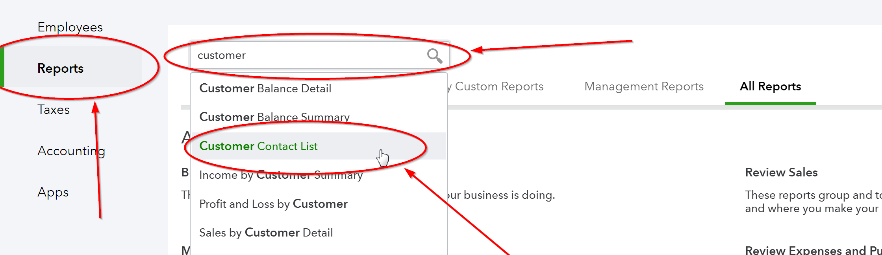
2. On the right, click the settings gear/cog wheel and check/uncheck the checkboxes to match the picture below. You may need to click “Show more” to view all columns. Then click on "Reorder columns".
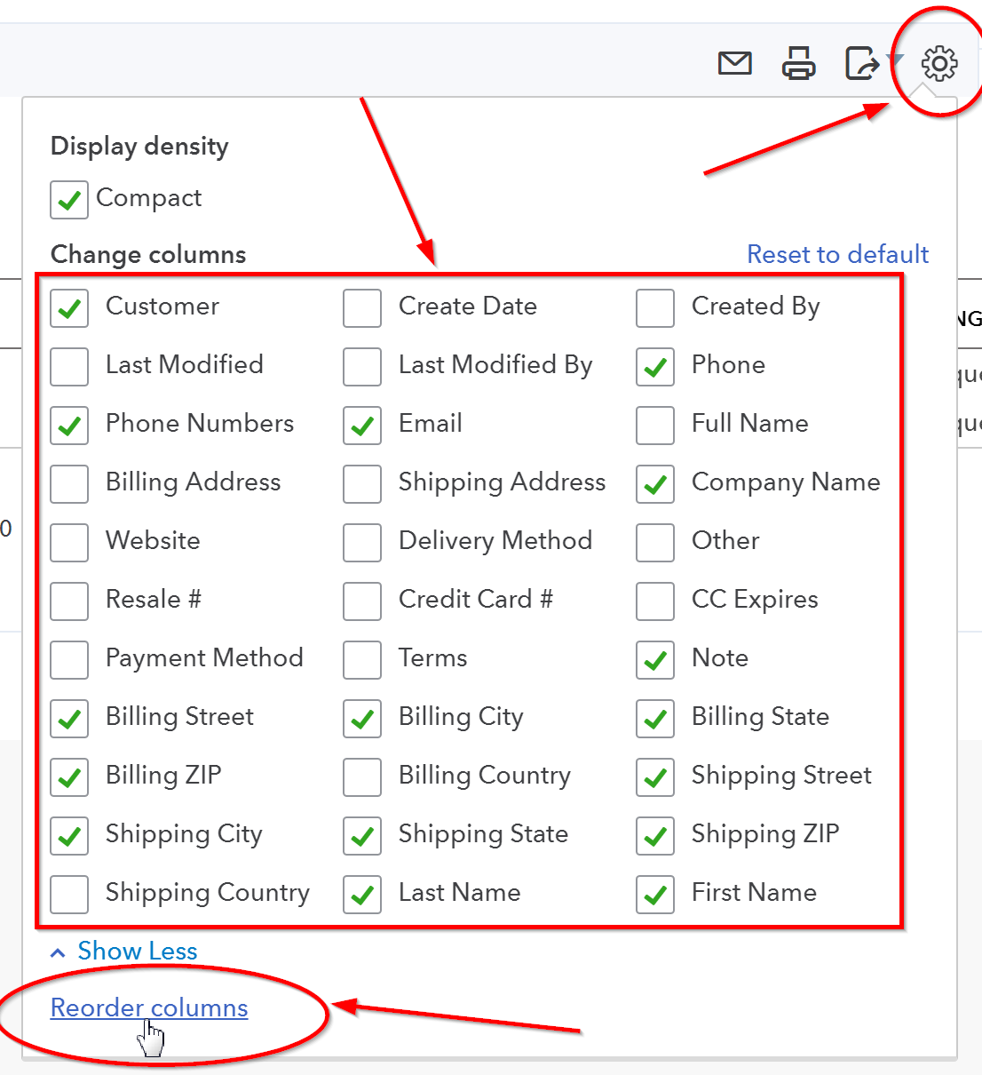

3. Use the move buttons on each side of the checkbox to reorder them like the picture below. Then click the "Run report" button.
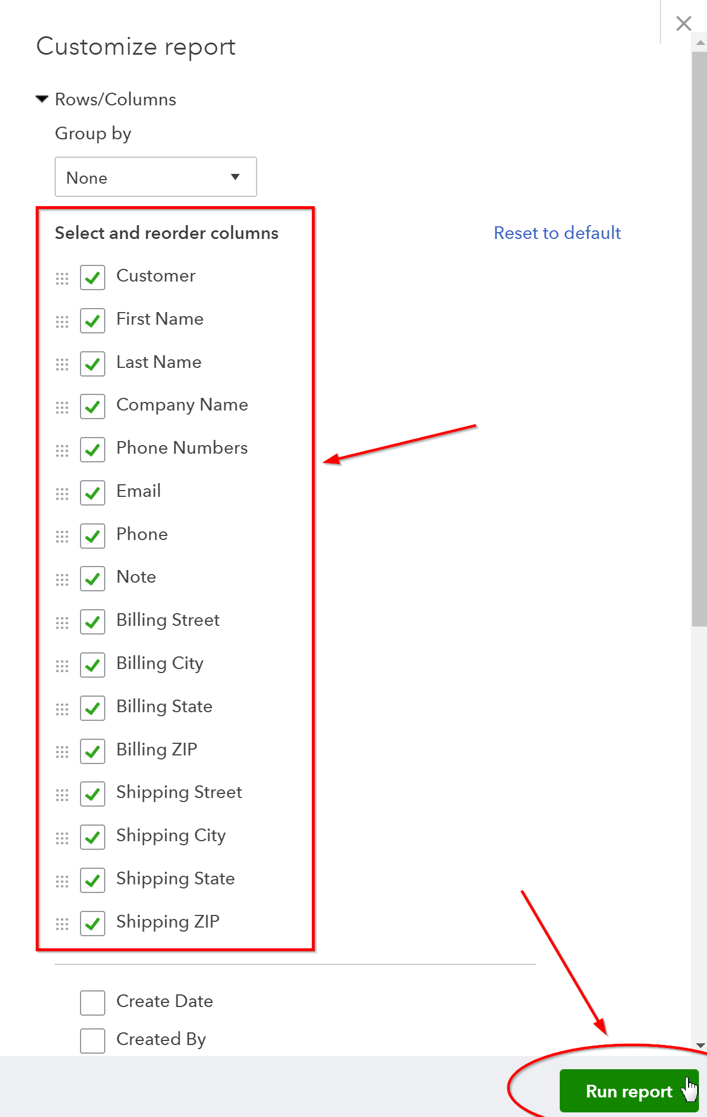

4. Then click on the export button at the top right and select "Export to Excel".
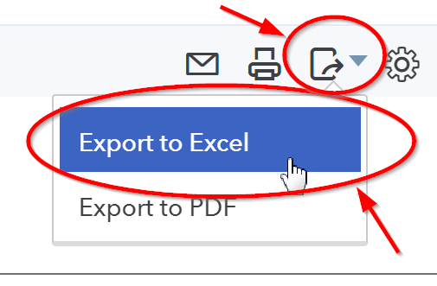
5. Save the file and look over this export thoroughly as you only get one import in to TG. Make sure it has all that the information you want and compare to clients in the system to make sure the items you checked off for the report is giving you the correct info. When you are ready, email the file to the ThermoGRID team so they can process and import your data.

