Administration
Account Set-Up 2: Manage Dropdowns

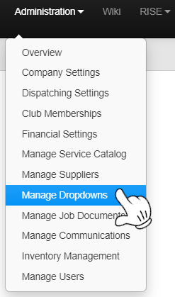
- Click on the Administration Tab
- Click on Manage Dropdowns

The Selection in Red will be Edited later on
When we begin to edit the Service Catalog
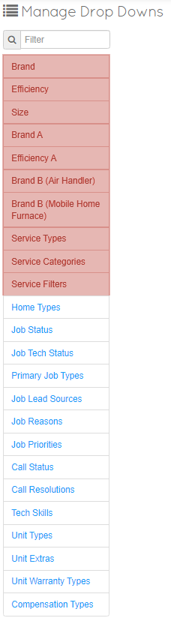

These Selections should be ignored for
the moment

Start Here on Home Types

Home Types

When Creating an Address for a Customer, these are the different types of Homes/Locations that can be Listen under that Address.

By editing this you will be able to add different types home types in your market. This allows a tech to know what they are getting into before arriving on the job.

It will default with:

Apartment
2 Story
Ranch
Duplex
Town House
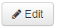
Just like on the Company Settings there will be an Edit Button on the Top Right

From here you can Add more Types and change Descriptions When Completed
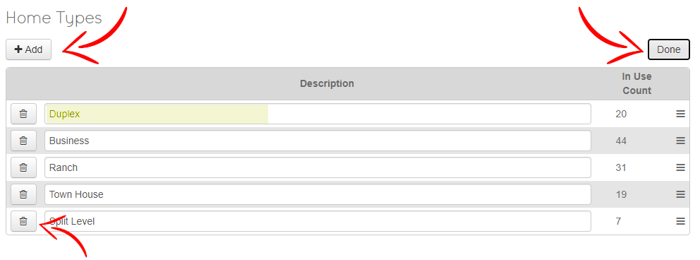
Delete any you do not need

You will now see Your Custom List in your Clients Addresses as a Dropdown Option
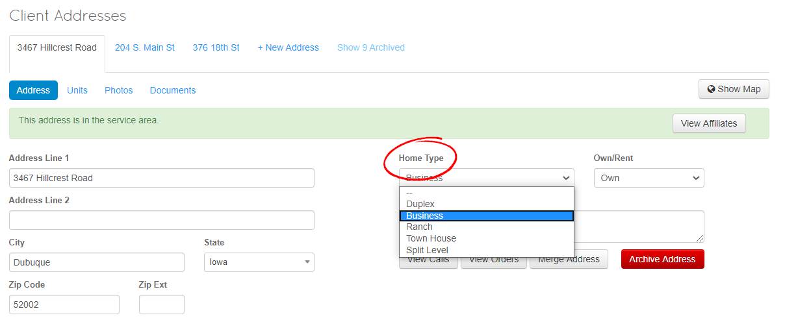
Job Status

By editing this you will be able to add a distinction to the current state of the Job.
This will allow you to sort Jobs by your own Custom Statuses.
Make sure any type of Job needing to be Closed, has the word Closed in it.

Ex: "Closed Client Canceled"

You can customize any way you wish to track
It will default with:
- Open
- Holding for parts
- Go Back
- Closed
Just like Home Types, there will be an Edit Button on the Top Right.
Make any Changes you would like to the Job Statuses.
Editing is consistent with the previous method

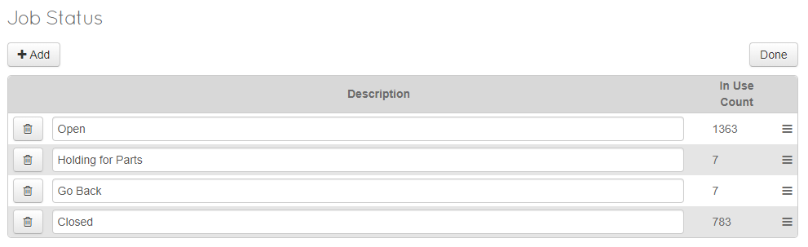

You will now see Your Custom List in your Job Info and Job Status Filter as a Dropdown Option
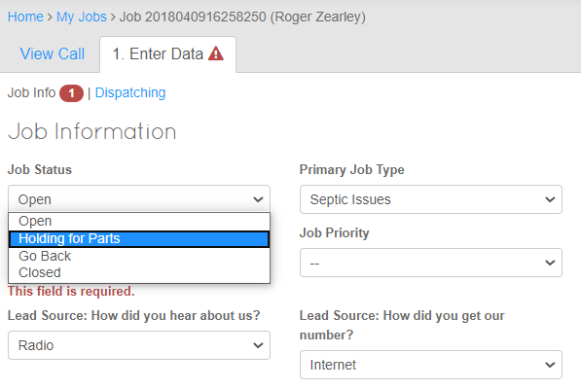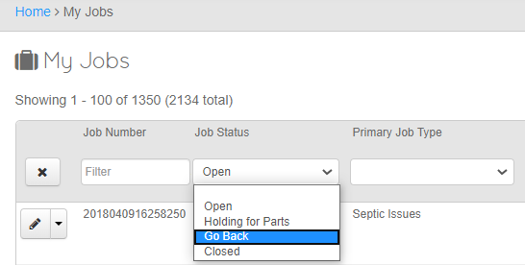
Job Tech Status

Provides a Simple and Quick way for Call Center/ Dispatch to see the Current status of a Job.
These are Updated by the Tech or Call Center.

This can allow Administration to see where each tech is at with a Job and have it color coded.

You can customize any way you wish.
(Note: This is not searchable, filterable and does not effect a call or job in anyway. It is a tool for quick communication between techs and admin/dispatch)

It will default with:

Waiting for Dispatch
Dispatched
In-Route
Onsite
Running Late
Just like on the Job Status, there will be an Edit Button on the Top Right.
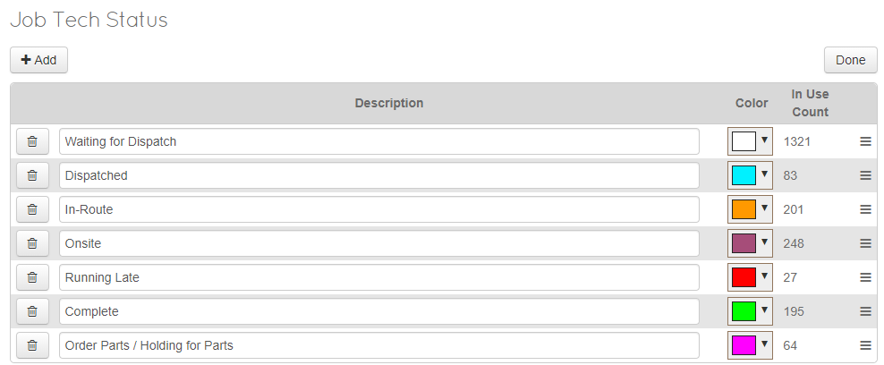
Make any Changes you would like to the Job Tech Statuses.
Editing is consistent with the previous method

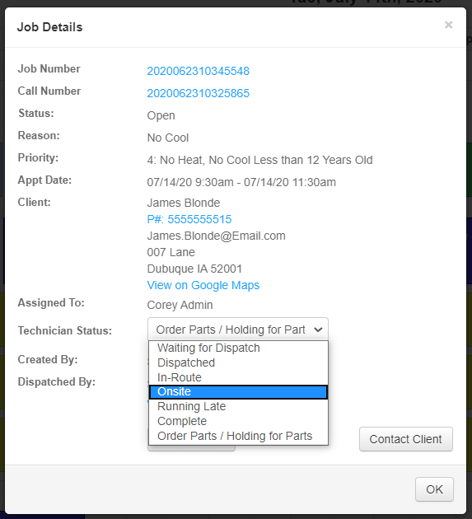
You will now see Your Custom List in any Job Details as a Dropdown Option
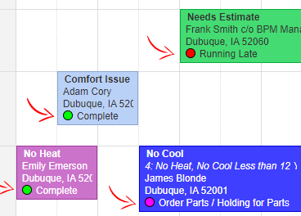
Color Correlations and Status will be shown when updated on each Job on the Calendar

Primary Job Types

Your Custom Primary Job Types will give you or your Tech an idea of the Type of Job that they will be performing. You will be able to customize the options displayed below.

(Note: This are not the Reason for the Job, that will be customized after this)
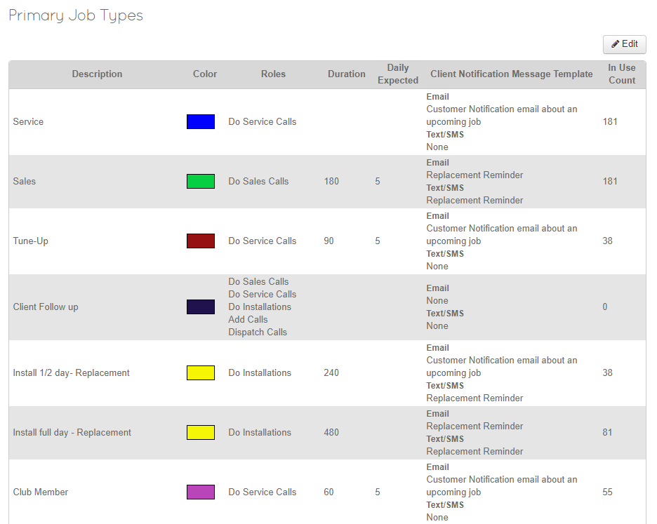
Assign to your Job Type:
Description – What is the PJT called
Color – What Color will the Job be on the Calendar
Roles – What Roles can do this Job
Duration - What is the Standard amount of time set aside on the calendar for this Job
Daily Expected – # of Expected Job Types
Client Notification Template – What Template will be used to Notify the Client that the Job has been Scheduled
(Note: Templates can also be Customized under Home>Administration>Manage Communications>Manage Email Templates OR Manage Text Templates)

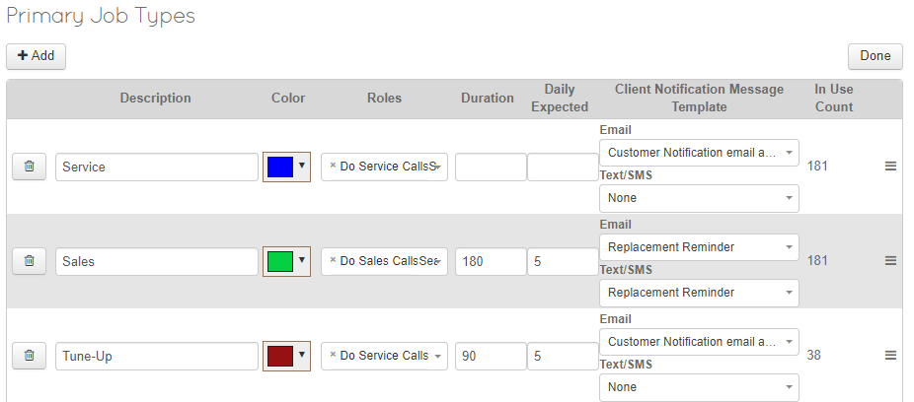
Make any Changes you would like to the Primary Job Types
Editing is consistent with the previous method.
In use count is not editable and will populate as Jobs get created

You will now see Your Custom List under +Add Job and Jobs as a Primary Job Type Filter Dropdown
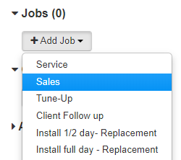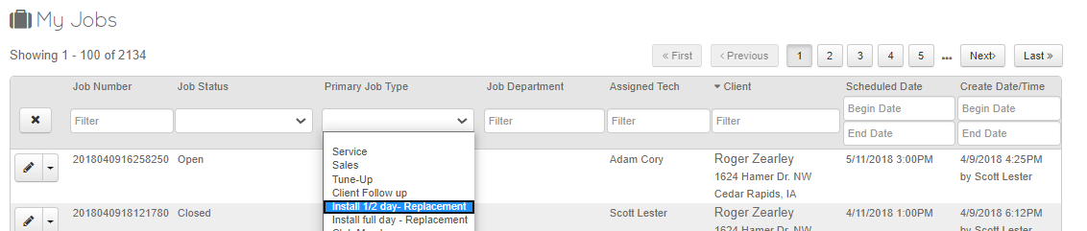

Job Lead Sources
By editing this you will be able to add different types of Lead Source you wish to track.
The VoIP (Voice Over I.P./Internet) system can automate this for you, but you can still edit it.
(Note: You will only see “Phone Number(s)” if you are using VoIP through ThermoGRID)
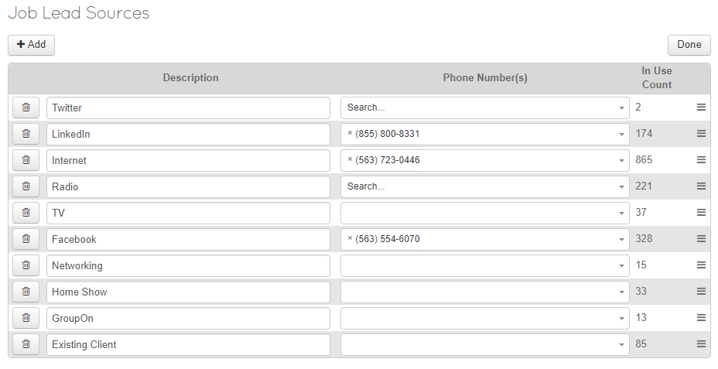
You are able to add this to a Job that is created and run reports based on lead source on the Orders Report.

It will default with:
- Internet
- Phone Book
- Radio
- TV
- Referral
- Networking
- Home Show
- Existing Client

Make any Changes you would like to the Job Lead Sources. Editing is consistent with the previous method.
You will now see Your Custom List under Job Info and as a dropdown in Orders Report.

Job Info Orders Report Home>Reports>Orders
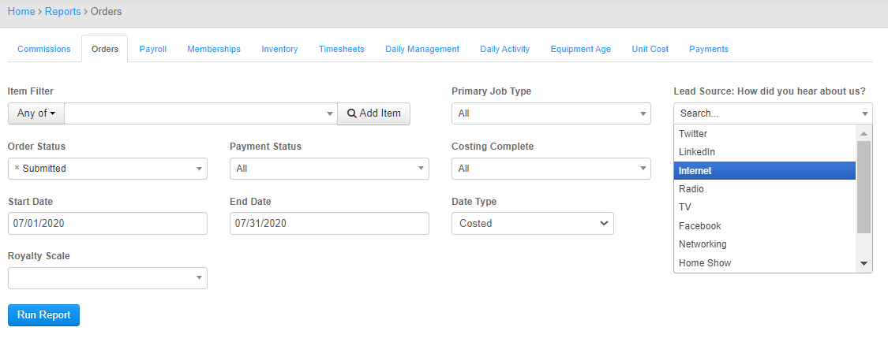
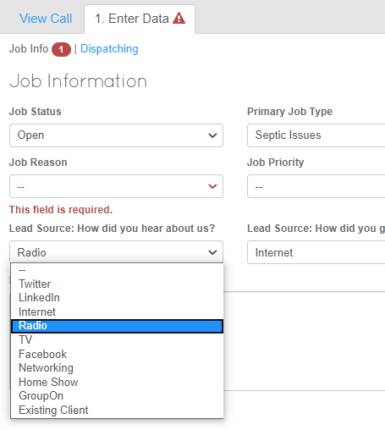

( VoIP will automatically populate this information, if a call comes in from one of your marketing numbers. If you are interested in this feature please contact Support for more information. )

Job Reasons
Job Reasons are the main purpose for the Job. These will consist of more detailed information from the Primary Job Type. (Ex: PJT = Service & Job Reason = Leak)

Make any Changes you would like to the Job Reasons. Editing is consistent with the previous methods.
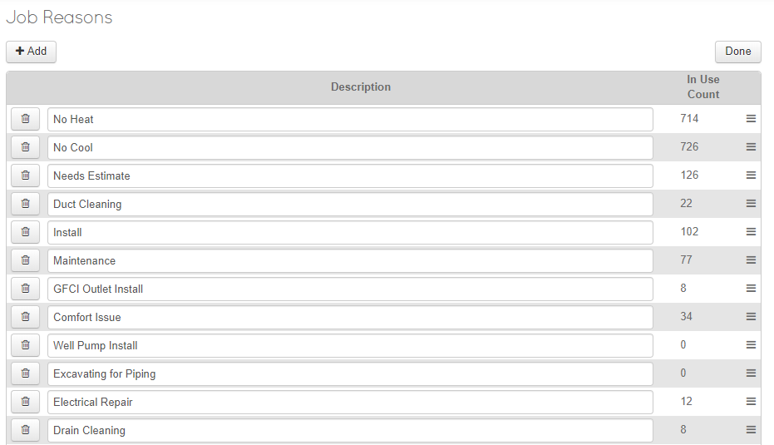
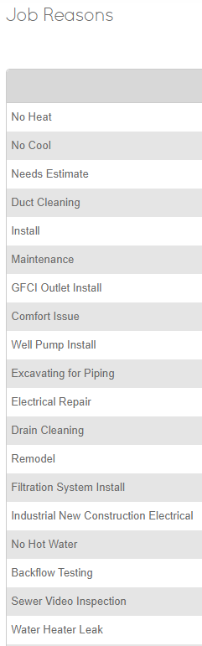
Some Examples are Listed here and as always, can be edited at anytime in the future.

You will now see Your Custom List under Job Information and displayed Job Details

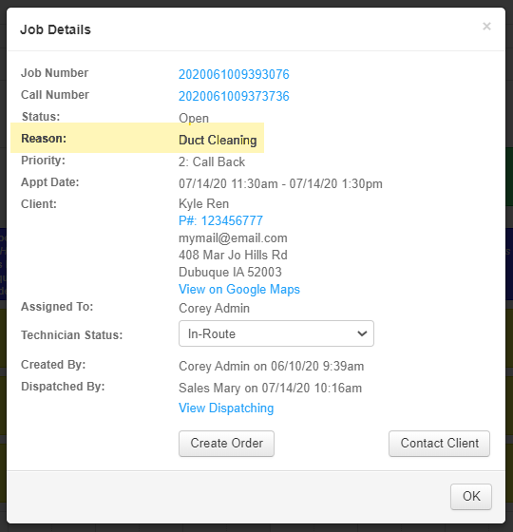
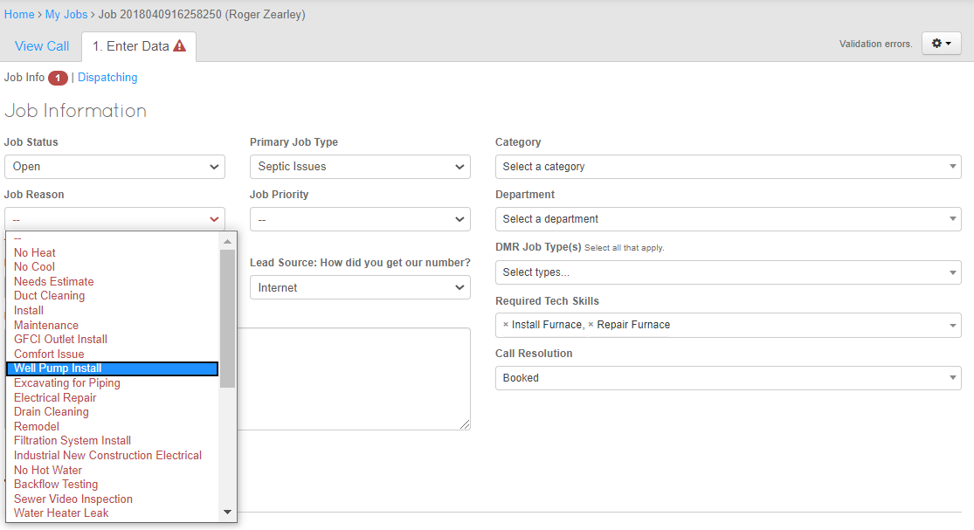
Job information Job Details

Job Priorities
By editing this you will be able to add different types Priorities for jobs. This way the call center can look at the dispatch board and quickly see which Job is a higher priority than another if ones need to be rescheduled.
Priority levels have no bearing on Notifications or Scheduling, they are for internal use and notation.

Make any Changes you would like to the Job Priorities. Editing is consistent with the previous methods.
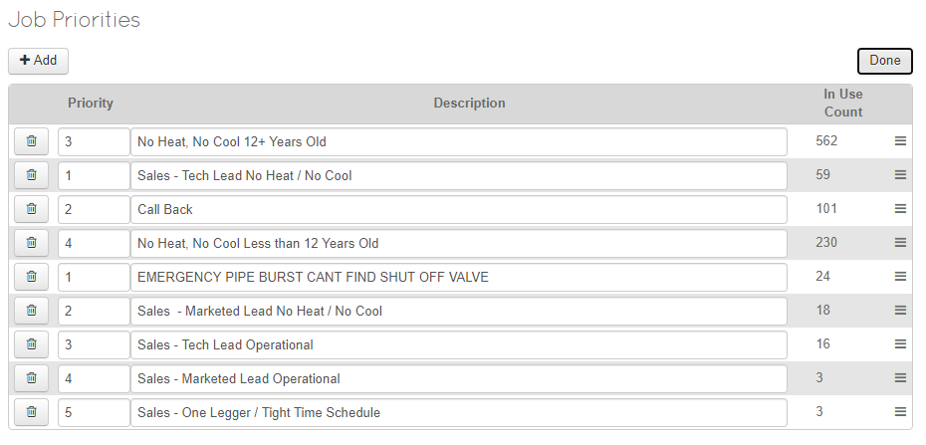
Some Examples are Listed here and as always, can be edited at anytime in the future.

You will now see Your Custom List under Job Information and Job Details
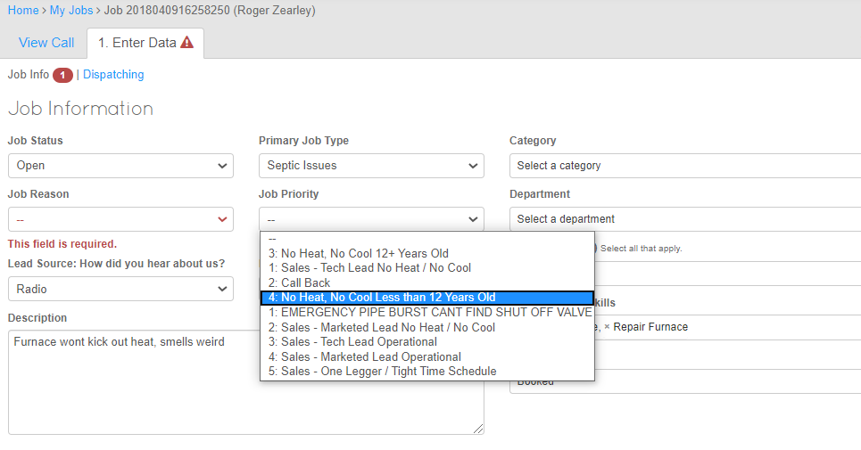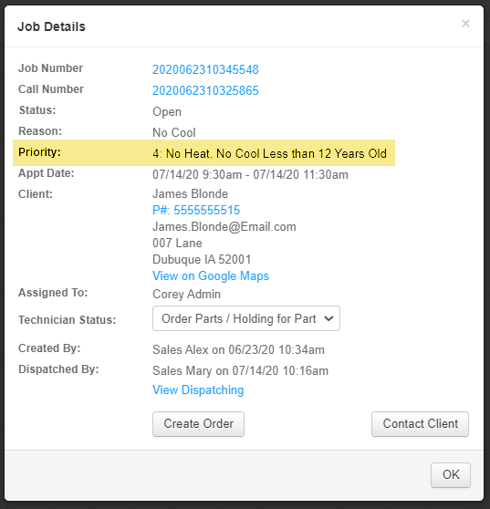

Call Status
This will give you the option to show the current state of the call. You can use this to filter and sort calls.
This can allow you to sort daily on people the need to be called back, etc. Just make sure any type of call needing to be closed needs to have the word closed in it. "Closed Client Canceled"
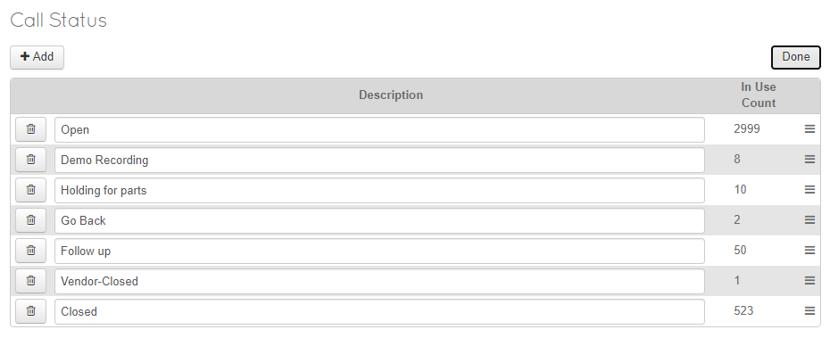
Make any Changes you would like to the Call Status. Editing is consistent with the previous methods.
It will default with:

- Open
- Holding for parts
- Go Back
- Closed

You will now see Your Custom List under a Call and as a filter in Calls
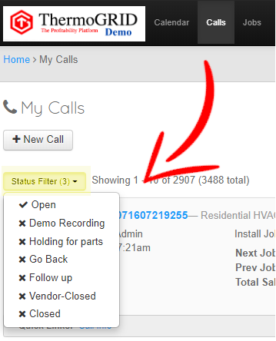
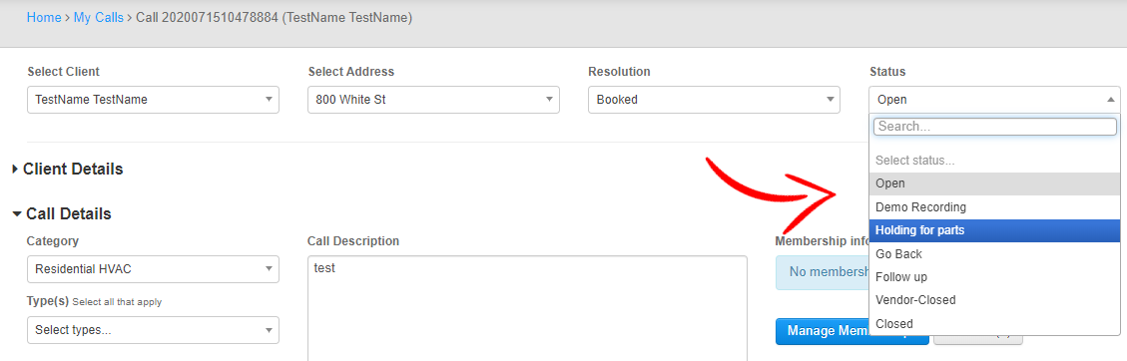

Call Resolutions
By editing this you will be able to add different outcomes from a Contact/Call with a client.
Call Resolutions are not filterable and are a simple reference to the result of the Contact/Call.

Make any Changes you would like to the Call Status. Editing is consistent with the previous methods.
It will default with:
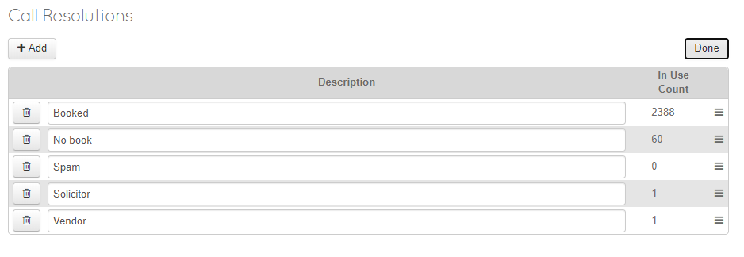
- Booked
- No Book
- Vendor
- Telemarketer
- Wrong Number
- Existing Client info

You will now see Your Custom List under a Call and as a filter in Calls
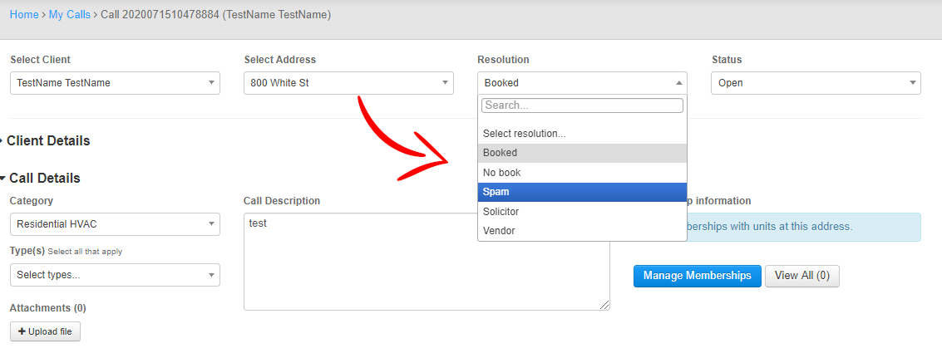

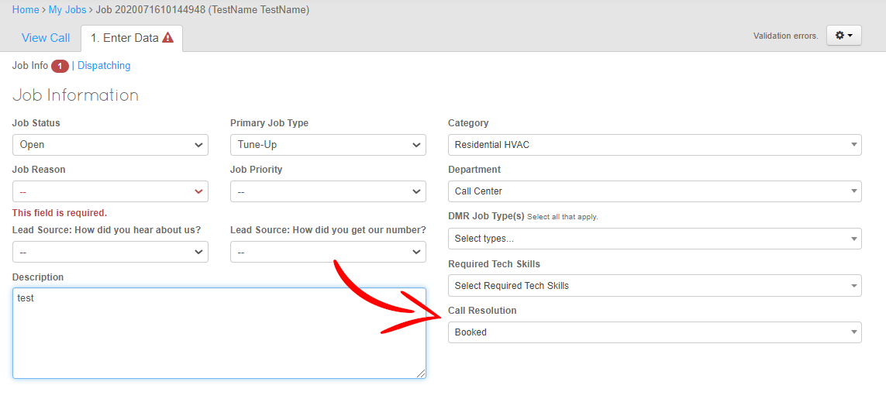
Also, if a Job is Created and the Call Center / Dispatch did not chose a resolution for the Call there will be an option on the Job Info Page.
IF the Call center does not pick a resolution on the Job info page, a Prompt will appear and require them to choose a resolution.
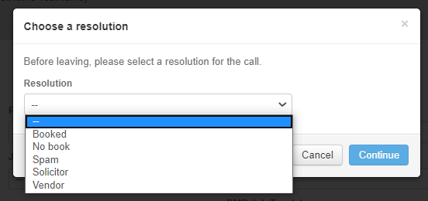

Tech Skills
By editing this you will be able to add different Skill/Abilities required to perform certain Jobs
When the Call Center / Dispatch does not know the specific qualifications or “Skills” of each Tech, this feature gives you a way to properly dispatch jobs without scheduling someone unable to perform the labor.

Make any Changes you would like to the Tech Skills. Editing is consistent with the previous methods.
(Tech skills will be assigned when adding/Managing Users)
It will default to:

- Call Back
- Repair Mini-split
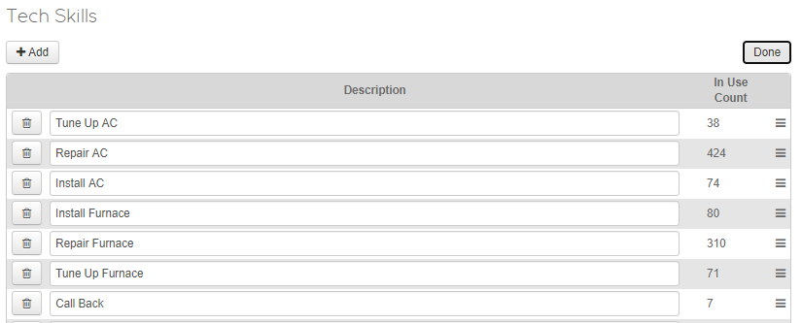
- Install Furnace
- Install AC
- Install HP
- Install Boiler
- Install Geo
- Install IAQ
- Sales IAQ
- Repair Geo
- Repair Boiler
- Tune Up AC
- Tune Up HP
- Tune Up Furnace
- Tune Up Boiler
- Tune Up Geo
- Repair AC
- Repair HP
- Repair Furnace
- Sales Replacement

You will now see Your Custom List under Job Info and as a Dropdown when Managing a User
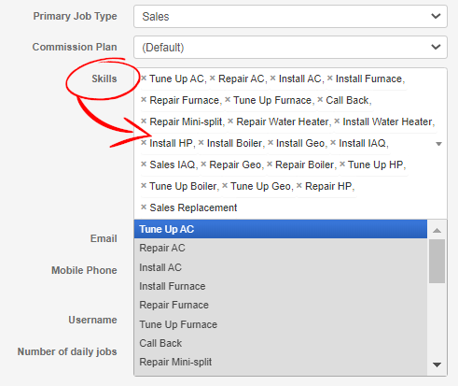
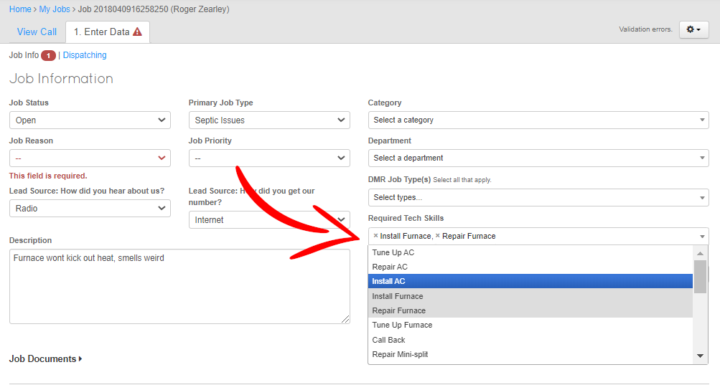

Unit Types
By editing this you will be able to add different the Pieces of Equipment that you would like to track at a customers address.
When a Tech is installing or working on Equipment they will be able to add the Data for that Unit.
Reports are able to be ran on Unit Age or Unit Cost over Time
Make any Changes you would like to the Unit Types. Editing is consistent with the previous methods.
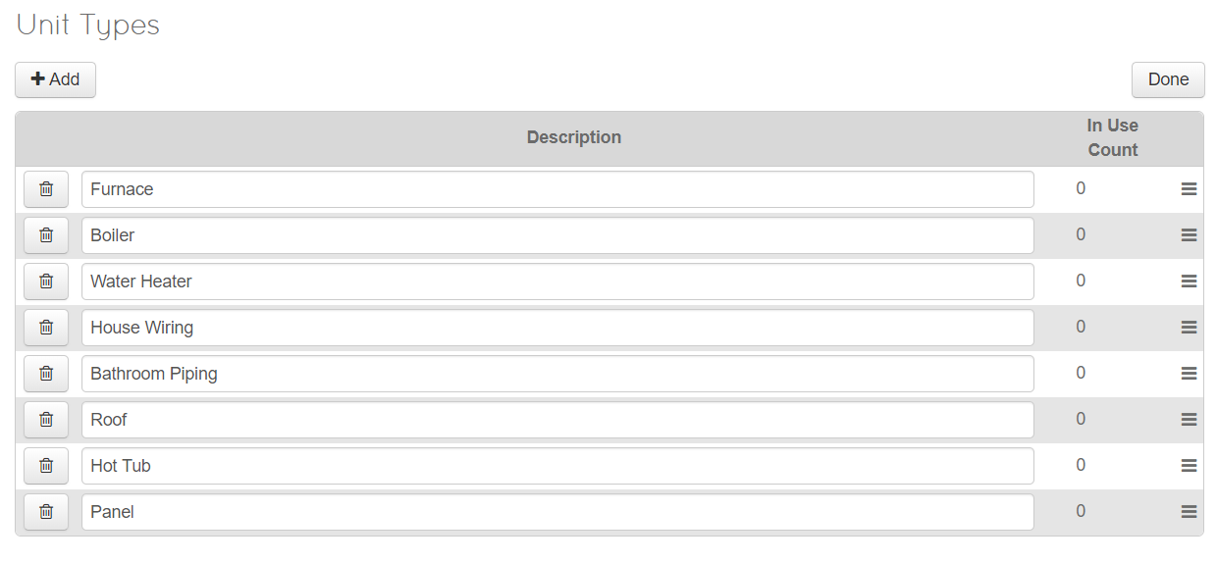
It will default with:
- Air Conditioner
- Water Heater
- EAC
- Package Unit
- Filter
- Humidifier
- Furnace
- Heat Pump
- Mini Split
- HRV
- Water Heater
- Boiler
- Geothermal

You will now see Your Custom List under Units
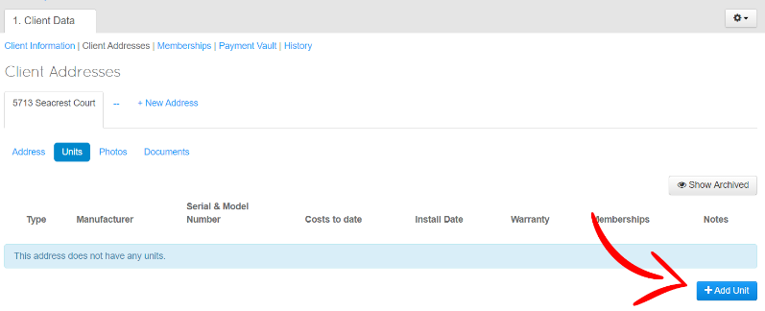
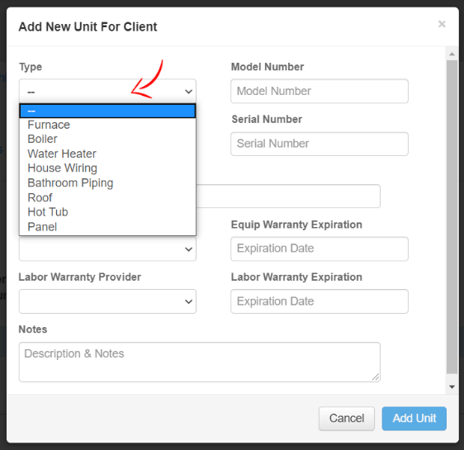
(Clients>[Chose Clients]>Client Addresses>Units)
After Clicking “+Add Unit” an “Add New Unit for Client” Pop-Up will appear. This will have the list of Unit Types.

The Unit Cost and Equipment Age Reports have the Dropdown Option
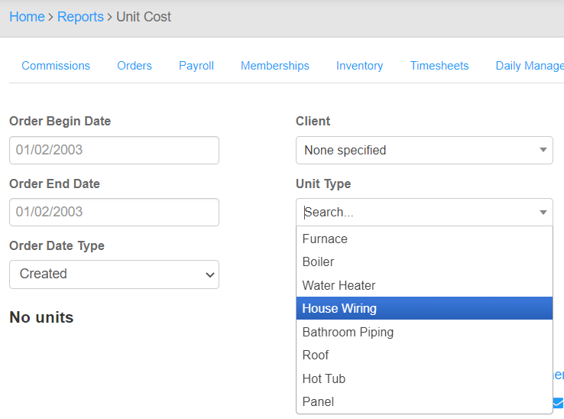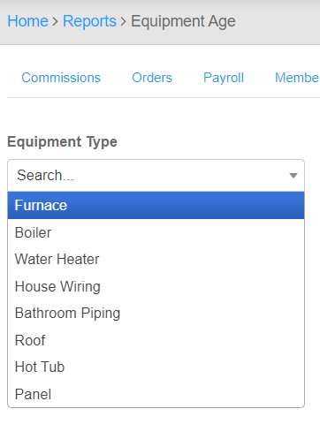
Unit Extras
By editing this you will be able to add different types of items your company provides as part of maintenance. (UV Lights, Filters, Belts Etc.)
Once a "Unit" (Furnace, AC, Hot tub, Panel, Ect.) is added in on the Call, Order, or Client section, then you may add the extras. **Must save the unit first**
This allows you to add the accessories to the units and see what the client needs before going out or even report on all of them from the Membership Report.
Make any Changes you would like to the Unit Extras. Editing is consistent with the previous methods.
There are no predefined Extras.
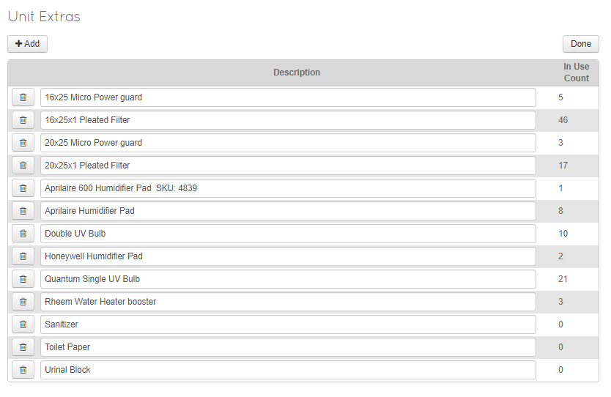

After the Extras have been created, you will be able to use the Edit button under Units to attach them.
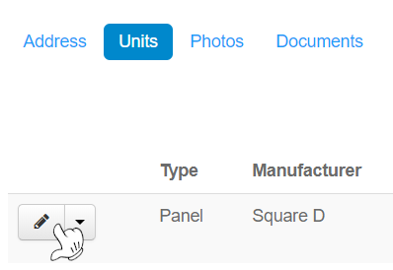

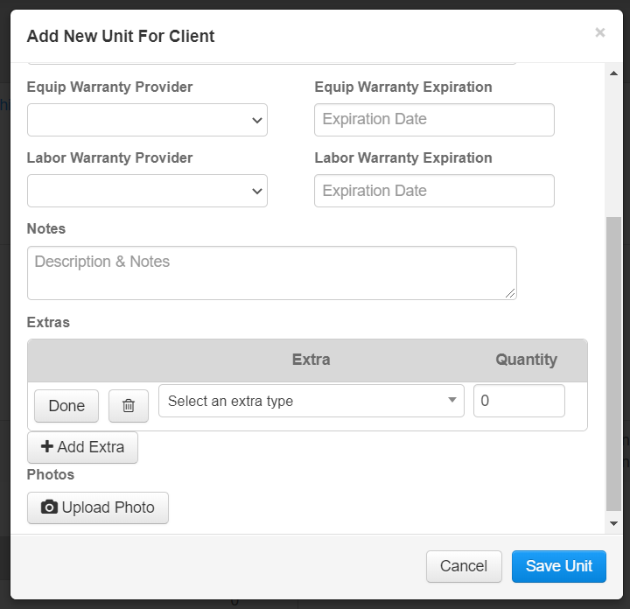

Editing is consistent with previous methods
Add any Unit Extras and Quantity needed here
Done when Complete
Trashcan to Delete
+Add Extra to add more

Save Unit

Unit Warranty Types
By editing this you will be able to add different types of warranties your company provides.
Make any Changes you would like to the Unit Warranty Types.
Editing is consistent with the previous methods.

It will default with:
- Manufacturer
- In House
- 3rd Party
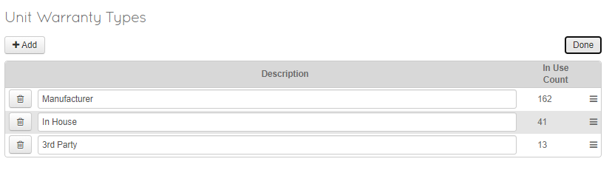
You will now see Your Custom List when adding a Unit to a Clients Address
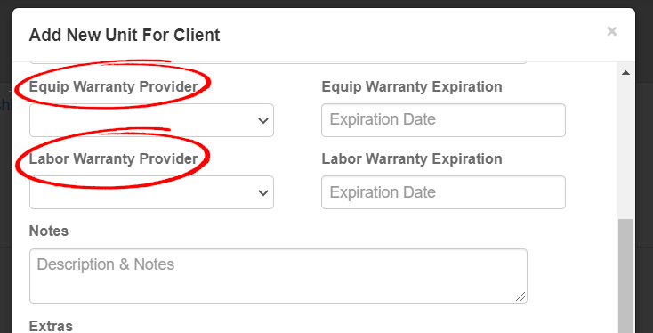

Compensation Types
By editing this you will be able to add different types of Compensation for Techs to Request or to Assign.
Make any Changes you would like to the Compensation Types.
Editing is consistent with the previous methods.
Calendar Event - will create a viewable event on the calendar when this compensation is requested
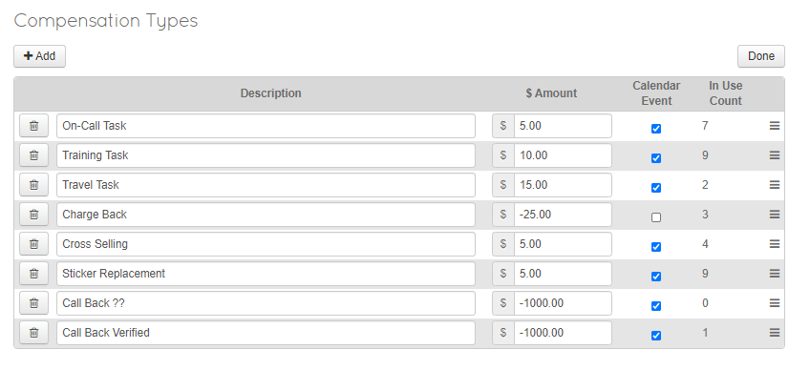
You will now see Your Custom List under Add>Add Compensation Request on the Calendar
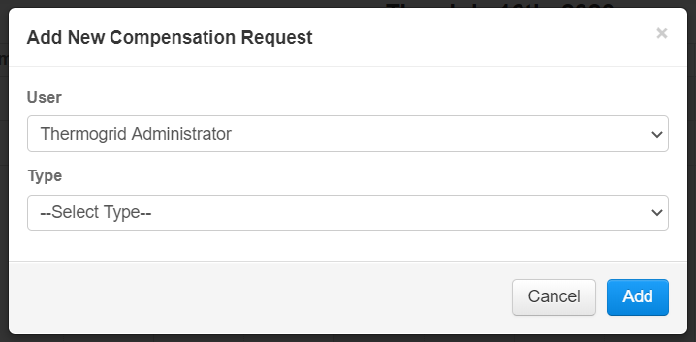
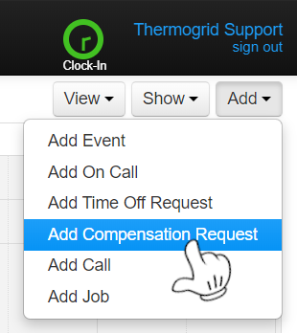

You will be able to Add the User and Type

This Concludes the Dropdown Customization Please Open Set-Up 3

