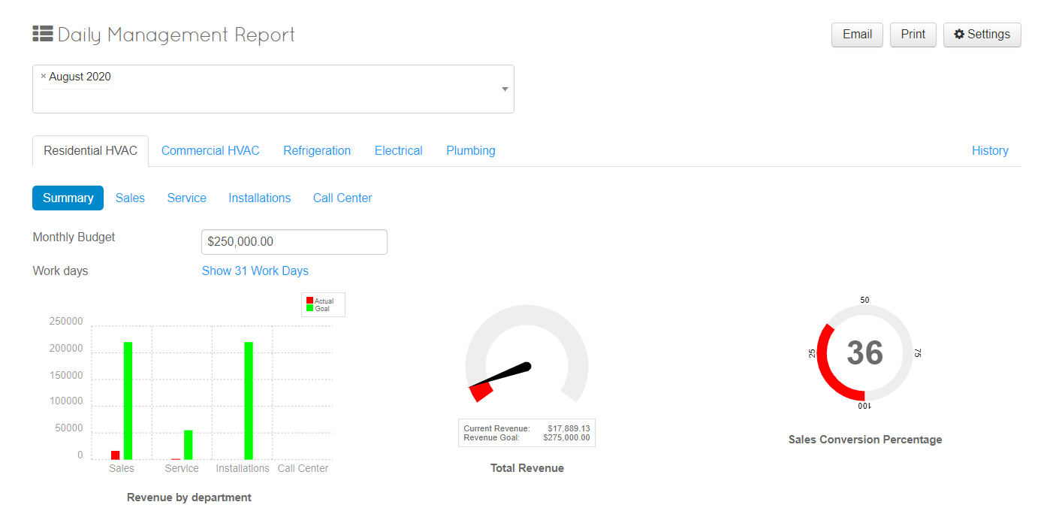
Building your Daily Management Report
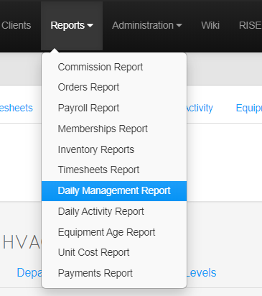
- Click Reports > Daily Management Report

- Click Settings in the Top Right Corner
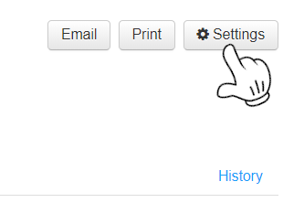

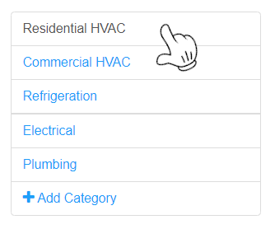
- Chose a Category you would like to Build or Update a Current Brach

Once you have selected a category you would like to build, customize data on each tab.
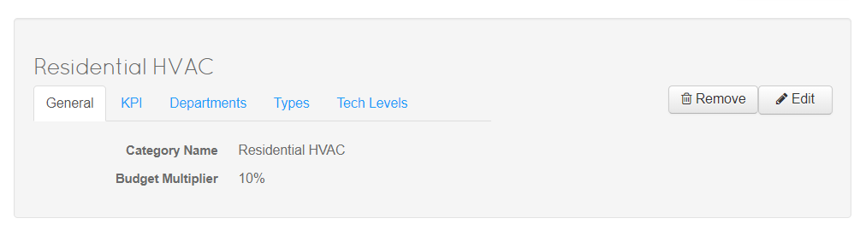

General – Customize Labels of different Branches within your Company
KPI – Key Performance Indicators allows the calculation of specific goals in categories
Departments – The departments that will be tracked with in the branches
Types – Call Type Goals: Allow you to specify percentage goals for call types for departments
Tech Levels – Allow you to easily specify the different revenue or percentage goals for different employees

Edit on the Right hand side will allow you to change the Category Name and Budget Multiplier (The Budget Multiplier takes your monthly Goal and Multiplies it to help you reach your target) OR If you have added a new Category there is a Create Button on the Top Right you will have to Click.
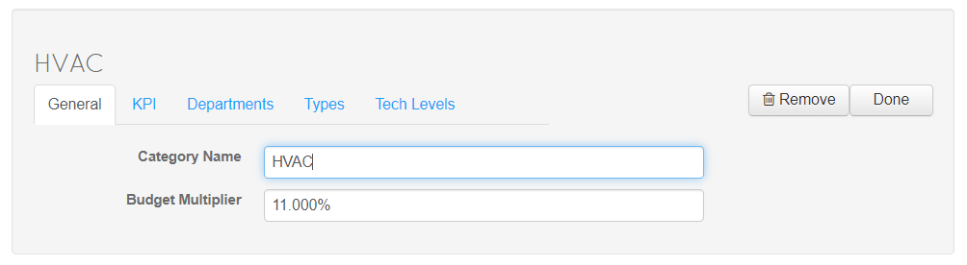
- Click Departments and Either, Edit available Departments or create New ones with Add Department 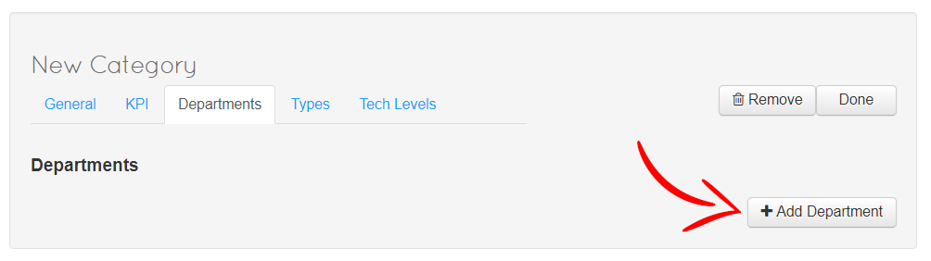
Name: What is the Department Called (Sales, Service, Installations & Call Center are standard)
Revenue: In this Category, what is the Percentage of Revenue This Department should be brining in (Ex: Sales is 80% while Service Might be 20%)
Avg $ per Call: What is the Average Dollar Amount Per Call you would like to see
Goal $ per Call: What is the Goal Dollar Amount Per Call you would like to see
User Roles: What Roles are needed for this Department
Applies To Budget: Apply revenue to the Budget Goal? You should not track sales and installs. This will result in double revenue. Sales should be do not track, installs track. Sales revenue goes to install revenue automatically
Track Sales: Do you want to Track the Sales of this Department?
Track Callbacks: Do you want to Track Callbacks for this Department?
Opportunity, Dollars/Lead, Sales, Sold Labels : What do you want the Labels in your DMR to say for these Options
Show Get Back on Track: Do you want to see what you need to sell to get back to your goal?
Includes in Sales Conversion Percentage: Does this get included in the percentage of sales?
Auto-Summarize: Uses default system settings to get metrics

Fill in the appropriate information
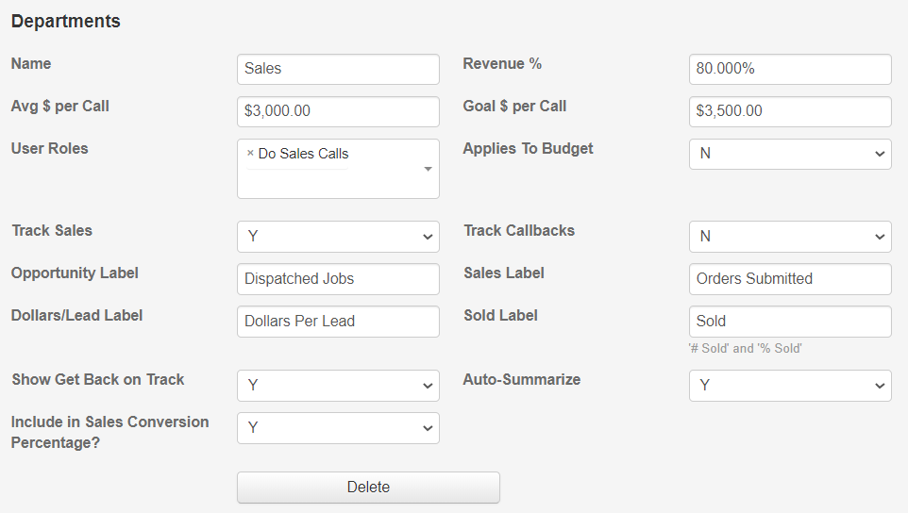

Add any more departments you would like to track and add information

- Click the Type Tab Reference this Image for the next section
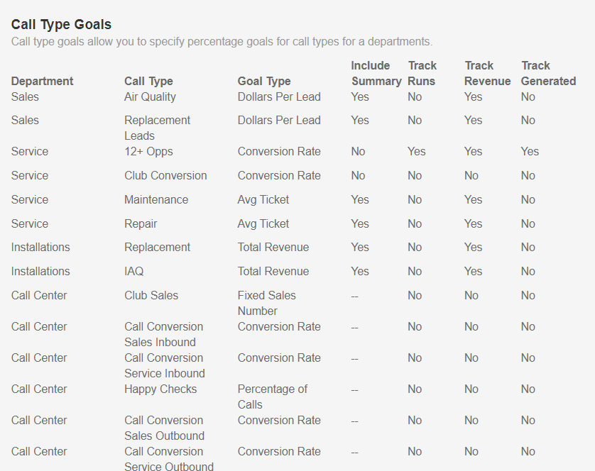
Use either the Prepopulated Options or Add you own based off the Departments you created.

Click +Add Type Goal
To add more goals

- Choose Department
- Input Name for the Call Type
- Choose Goal Type

Include in Summery: Will this show in Departments Summery?
Track Runs: Track orders that meet order goal?
Track Revenue: Track income within the department?
Track Generated: do you want to track all generated for this type?

Based on the Image Above the Call Center (Department) Choses a Category
Then Choses the Call Type for that Department
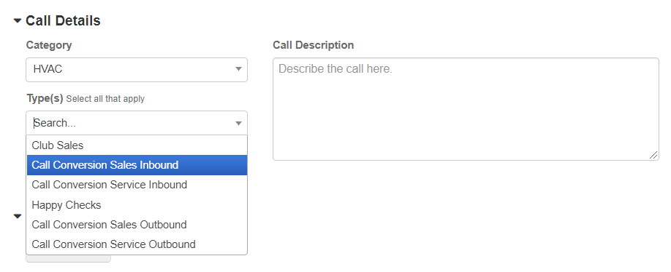
After Choosing the Type this is the Job Information page
Based on the refence Image you can see the Category>Department>Job Types
This is for reference so you can see where these changes will be populated
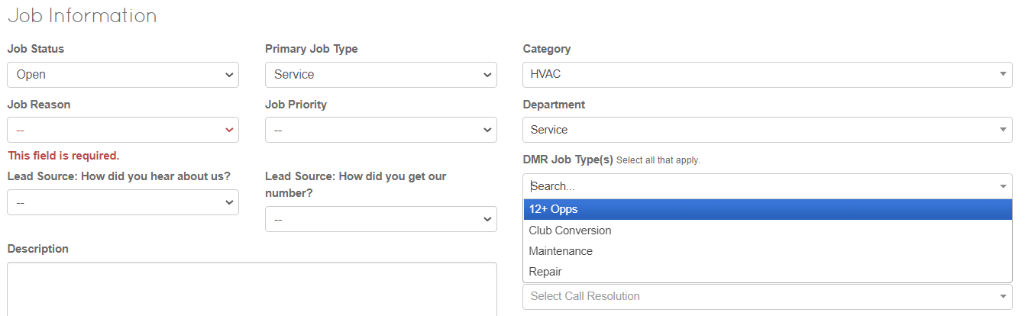

- Click the KPI Tab
There will be prebuilt Key Performance Indicators but this allows you to create your own for each
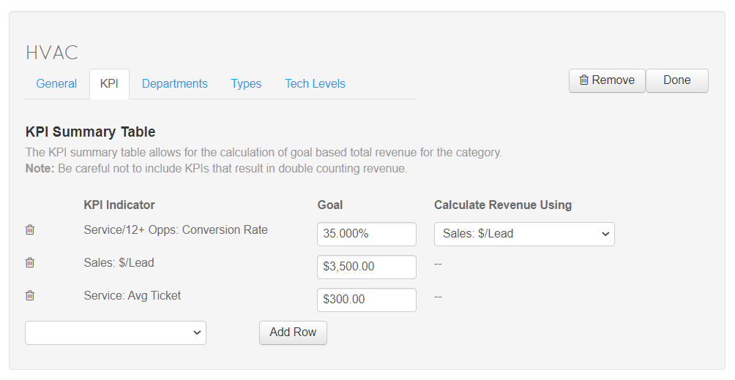
Clicking the Menu by Add Row will allow you to add more KPI indicators
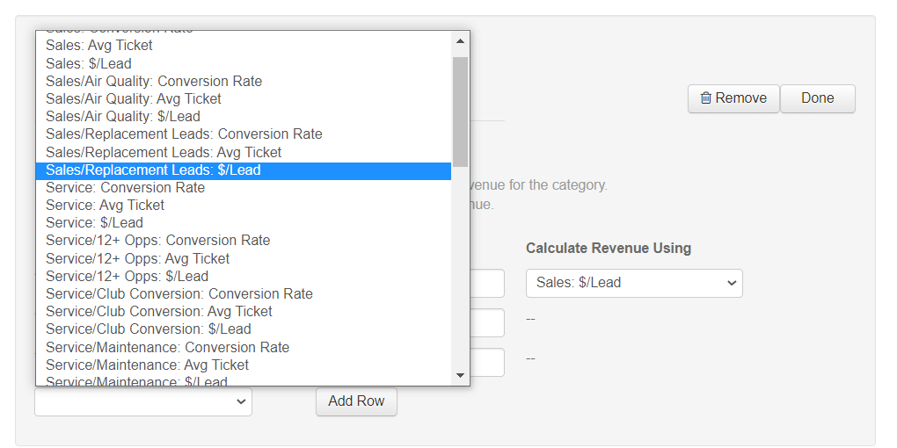
you can see here, all the options that have been created from the previous menus are now in this list.

Selecting one and Chose Add Row
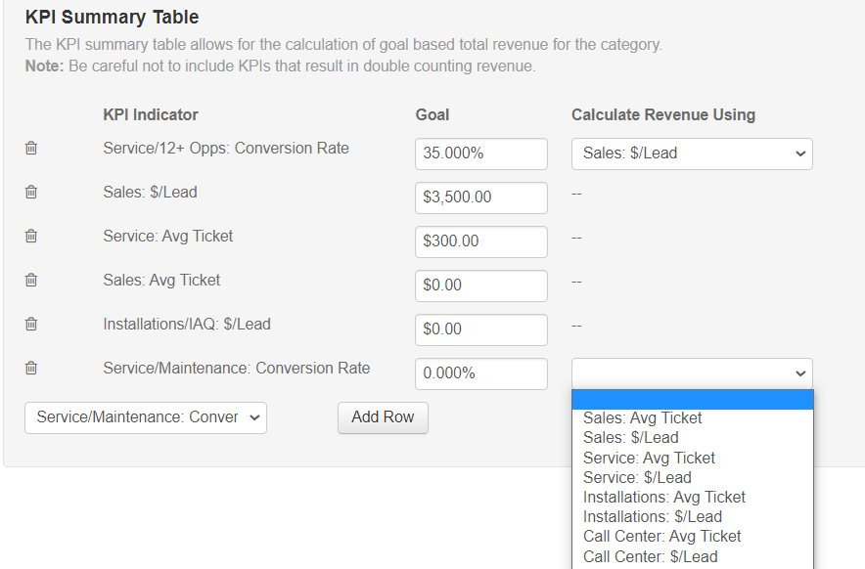
If the KPI Requires Revenue Tracking you can chose how that will be tracked on the right hand side of the table.

- Click on Tech Levels
You are able to divide your Technicians up based on your own Expectation Levels.
Chose a Name for the Level and Select the Users.
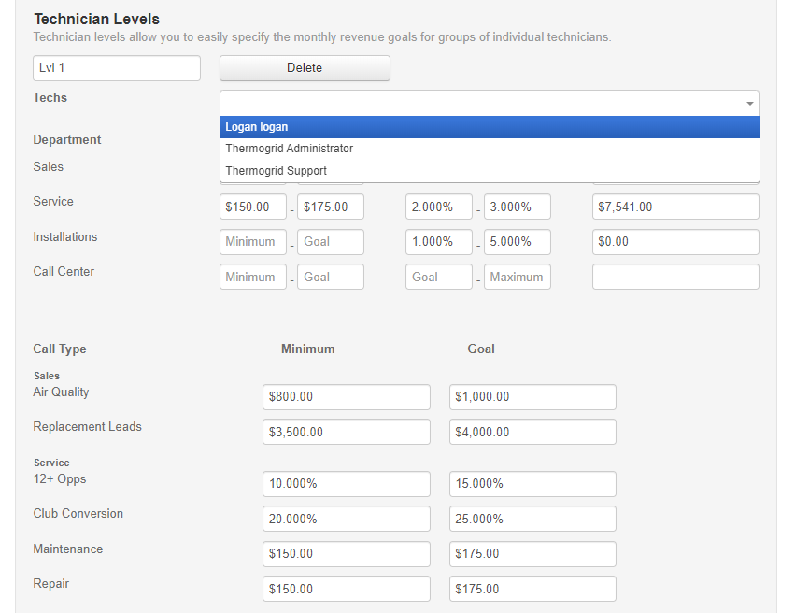

As you can see in the Image above, you are allowed to input revenue expectations as:
Department:
- Revenue Per call
- Callback Rate
- Total Revenue Goal (Monthly)
Call type:
- Minimum
- Goal

Use + Add Tech Level to Create more Levels if you run out

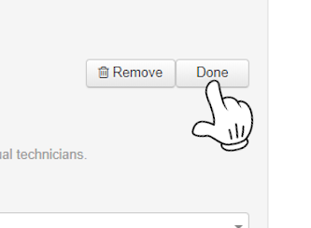
After you are completed filling out each Technician level Click Done on the top Right.

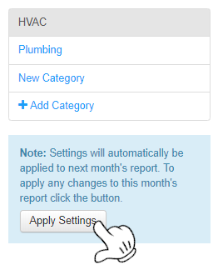
Next Click on Apply Settings on the Left Side of the Page to Apply all Settings that were changed today.

Note: You can change settings in the middle of the Month based off of new Goals, but the new Settings will only start at the Beginning of a new month, unless you “Apply Settings”.

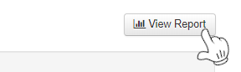
Then View Report to see the Results

