Administration
Account Set-Up 3: Manage Users
We will now go over Adding Users(Techs, Admins, Call Center reps, Ect..) to your Account.
- Click on the Administration Tab
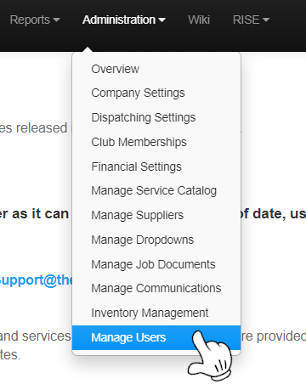
- Click on Manage Users

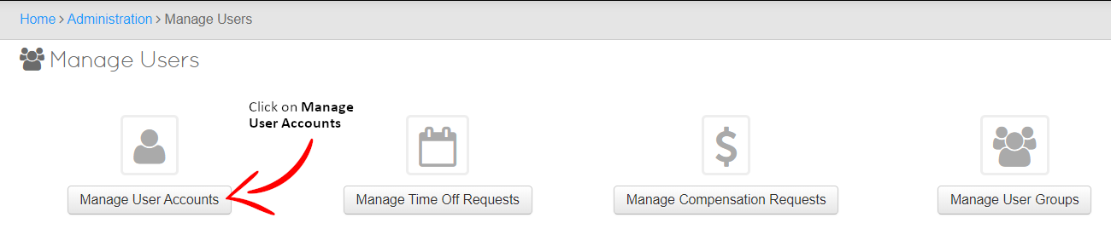
Clicking will bring you to the following page
You may now Add a new User to the Account To Create a new User Click

Customizing a User
You will be presented with a list of options for your new user
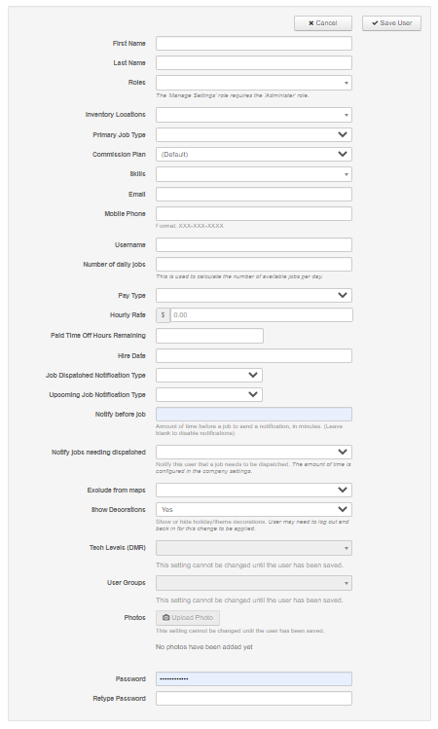
(There will be selections that are not setup yet, you may skip these for now or go to the appropriate channel to configure these options)
Options Include:
First Name – Displayed First Name
Last Name - Displayed Last Name
Rolls – What does the User do within the Company
Inventory Locations – Where Inventory is pulled from
Primary Job Type – What PJT(s) can this User do
Commission – What is the Users Commission Plan
Skills – Assign Custom Skills to the User
Email – Users Email
Mobile Phone – Users Phone Number for Text/SMS notifications
Username – What the User will login to ThermoGRID with
Number of daily Jobs – Allowed Daily Jobs
Pay Type – Task Based, Hourly or Both
Hourly Rate – What is User paid per hour
Paid Time off Hours Remaining – Accumulated PTO
Hire Date – Start date with Company
Job Dispatched notification Type – What kind of notification does the User want to receive when a Job is Dispatched to their Calendar
Upcoming Job notification Type – What kind of notification does the User want to receive when a Job is Upcoming on their Calendar
Notify before job – How many minutes before the Next job does the User want a notification
Notify Jobs needing dispatched – Will the tech be notified of jobs they are assigned that have not been dispatched
Exclude from maps – Will this user be able to be viewed on Show Map
Show Decorations – Would you like holiday themes turned on for the user
Password – What password will the User use to login to ThermoGRID
Retype Password – Verification of previously typed password

When you Complete Creating a User, Click the Save User Button on the top and repeat for all Users.
Advanced

Roles
Manage Settings = Can change company settings such as gross margin, pricing, billing info.
(For Senior Management or Purchasing)
They will have access to all under the Administration Tab except Manage Users.
They must have Administration role as well.

Access all roles below and can access and edit reports (For Managers)

Reopen Calls = Can open a Call, Job or Order that has been completed and Job Costed.
(Not many should be able to do this)
(For Senior Management)

Administer = Access all roles and can access and edit reports
(For Managers)

Do Sales Calls = Can access calls assigned to them and access items in the price book
(For Sales Reps)

Do Service Calls= Can access calls assigned to them and access items in the price book
(For Technicians)

Do Installations = Can access calls assigned to them and access items in the price book
(For Installers)

Add Calls = Can schedule calls when clients call in.
(For Call Center Reps)

Dispatch Calls = Can see all Scheduled and unassigned jobs and can dispatch them.
(For Call Center Reps and Dispatchers)

View Calendar = Can see everyone’s calendar in the company.
(For anyone you want to see all calendars)

Edit On Call Calendar = Can edit the on call calendar.
(For Call Center Reps and Dispatchers or Managers)
Manage Users = Must have Manage Settings and Administration as well.
This allows someone to be able to access and setup new and existing users.
Can change company settings such as gross margin, pricing, billing info.
(For Senior Management or Purchasing)
They will have access to all under the Administration Tab except Manage Users.
They must have Administration role as well.
Access all roles and can access and edit reports (For Managers)

Inventory Locations
Inventory can be turned on when the catalog for your company is complete
Editing and Training on this will come later.

Commission Plan
Can be edited under Administration>Financial Settings>Commission Scale
There will be a prepopulated “Default” Scale that is editable
Here you can set up a commission scale.

If you want to give 10% commission on everything sold no matter what.
Discount Percentage = 1
Sales Only % = .1
If you want to give 10% if the sales rep discounts less than 10% and 5% if they discount 20% and nothing above that.
Discount Percentage = .1
Sales Only % = .1
Discount Percentage = .2
Sales Only % = .05
If you want to give 10% if the sales rep discounts less than 10% and 5% if they discount 20% and nothing above that and if it's a tech lead the tech gets 2% and it goes against the sales rep.
Discount Percentage = .1
Sales Only % = .1
Sales w/ Tech % = .08
Tech % = .02
Discount Percentage = .2
Sales Only % = .05
Sales w/ Tech % = .03
Tech % = .02

These Can be Copied and Edited to build more efficiently with the “Create Plan” button
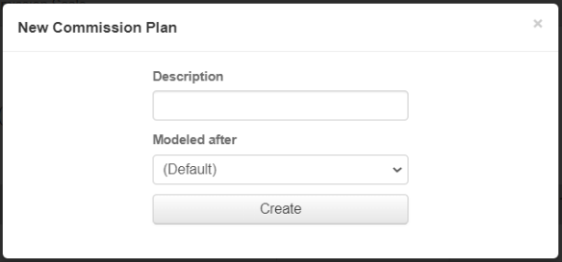
Chose a Description of the Plan

Chose what Plan you would like to have it Modeled after
You can Edit the Plan after it is Created

Editing Is consistent with previous methods

Tech Levels (DMR)
Tech Levels will have different expectations for the experience of Technicians, these expectations will reflect in the Daily Management Report.
After you have saved the User you will be able to add a Tech level to the User. Tech Levels are set up in the Daily Management Report. The DMR will be setup or edited later on, Please Skip for now.

User Groups
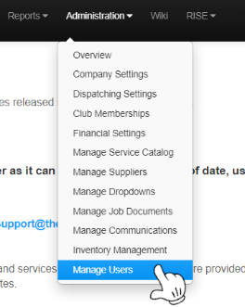
If your company has a large number of employees and ease of use on your Calendar is being limited, you may want to set up User groups.
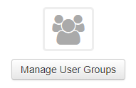
- Administration>Manage Users
- Manage User Groups

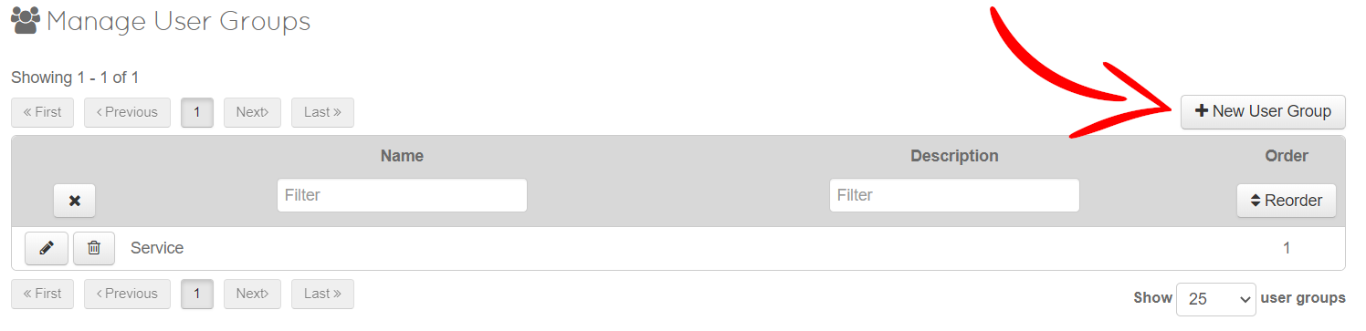
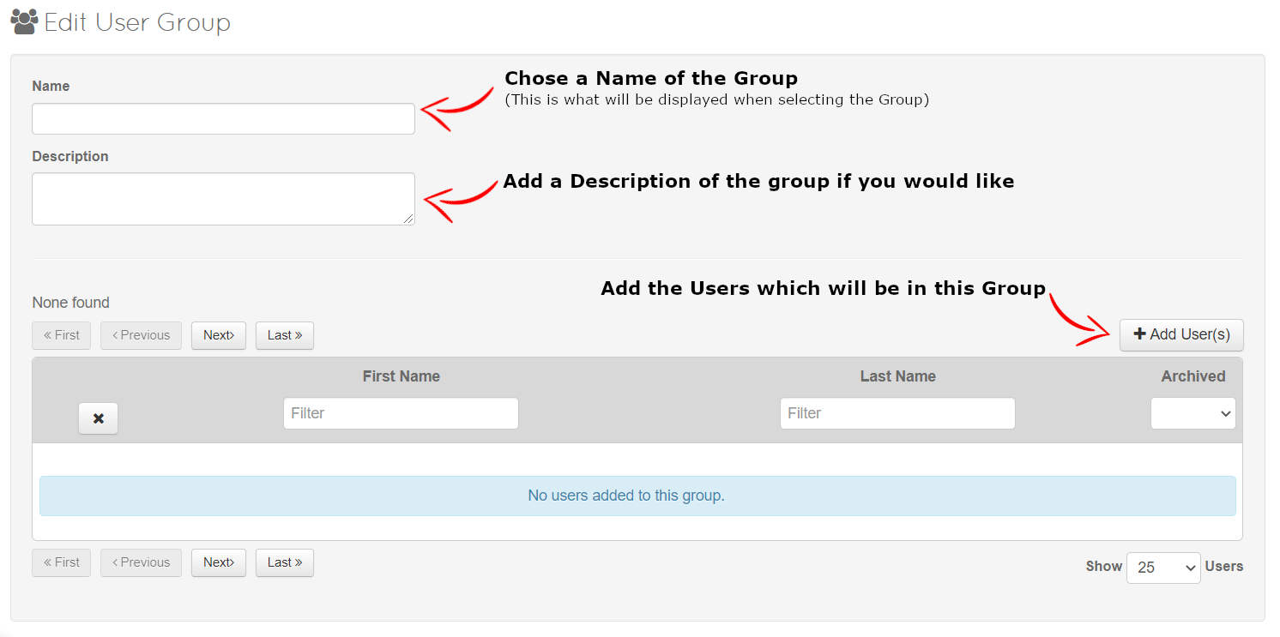

When you’re on the Calendar, Groups will be displayed under the Date
Click on this to bring up the Groups
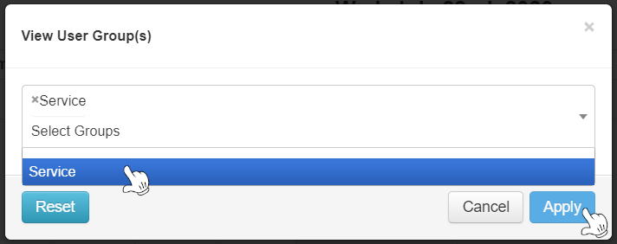
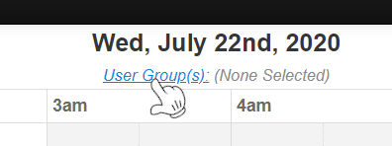

Once you have Chosen what groups you would like displayed, Click Apply and the Calendar will now only display those selected
(When Managing Users you can also Assign Groups on their User Account Page)

Photos
Add and upload a Photo of your User here
If they are assigned to a Job and Notifications are turned on for Dispatching, the Client will receive the Image and Bio if the “Show to Client” Box is Checked.

Click Upload Photo to Select a File
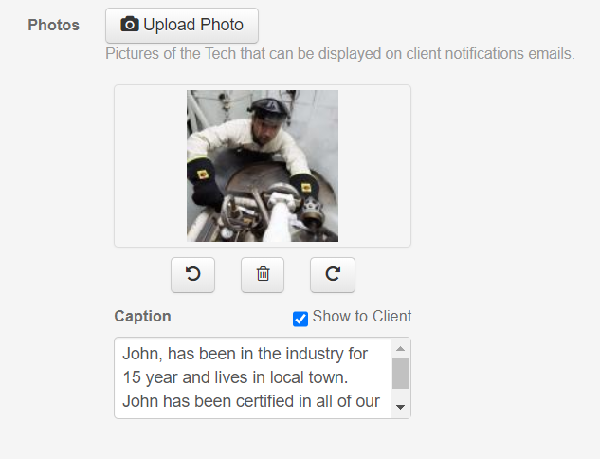
You may put in a Biography with the Image, Rotate or Trash and reupload.

This Concludes the Manage Users Please Open Set-Up 4

