Administration
Account Set-Up 9: Manage Service Catalog
We will now Cover Organizing and Adding items to your Service catalog.
The first thing is understand the format of the Catalog and how you can integrate your current Pricebook/Service Catalog
The catalog is currently broken down into 10 Service Types with up to 3 filters and more can be added
Nine of the Ten Service Types will Appear in your catalog automatically
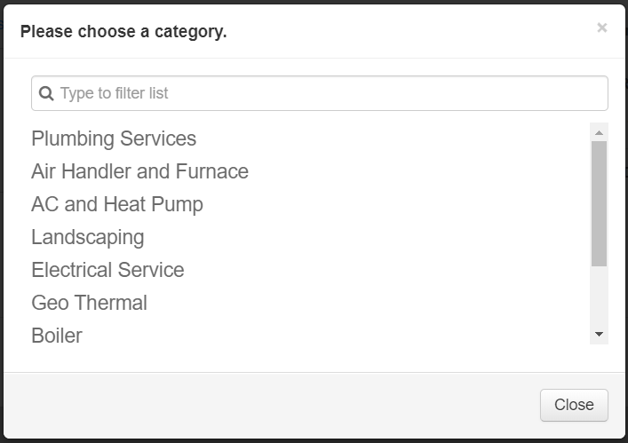
Here is an example of what a catalog could look like when your see your Service Types

Each Type has filters attached to them to break down items more precisely to find what you’re looking for

Let’s move on to the first steps of creating your Service Types and Catalog
You may want to mock up a paper copy to give yourself an outline of how your catalog will be filtered
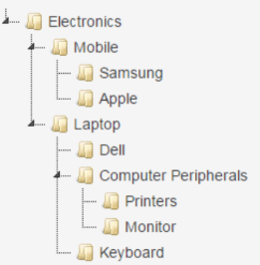
This is a jQuery tree
It is a standard in filtering in operating systems to find what you’re looking for, ThermoGRID Catalog will be similar to this Concept. We will chose the initial category and then filter down from there, your mock up may look something like this.

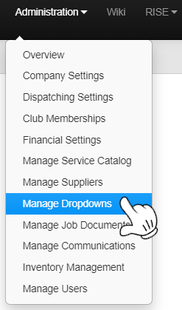
- Click on Administration and Manage Dropdowns
- Click on Service Types

The Green Highlighted Area
are the items that will be edited
for the Service Catalog
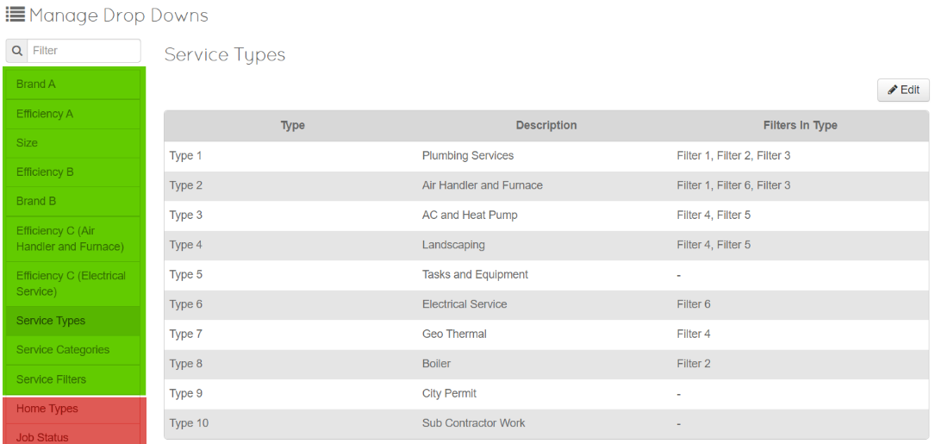
You will notice necessary Filters are listed on the right

Change the Name of any of the Descriptions you would like with Edit Button, but be aware that the filters on the right MUST be used. If there is a Category that you do not need to filter on, Type 9 and 10 have none. (Don’t Edit Tasks and Equipment, this will be addressed in “Creating a New Service Category”)

For this Demonstration, we will change and customize the filters on Type 1 Next Page 🡺
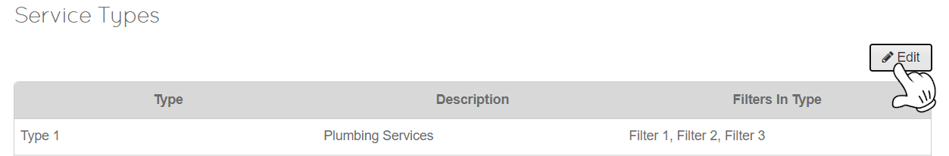
- Click Edit

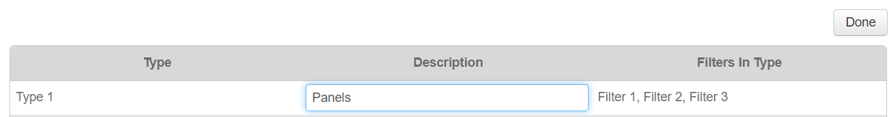
- Change the Description to whatever you would like and Click Done (Under 21 Characters).
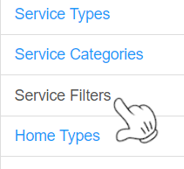
- Click on Service Categories on the left side of the page, Add a Category. These will be available to search by when managing the catalog. Click Done when completed

- Click on Service Filters on the left side of the page, Click on Edit and Change Filter 1, Filter 2 and Filter 3 to whatever you would like and Click Done when completed
(These will be the names of Filters types you will be searching through to find Equipment/Items/Parts/Service in your catalog. These do not NEED to be changed)
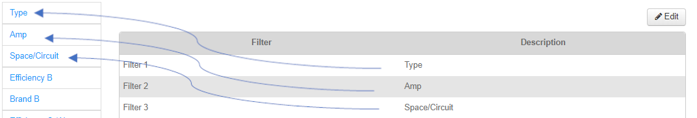
You will notice that your Custom Filters have replaced the Drop Down Categories

- Click on the Name of Filter 1 on the left, In my scenario, I’ve named it “Type”
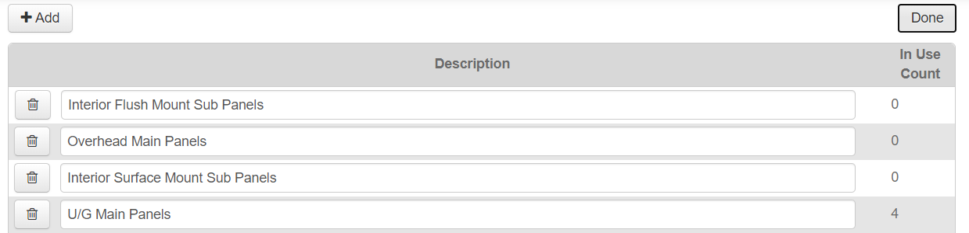
- Click on Edit and Add/Change the First Set of filters, Click Done When Complete
I’ve created an Option to view 4 Different Types of panels after I select Panels in the Service Catalog

- Click on the Name of Filter 2 on the left, In my scenario, I’ve named it “Amp”
- Click on Edit and Add/Change the Second Set of filters, Click Done When Complete
I’ve created an Option to view 3 Different Amps after I select Panels>Filter 1 in the Service Catalog

- Click on the Name of Filter 3 on the left, In my scenario I’ve named it “Space/Circuit”
- Click on Edit and Add/Change the Second Set of filters, Click Done When Complete

I’ve created an Option to see 3 Different Space/Circuits after I select Panels>Filter 1>Filter 2 in the Service Catalog

Next Page 🡺

Let’s see what this would look like in the service Catalog
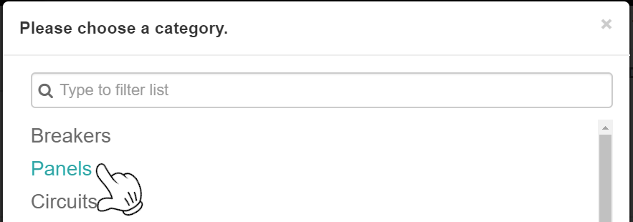

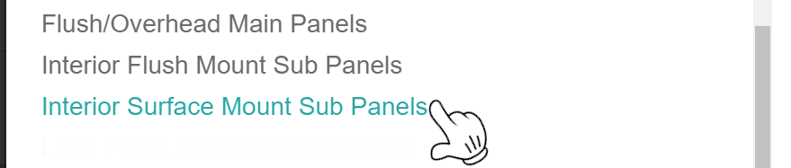
Now we will Add an Item to these Filters so It can be seen in the catalog

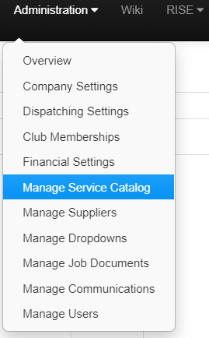
- Click Administration and Manage Service Catalog

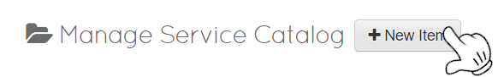
- Click new Item

- You will be presented with the Options on the Next Page to edit your catalog Item.

Each input has a useful functionality and this will outline adding and assigning those options.

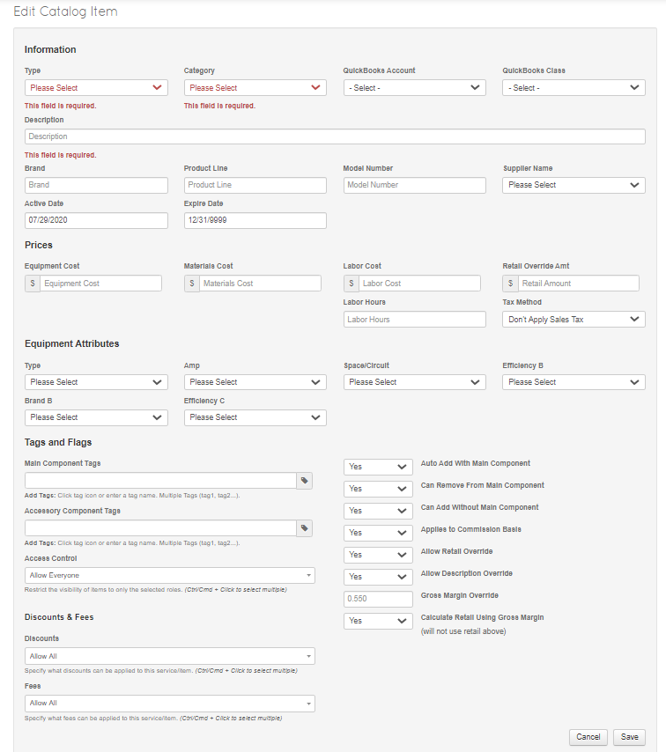
Hello
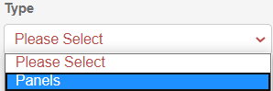
Information
- Chose Service Type we Created

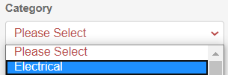
- Chose Category we created

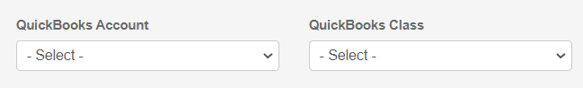
- Chose QuickBooks Account and Class if needed

- Input a Description of your Line Item

- Input a Brand, Product Line and Model number if the Item has one

- Chose a Supplier you get the Item from if needed 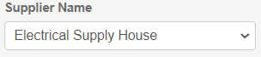

- Chose What dates you would like the item to be active for 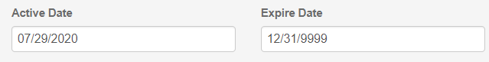

Prices

- Add any Equipment Cost you have for this Item
(What does this Item Cost you to Purchase)

- Add any Material Cost you have for this Item
(Misc. Materials that need to be used for install that you don’t want to track)

- Add any Labor Cost you have for this Item
(Highest Paid Tech x Labor Hours for job) or ($30/h x 3 hours = $90)
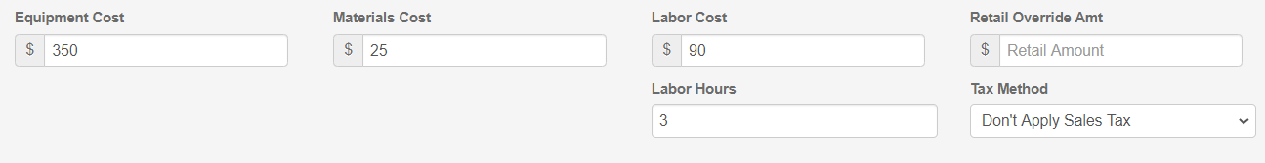
- Retail Override Amount is only used if you’re NOT using GPM
(you can always enter a number here just to try to compare it to GPM)

- How many Labor Hours does this take?

- What will be the Tax Method for this Item
  - Don’t Apply Sales Tax
  - Include Tax in Item Cost
  - Separate Tax from Item Cost

Next Page 🡺

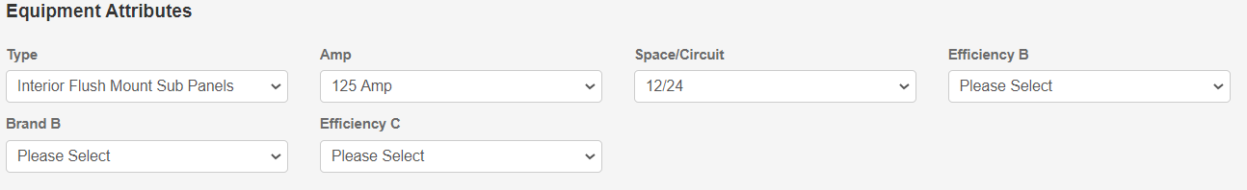
Equipment Attributes
The Filters that we created earlier are now available under the Filter Types here
I’ve Chosen
Type 1 (Type) = Interior Flush Mount Sub Panels
Type 2 (Amp) = 125 Amp
Type 3 (Space/Circuit) = 12/24

I chose the 3 Filters here because Panels (Type 1) had these 3 filters attached to it
We do not need to input data for the other filters because they do not effect this Item

Next Page 🡺
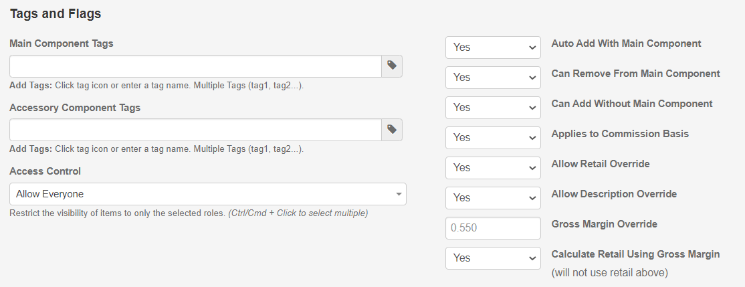
Tags and Flags

- Main Component Tags - add Item Tags to show up with this Item when selected
- Accessory Component Tags – what is the Item Tag for this Item
- Access Control – Who can Select this Item for Sale
Example:
You’re selling a Water Heater and want all Items needed to come with it when you select the water heater.

The Catalog Items that we want to attach would have an Accessory Component Tag

The Items description could be : Drip Pan for Full Water Heater Install
But the Accessory Component Tag Could be: DripPan
or
The Items description could be : Water Shutoff (Ball Valve)
But the Accessory Component Tag Could be: ballvlv

Now if we wanted these Items to come in with our Water Heater, Put the Accessory Component Tags in the Main Component Tags

Which would look like this:
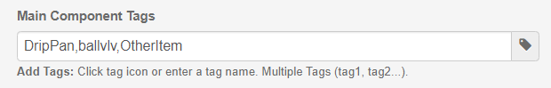
If you have issues with setting this up or difficulty understanding the process please feel free to content customer support at anytime to go over possible training packages or quick questions
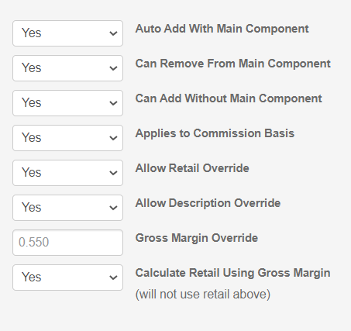
- Can the Item be added with the Main Tagged Item
- Can it Be removed from the Main Item on an invoice
- Can the Item be added without the Main Item
- Does this item apply to commission
- Able override selling price on an invoice
- Able override Description on an invoice
- Change GPM for this one Item
- Will you Calculate the Invoice Cost of this Item with GPM
Discounts and Fees
Select the Discounts and Fees that can be applied to this Item, if none are selected, all are available.
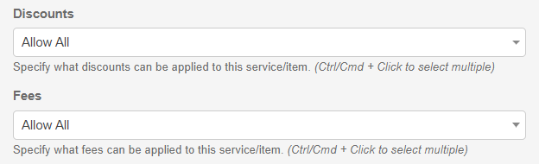 Next Page 🡺
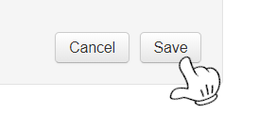
Once you have Completed entering all the information needed for this Catalog Item, Click Save on the Bottom Right.

The Item now will be available for selection when navigating through your service Catalog.

Creating a new Service Category
After you have edited the 9 visible Categories you may way more Categories to sort line items into.
- Click on Administration and Manage Dropdowns
- Click on Service Categories on the left

- Add the Name that you want to create as a new Category to the Category List

- Create a new Line Item and under “Information”

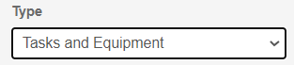
- Chose Service Type : Task and Equipment

- Chose the new Category that was just created

- Fill in All necessary Item Details and Click Save

Let’s see what this would look like in the service Catalog

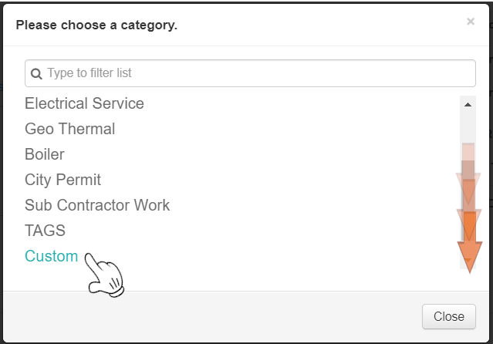
You can see here that at the End/Bottom of our Service catalog, The Option for “Custom” (which was my specific category name, yours can be whatever you like)

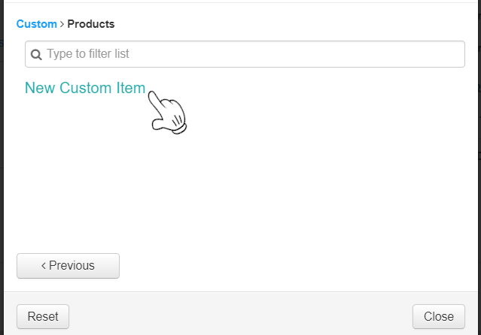
Any Line Items that a Sorted under “Tasks and Equipment>Custom” will now show up here

You can make as many of these categories as you wish

This concludes the Manage Service Catalog Tutorial

