New Order Estimate “Add Item” SOP
- Intro
- Add Item Card/View
- Catalog Search
  - Whole Catalog
  - Using Filters
- Reorder Categories
  - How to Add/Edit Categories

Intro
When adding items to an order estimate from your catalog, you now are able to search for your catalog item multiple ways. You can search by using the Filters Menu, or simply by doing a keyword search through the whole catalog.
Additionally, when selecting the category in ThermoGrid, you are able to decide which order the categories will appear when the Add Item button is selected.

Add Item Card/View
When putting together an invoice for the customer, you will need to start on the Order Estimate page and select one of the “Add Item” buttons.
This will pull up a list of your categories that are being used in your service catalog. The list is alphabetical, and in parenthesis it will show how many items are within that category.
Note: Categories that do not have any items assigned will not show up in the card.
Catalog Search
On the top right of the card, there is a toggle button in blue. If it is to the right and highlighted blue, you will be able to search your entire catalog by performing a keyword search for the descriptions of the line items in your catalog.

By typing in a word into the keyword search, the entire catalog is queried by description, brand name, and model number.

If a search is too broad and using the filters set in place when setting up your catalog are needed, you will be able to turn of the whole catalog search and use the filters. Turn off the whole catalog search by turning off the toggle on the top right.
Categories that do not have filters behind them will have an asterisk after them.

Reorder Categories
On the order estimate, the categories are sorted in alphabetical order. You can edit your categories in your ThermoGrid account settings. There are two areas you will need to work with to edit.
Note: If using numbers to reorder, this is ordering alphabetically. Which will use the first character, then the second character. If you want to use numbers over 10, you will want to use 01 and 02 as the number scheme.
Administration > Manage Dropdowns > Service Types
The other area you will need to edit is the service categories. These areas will be combined and used on the Order Estimate page when you select “Add Item.”
Administration > Manage Dropdowns > Service Categories

Editing Service Types:

To change the description, you will click on the “Edit” button on the top right, it will make the fields editable, and then you can change that description to reorder.

To change the description, you will click on the “Edit” button on the top right, it will make the fields editable, and then you can change that description to reorder.

Editing Service Categories:
Changing service categories is the same process as editing the service types. Reminder, both of these fields will combine on the Order Estimate page when you click on “Add item.” By putting a 01 as a service category, it will be first because we started with 02 on the service types.
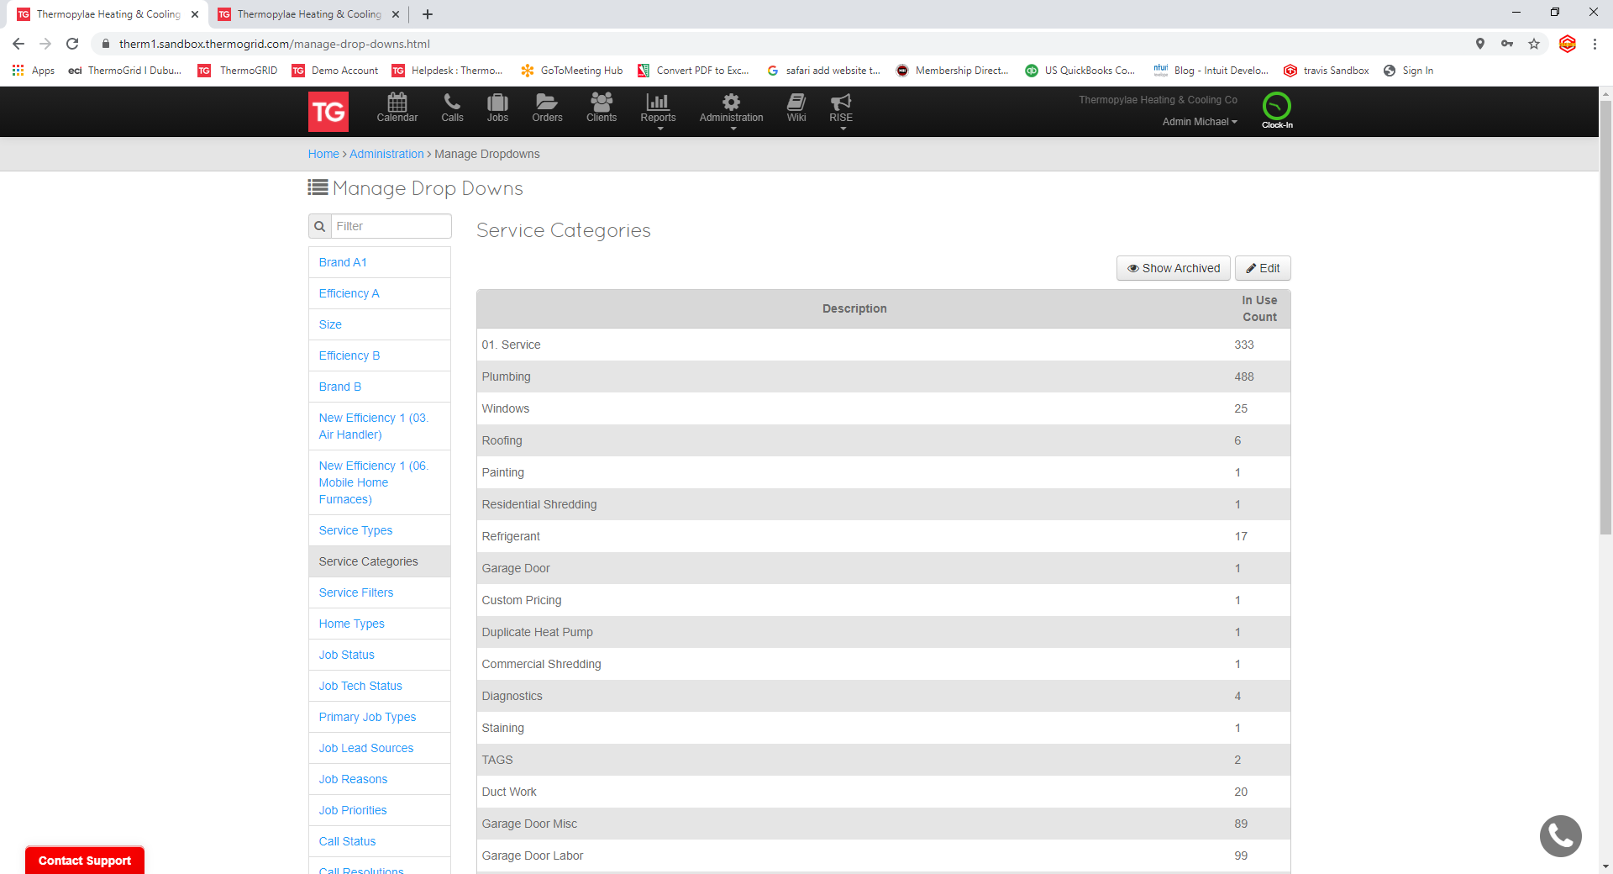
To change the description, click on the “Edit” button on the top right, it will make the fields editable, and then you can change that description to reorder.

When finished, click on “Done” and the changes will be finalized.
Organizing the Service types and Categories is now complete, and the results will now be shown in the Order Estimate tool.

