Administration
Account Set-Up 6: QuickBooks Settings
Administration>Company Settings

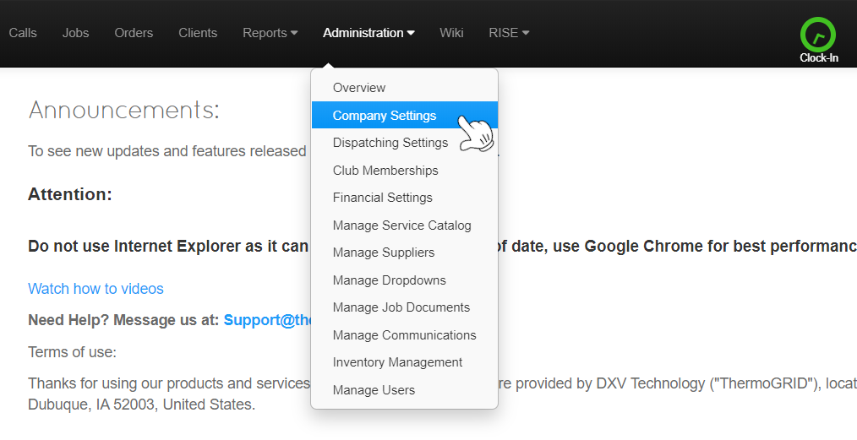
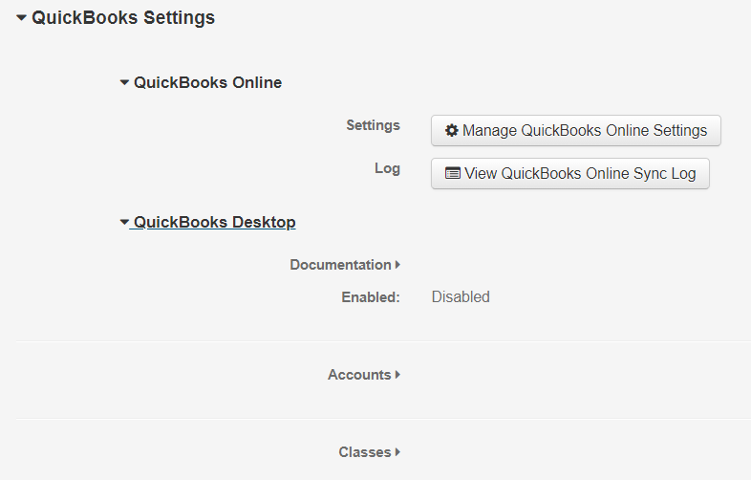

To enable Either, Click on Manage QBO Settings or the EDIT in Top Right corner to Enable

QB Tutorials: https://quickbooks.intuit.com/tutorials/all-quickbooks-tutorials/

***Please Use the appropriate Document for Desktop or Online***

QuickBooks Online
Getting Started

Linking - QBO
Linking Intuit QuickBooks Online is the first step
  - Click Company Settings

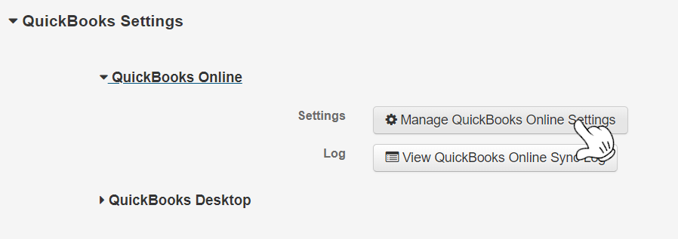
  - Click Manage QuickBooks Online Settings

  - Click a. Edit > b. Enabled > c. Save
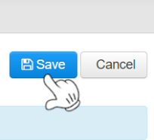
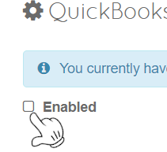
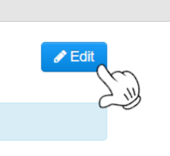
a. b. c.

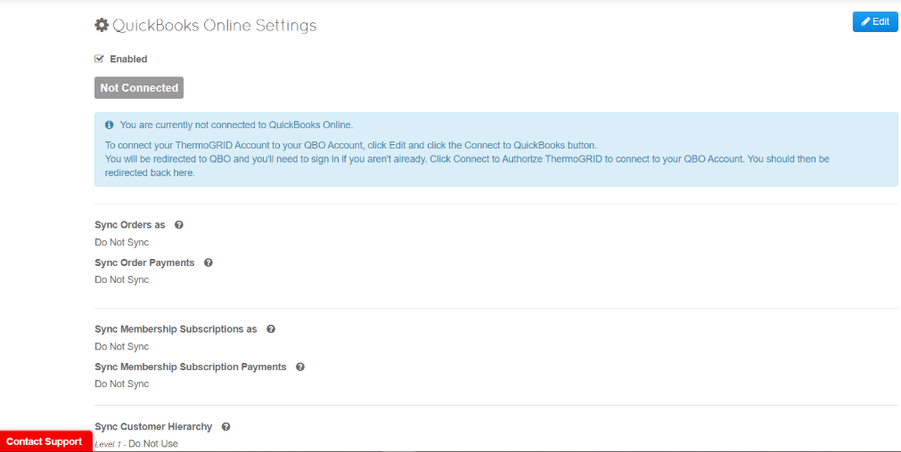
This will be the page displayed when completed

  - Click Edit in the top right

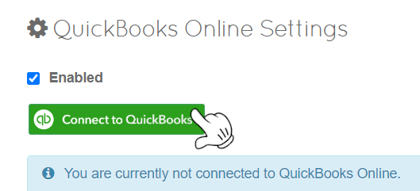
  - Click Connect to QuickBooks

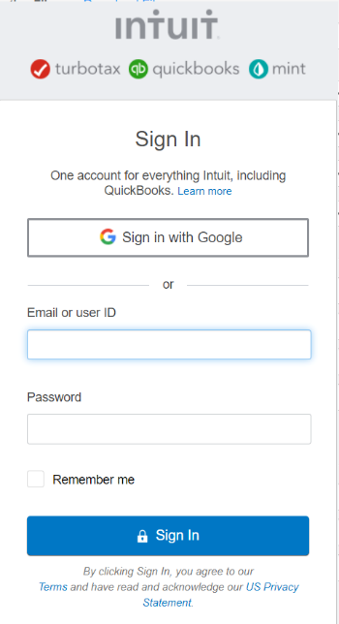
  - Sign into QuickBooks Online with your Email or user ID and Password

You will now see your business under “Connected to”

Syncing - QBO
Please Select the Appropriate Settings for your Company
Syncing Orders
The default type of transaction that ThermoGRID will sync an Order to QBO as. This can be overridden for each Order on the Job Costing page.

- Do Not Sync - ThermoGRID will NOT sync any Orders. All transactions and payments will need to be manually created and received in QBO.

- Invoice - The sale took place, but wasn't fully paid for. A document to inform the customer about how and when to make the payment. ThermoGRID will sync an Order as an Invoice and if enabled, include any Payments you've already recorded. Any future payments will need to be manually created and received in QBO.
We recommend you use this as the default option for Orders as it tends to be the easiest and allows for Checks and Balances.

- Sales receipt - The payment happened at the time of the sale, or before. An acknowledgement that the money owed for a product or a service is paid. ThermoGRID will sync an Order as a Sales Receipt and will NOT include any payments you've recorded as it's assumed the entire Order has been paid for.

Syncing Order Payments
The default option for syncing the Order Payments to QBO. This can be overridden for each Order on the Job Costing page.

- Do Not Sync - ThermoGRID will NOT sync any Payments for Orders. All payments will need to be manually created and received in QBO.

- Yes Sync Payments - When syncing Invoices for Orders to QBO, ThermoGRID will also sync any Payments recorded on the Order. Any future payments will need to be manually created and received in QBO.

Sync Membership Subscriptions as
The default type of transaction that ThermoGRID will sync a Membership Subscription to QBO as. This can be overridden for each Membership Subscription on the client's Memberships page.

- Do Not Sync - ThermoGRID will NOT sync any Membership Subscriptions. All transactions and payments will need to be manually created and received in QBO.

- Invoice - The sale took place, but wasn't fully paid for. A document to inform the customer about how and when to make the payment.
ThermoGRID will sync a Membership Subscription as an Invoice and if enabled, include the Payment that's already recorded. Any future payments will need to be manually created and received in QBO.
We recommend you use this as the default option for Membership Subscriptions as it tends to be the easiest and allows for Checks and Balances.

- Sales receipt - The payment happened at the time of the sale, or before. An acknowledgement that the money owed for a product or a service is paid.
ThermoGRID will sync a Membership Subscription as a Sales Receipt and will NOT include any payments recorded as it's assumed the entire Membership Subscription has been paid for.

Sync Membership Subscription Payments
The default option for syncing the Payments for Membership Subscriptions to QBO.

- Do Not Sync - ThermoGRID will NOT sync any Payments for Membership Subscriptions. All payments will need to be manually created and received in QBO.

- Yes Sync Payments - When syncing Invoices for Membership Subscriptions to QBO, ThermoGRID will also sync any Payments recorded on the Membership Subscription. Any future payments will need to be manually created and received in QBO.

Sync Customer Hierarchy
QuickBooks Online supports Customers and Sub-Customers/Jobs in several different levels. ThermoGRID supports 3 levels of this Hierarchy.
Level 1 is required can be Client or Address.
Level 2 is optional and can be Client, Address, Job, or Not Used.
Level 3 is optional and can be Job or Not Used.
If you mostly have residential clients, we recommend just having just one level (Client) as it tends to be the easiest.
If you have a lot of commercial or property management type clients, it may be helpful to use two levels (Client > Address) so each service location can have its own section.
Having a third level of Job is available, but isn't recommended by ThermoGRID, as it doesn't tend to be necessary or helpful.

PROCEED TO NEXT PAGE

Syncing - QBO
Mark the Accounts from the QBO Chart of Accounts that you would like ThermoGRID to use when syncing transactions.
    - Expand the accordion arrow to show the Accounts and Click 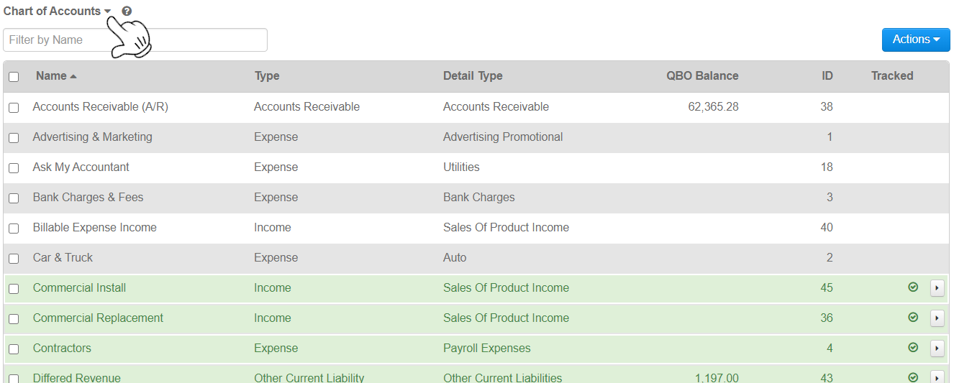

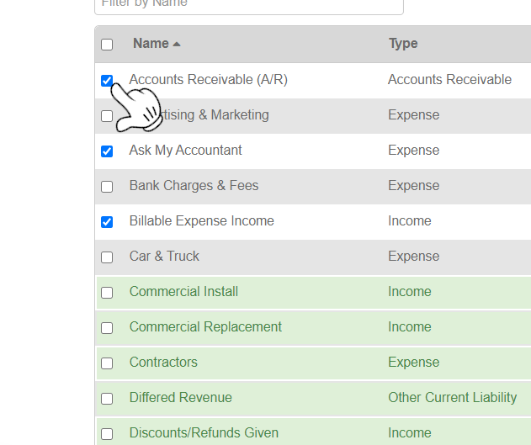
    - check the boxes next to each one you want to use
!!DO NOT SYNC TO BANK!!
You will then be able to map these Accounts from QBO to service catalog entries, membership plans, and discounts and fees in ThermoGRID.
ThermoGRID will create Items in your QBO account which will map to your selected Accounts. Do NOT delete these Items.
Any transactions that ThermoGRID will sync will utilize these Items so that revenue and expenses are categorized into your Accounts correctly.
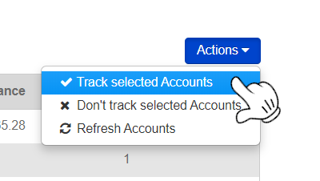
    - Click Actions on the top right and Track Selected Accounts

Mark the Payment Methods from the QBO List of Payment Methods that you would like ThermoGRID to use when syncing transactions.
Expand the accordion arrow to show the Payment Methods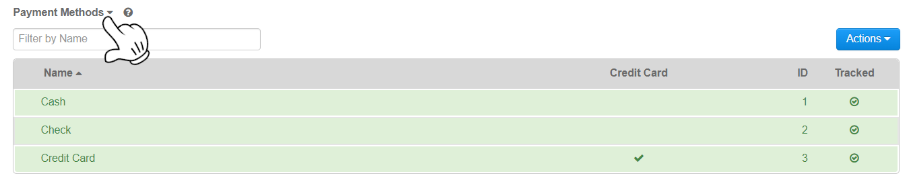check the boxes next to each one you want to use
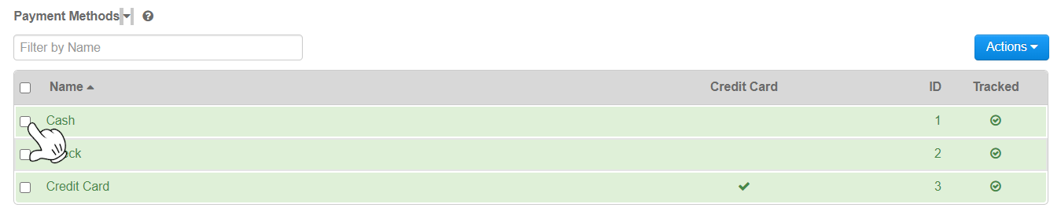Click Actions and Track selected Payment Methods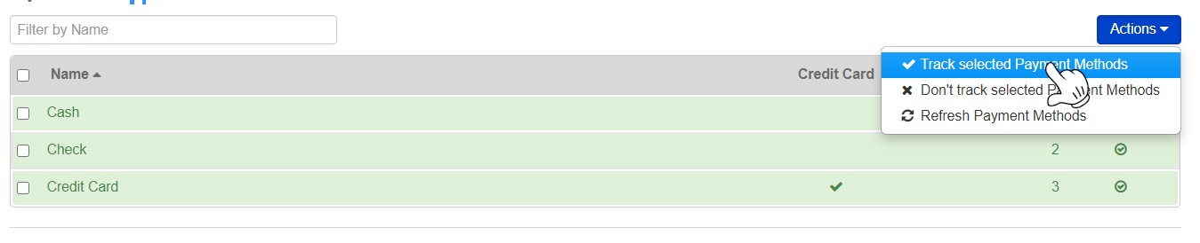
You will then be able to map these Payment Methods from QBO to the payment methods in ThermoGRID on the Administration > Financial Settings > Payment Methods page.
Any Invoice Payments that ThermoGRID will sync will then utilize the Payment Methods you've mapped.

Tax Center & Rates
A feature in QBO which allows you to keep track of taxes on various types of transactions.
If you'd like to use Taxes, sign into QBO and click on Taxes from the left navigation. Then click "Set up sales tax" and follow the setup process. There are two methods in QBO of managing taxes:
- New Tax Center - Manages sales tax calculations via an automated sales tax (AST) engine. Sales tax is determined based on the source and destination address.
The source address is the company’s legal address as available in the company settings. The destination address is the shipping address (service location) provided on the sales transaction.
If a shipping address (service location) is not provided, the company address is considered as the destination address.
When syncing a transaction with tax, ThermoGRID will specify the line items that are taxable and the total amount of tax calculated. QBO will use this amount and prorate it across associated tax rates in an AST-assigned tax code.
- Old Tax Center - Manages sales tax with tax rates, groups, and agencies that you manually enter yourself.
Use a single rate if you pay just one rate to a single agency. Enter a name for the tax, the agency you pay, and the percentage for the rate.
If you're required to track sales tax for more than one tax agency (like to your city, county, and state), consider setting up a combined tax rate. Enter a name for the tax and each component's name, the agency you pay, and the percentage for the rate.
When syncing a transaction with tax, ThermoGRID will specify the line items that are taxable, the total amount of tax calculated, and the tax rate it used to calculate. QBO will use this amount and display the tax rate used.
Any account recently created in QBO will not have this option available in QBO and only the New Tax Center with the automated sales tax (AST) engine is available.
Tax Rates
- Mark the Tax Brackets from the QBO List of Tax Brackets that you would like ThermoGRID to use when syncing transactions.
- Expand the accordion arrow to show the Tax Brackets, check the boxes next to each one you want to use, and then select Actions > Track selected Tax Brackets.
You will be able to map the Tax Brackets from QBO to the Tax Brackets in ThermoGRID on the Administration > Financial Settings > Tax Rates page.
Any Transaction that ThermoGRID will sync will then utilize the Tax Brackets you've mapped.

Track Classes
A feature in QBO which adds a Class field on forms so you can assign transactions to different segments like departments, locations, and product lines. There are two methods of Tracking Classes:
• One to entire transaction - One Class will be assigned to the entire Invoice or Sales Receipt. Select this option if you don't need to enter a Class for each line item on a transaction.
• One to each row in transaction - One Class will be assigned to each line item on the Invoice or Sales Receipt. Select this option if you want more control over how you categorize and organize your revenue and expenses.
If you'd like to use Class Tracking, sign into QBO and go to Settings > Company > Categories and enable "Track classes" and select the method for tracking them.
Not Using Classes in QBO
Classes
× Mark the Classes from the QBO List of Classes that you would like ThermoGRID to use when syncing transactions.
Expand the accordion arrow to show the Classes, check the boxes next to each one you want to use, and then select Actions > Track selected Classes.

You will then be able to map these Classes from QBO to service catalog entries, membership plans, and discounts and fees in ThermoGRID.
Any transactions that ThermoGRID will sync will utilize these Classes so that revenue and expenses are categorized correctly.

