Client Import – QuickBooks Desktop

This document covers how to export your client list from QuickBooks Desktop (QBO) into a format that the ThermoGRID team can process and import into your TG account.

Steps:

1. In QBD, click on “Reports” in the menu bar, then click “List”, then choose “Customer Contact List”.
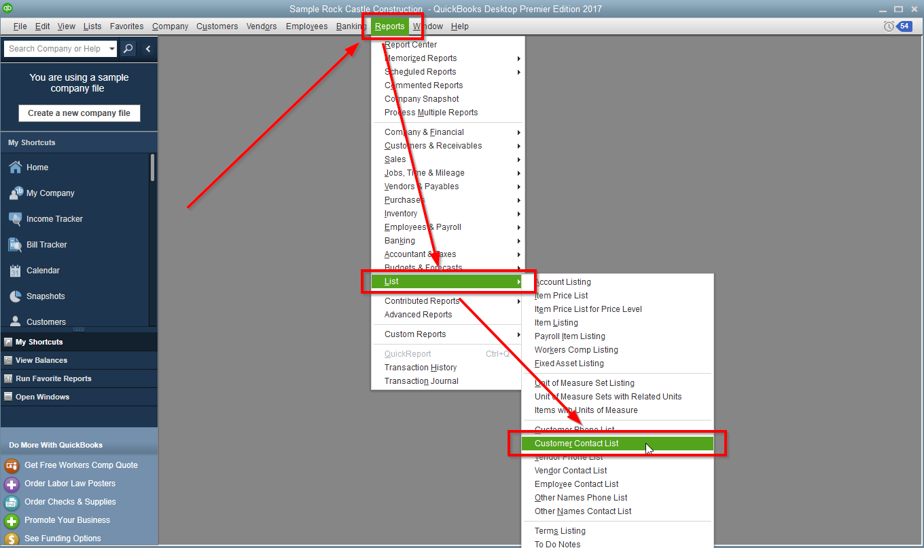
2. On the Customer Contact List pop-up, click the “Customize Report” button.
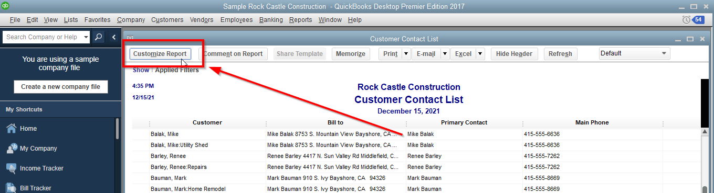

3. On the Modify Report: Customer Contact List popup, scroll through the list of fields on the left and make sure each item below is checked. Click the OK button when done.
- Customer
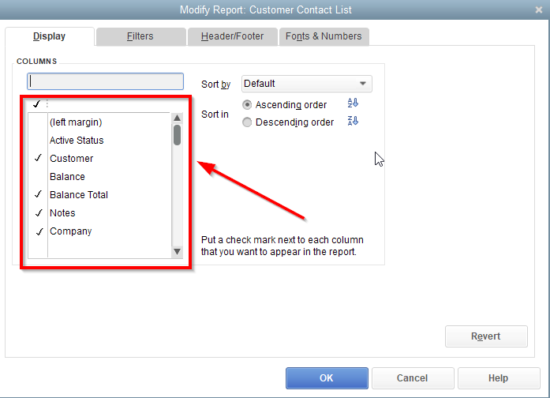
- Balance Total
- Notes
- Company
- First Name
- MI
- Last Name
- Main Phone
- Mobile
- Main Email
- Street1
- Street2
- City
- State
- Zip
- Ship To Street1
- Ship To Street2
- Ship To City
- Ship To State
- Ship To Zip

4. Then click on the “Excel” button at the top right and select "Create New Worksheet".
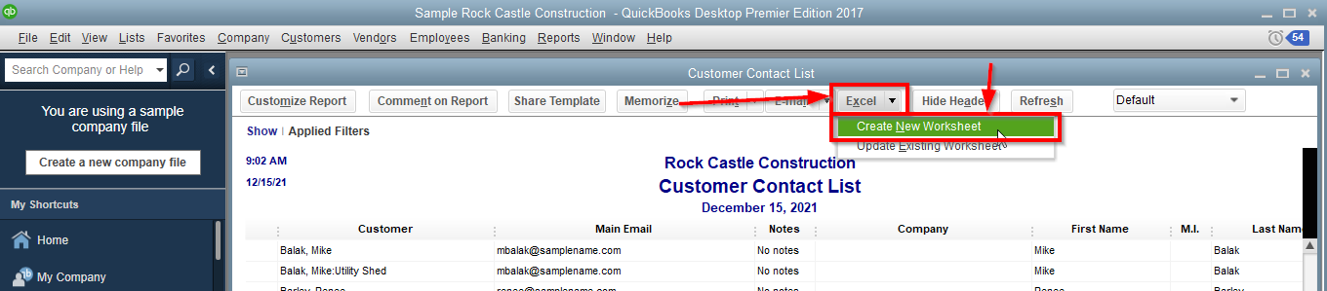
5. Save the file and look over this export thoroughly as you only get one import in to TG. Make sure it has all that the information you want and compare to clients in the system to make sure the items you checked off for the report is giving you the correct info. When you are ready, email the file to the ThermoGRID team so they can process and import your data.

