Administration
Account Set-Up 5: Financial Settings

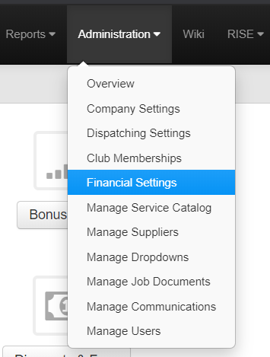
Click on Administration>Financial Settings
You will be presented with these options:
- Commission Scale
- Bonus Scale
- Payment Methods
- Tax Rates
- City Permits
- Discounts and Fees
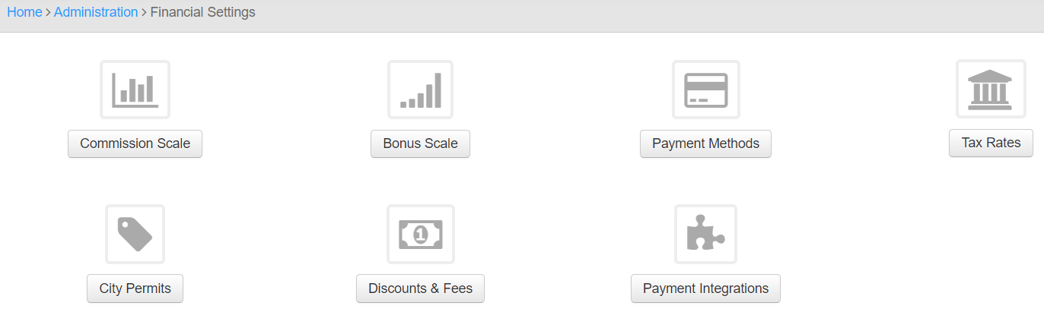
- Payment Integrations

Commission Scale
There will be a prepopulated “Default” Scale that is editable
Here you can set up a commission scale.

If you want to give 10% commission on everything sold no matter what.
Discount Percentage = 1
Sales Only % = .1
If you want to give 10% if the sales rep discounts less than 10% and 5% if they discount 20% and nothing above that.
Discount Percentage = .1
Sales Only % = .1
Discount Percentage = .2
Sales Only % = .05
If you want to give 10% if the sales rep discounts less than 10% and 5% if they discount 20% and nothing above that and if it's a tech lead the tech gets 2% and it goes against the sales rep.
Discount Percentage = .1
Sales Only % = .1
Sales w/ Tech % = .08
Tech % = .02
Discount Percentage = .2
Sales Only % = .05
Sales w/ Tech % = .03
Tech % = .02

These Can be Copied and Edited to be built more efficiently with the “Create Plan” button
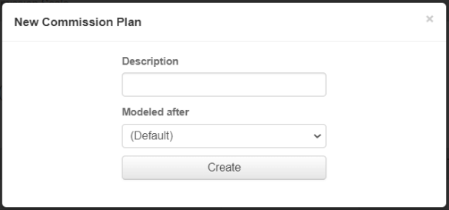
Chose a Description of the Plan

Chose what Plan you would like to have it Modeled after
You can Edit the Plan after it is Created

Editing Is consistent with previous methods
Bonus Scale
If you want to pay by Gross Margin or Bonus you can Edit it here.

There will be a prebuilt “Default”
Editing Is consistent with previous methods
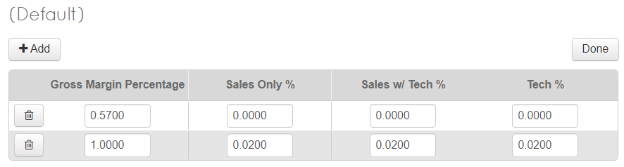
Examples:
If you want to pay sales rep 2% if GM is over 55%
Gross Margin Percentage = 0.57
Sales Only % = 0.00
Sales w/ Tech % = 0.00
Tech % = 0.00

Gross Margin Percentage = 1.00
Sales Only % = 0.02
Sales w/ Tech % = 0.00
Tech % = 0.00

If you want to pay sales rep 2% if GM is over 55% only if it is a tech lead.
Gross Margin Percentage = 0.57
Sales Only % = 0.00
Sales w/ Tech % = 0.00
Tech % = 0.00

Gross Margin Percentage = 1.00
Sales Only % = 0.00
Sales w/ Tech % = 0.02
Tech % = 0.0

Payment Methods
When adding a payment to an invoice these will be the Selectable Options
Editing Is consistent with previous methods
Edit your:
Display Name/Lender Name
Description
Dealer Fee = Cost % Increase because type of payment. This will be added to the customers invoice when this option is chosen. The % is not visible to the customer
Interest Rate = Used to Calculating Financing. This will be added to the customers invoice when this option is chosen. The % is not visible to the customer
Payment Factor = Used to Calculating Financing. This will be added to the customers invoice when this option is chosen. The % is not visible to the customer
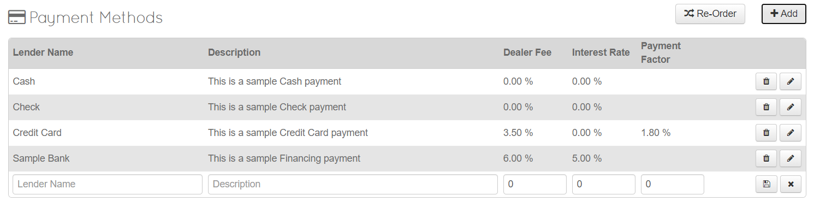
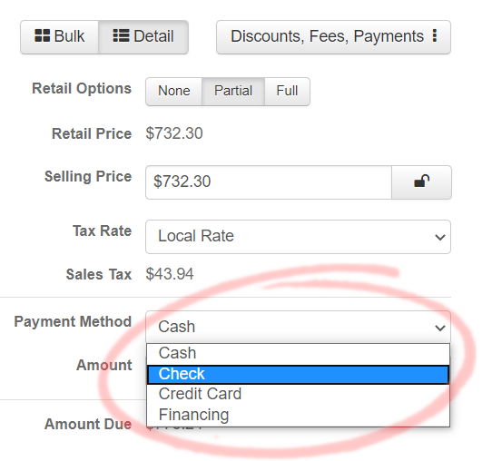
When Completed your Payment Methods will be available on Order Estimate

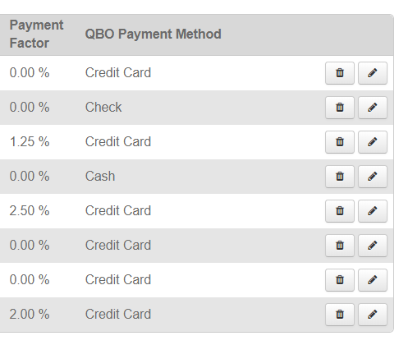
(If QuickBooks is Setup, you will also have the option to link to the correct Payment method in QuickBooks)

Tax Rates
When adding a Taxes to an invoice these will be the Selectable Options
Taxes Will prepopulate on an Order Estimate based on Customers Zip/Postal Code as long as it is mapped under their Zip/Postal Code
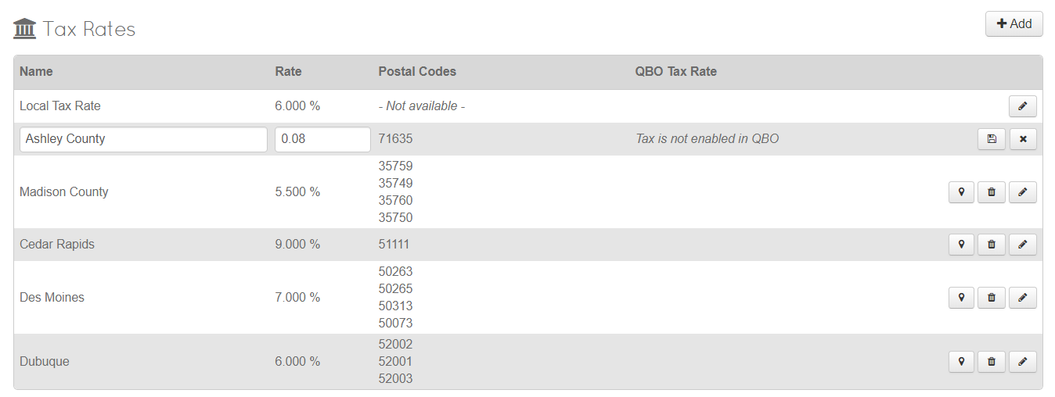
Add any Tax rates with the Add Button in the Top Right.
Edit with the Pencil/Edit Icon on the Right after the Tax is Created.
Chose all postal codes that the Tax Rate will automatically populate to. (Click on the GPS Icon)

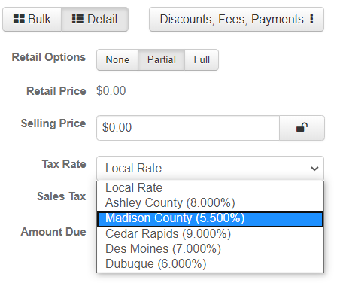
You will now see Your Customer List in the Tax Rate Dropdown when adding a Payment to an Order Estimate.

Discounts and Fees
When adding a Discounts or Fee to an invoice, these will be the Selectable Options
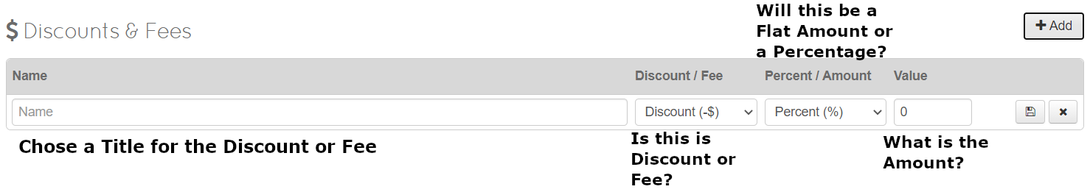
Editing is consistent with previous methods
Click the Save Icon when complete
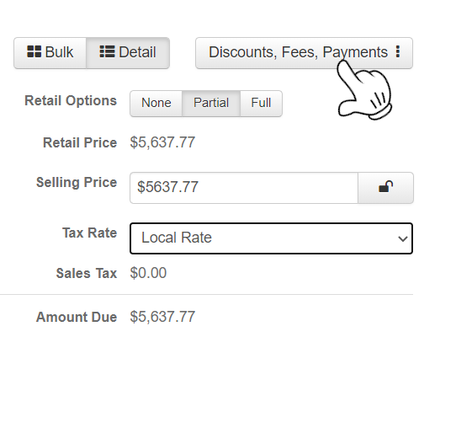
You will now see Your Custom Options under Discounts and Fees when adding them to an Invoice

Click on Discounts, Fees, Payments
And Chose Discounts and Fees

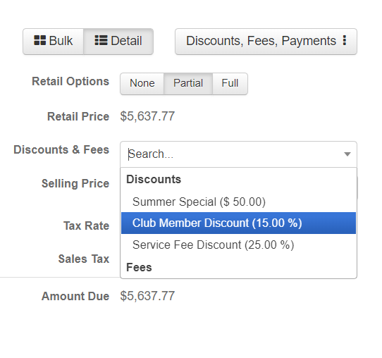

You will then have the Discounts & Fees Option on the Invoice

Chose what Discount or Fee you would like to add to the Invoice

Payment Integrations
ThermoGRID Uses CardConnect and 1st Pay Gateway for Credit Cards and ACH Transactions
If you would like to set these up Please contact ThermoGRID Support
*THIS CONCLUDES BASIC SETUP*

