Administration
Account Set-Up 10: Upload Client List
All Client Data Must be uploaded in an Excel Format, to export Client Information Please contact your current CRM or Client Data Management Provider. If you are Exporting Client Data from Quick Books Follow one the Tutorials below.
If you have more than two addresses per client to import please contact Customer support to upgrade your set up
QuickBooks Desktop
Client Import – QuickBooks Desktop

This document covers how to export your client list from QuickBooks Desktop (QBO) into a format that can be processed and imported into your ThermoGRID account.

Steps:
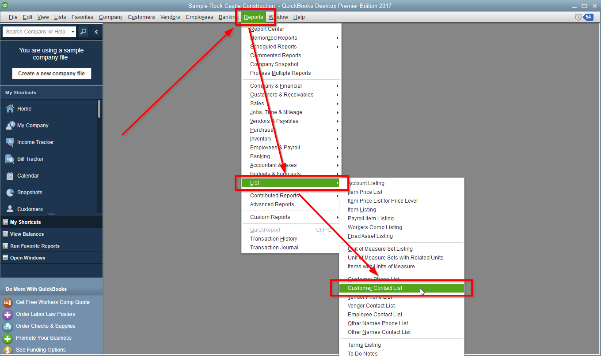
1. In QBD, click on “Reports” in the menu bar, then click “List”, then choose “Customer Contact List”.

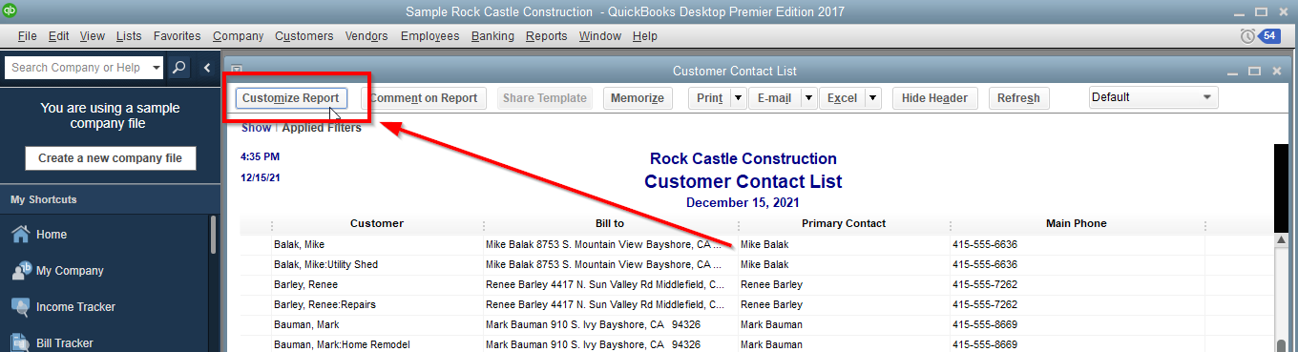
2. On the Customer Contact List pop-up, click the “Customize Report” button.

3. On the Modify Report: Customer Contact List popup, scroll through the list of fields on the left and make sure each item below is checked. Click the OK button when done.
- Customer
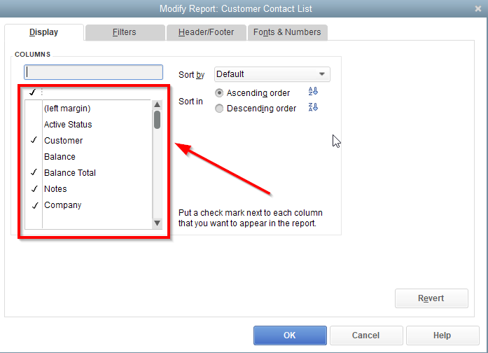
- Balance Total
- Notes
- Company
- First Name
- MI
- Last Name
- Main Phone
- Mobile
- Main Email
- Street1
- Street2
- City
- State
- Zip
- Ship To Street1
- Ship To Street2
- Ship To City
- Ship To State
- Ship To Zip

4. Then click on the “Excel” button at the top right and select "Create New Worksheet".
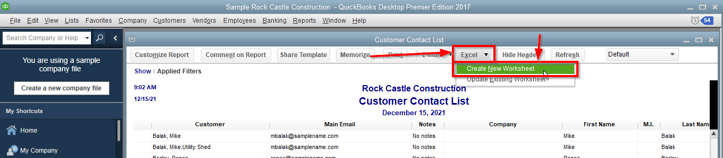
5. Save the file and look over this export thoroughly as you only get one import in to TG. Make sure it has all that the information you want and compare to clients in the system to make sure the items you checked off for the report is giving you the correct info.

QuickBooks Online
Client Import – QuickBooks Online

This document covers how to export your client list from QuickBooks Online (QBO) into a format that the ThermoGRID team can process and import into your TG account.

Steps:

1. In QBO, click on the reports tab on the left, then search for “customer” in the search bar and select “Customer Contact List”.

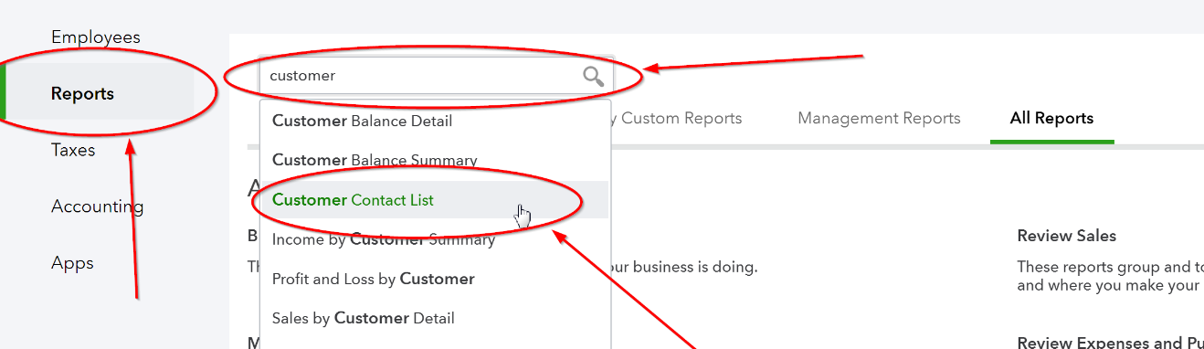
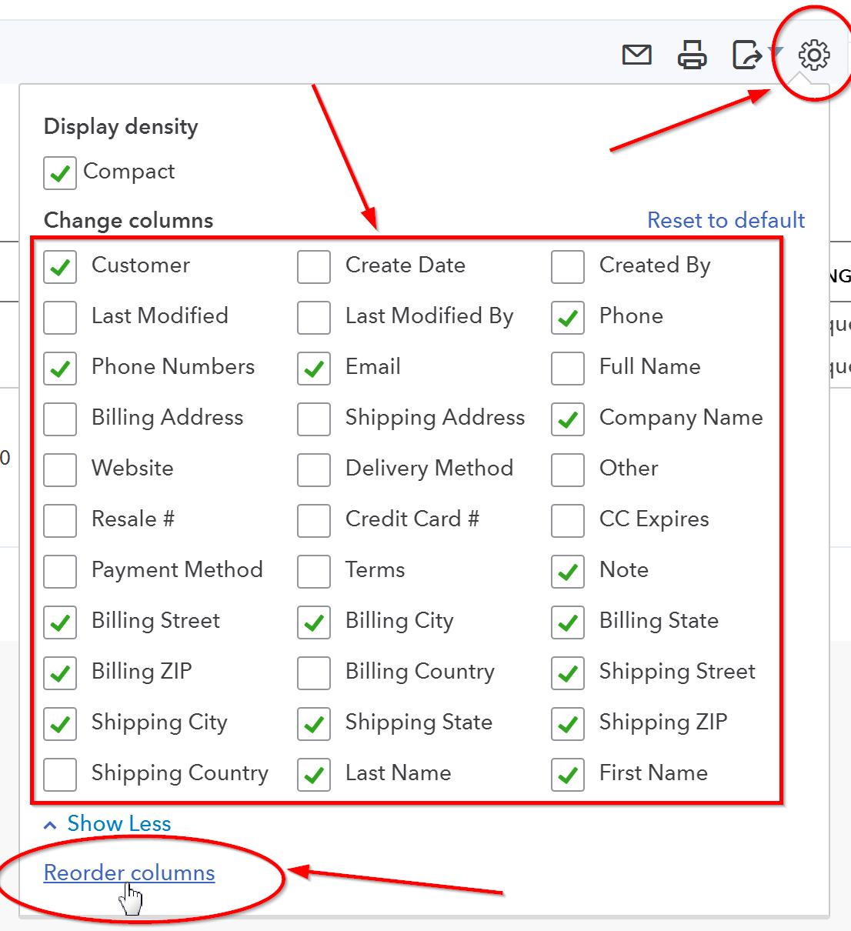
2. On the right, click the settings gear/cog wheel and check/uncheck the checkboxes to match the picture below. You may need to click “Show more” to view all columns. Then click on "Reorder columns".

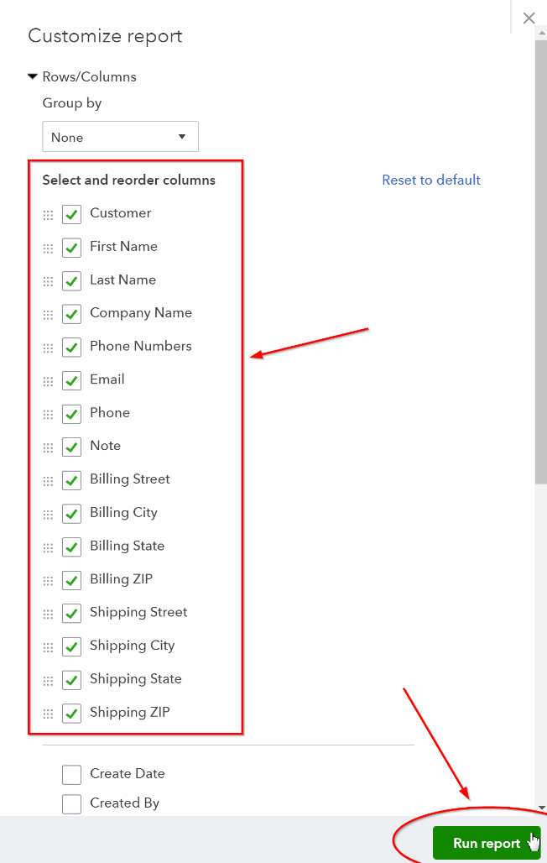

3. Use the move buttons on each side of the checkbox to reorder them like the picture below. Then click the "Run report" button.

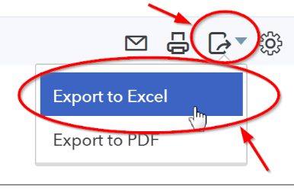
4. Then click on the export button at the top right and select "Export to Excel".

5. Save the file and look over this export thoroughly as you only get one import into TG. Make sure it has all necessary information you want, and compare it to clients in the system to make sure the items you checked off for the report gives you the correct info.

Uploading Client Data
- Click Clients

- Add New Client

- Fill in All the information you can for a TEST or Real Client. We are creating a Client to Export from TG so you can See where Data should be imported a little easier.

- When Finished inputting client data, Click on Clients Again.

- Click the Arrow next to Import/Export and Click on Export Clients - Basic
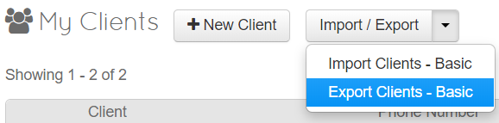

- Save the File someplace easy to find - Keep as .CSV file.
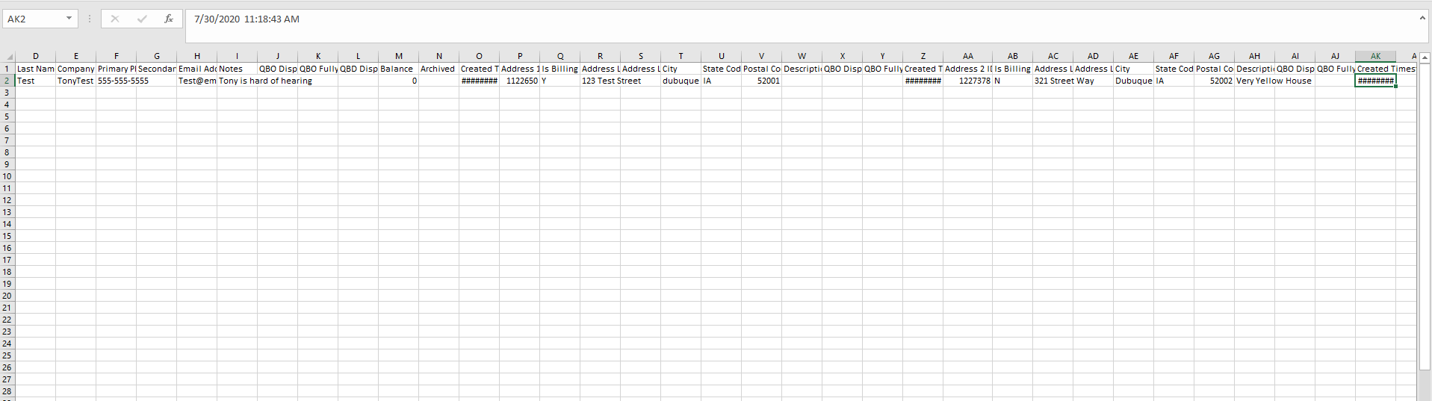
- Open the File and you will be presented with an Excel Document like this
- Copy the Columns from your Export from QB or your other Software to fill in the Data in the Appropriate columns

You have these Options to fill in
A | Client ID
B | First Name
C | Middle Initial
D | Last Name
E | Company Name
F | Primary Phone
G | Secondary Phone
H | Email Address
I | Notes
J | QBO DisplayName
K | QBOFullyQualifiedName
L | QBD DisplayName
M | Balance
N | Archived
O | Created Timestamp
P | Address 1 ID
Q | Is Billing Address (Y/N)
R | Address Line 1
S | Address Line 2
T | City
U | State Code
V | Postal Code
W | Description
X | QBO DisplayName
Y | QBOFullyQualifiedName
Z | Created Timestamp
AA | Address 2 ID
AB | Is Billing Address (Y/N)
AC | Address Line 1
AD | Address Line 2
AE | City
AF | State Code
AG | Postal Code
AH | Description
AI | QBO DisplayName
AJ | QBOFullyQualifiedName
AK | Created Timestamp

If you have QuickBooks and would like to Sync to current clients, make sure the QB Display name and Fully Qualified name are Correct!

QuickBooks uses a “Parent/Child” Relationship for their Addresses and Clients
This means the Main Account/Client has “Parent Data” and Each Address has “Child Data” that is managed to attached them together

Example:

Client name: Tommy Tester
QB Display name: Tester, Tommy
QB Fully Qualified name: Tester, Tommy

1st Address : 123 Street Road
QB Display name: 123 Street Road
QB Fully Qualified name: Tester, Tommy:123 Street Road

2nd Address : 321 Circle Way
QB Display name: 321 Circle Way
QB Fully Qualified name: Tester, Tommy: 321 Circle Way

- When you have all the Data Copied into the Appropriate Locations Save the Document

- Click on Clients and Click on Import/Export Arrow and Choose Import Clients – Basic

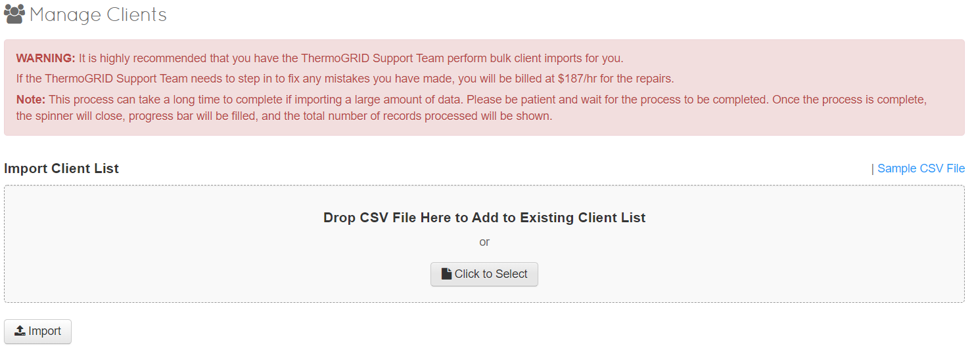
You will be presented with this Screen

- Click “Click to Select” and Chose the file you have just Saved
- Click Import and wait for the Client list to be processed

This will import your client list into ThermoGRID

