Administration
Account Set-Up 12: Dispatching Settings
Daily Management Report must be set first (These settings do not NEED to be changed)
Meeting the KPI’s that are Set will advance Users to the Top of the Calendar for Smart Dispatching
by default, we are tracking national standards. If you do not feel comfortable making these adjustments give us a call. Any errors can result in double revenue being applied to this report.
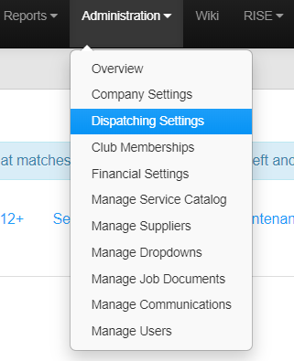
Click Administration> Dispatching Settings

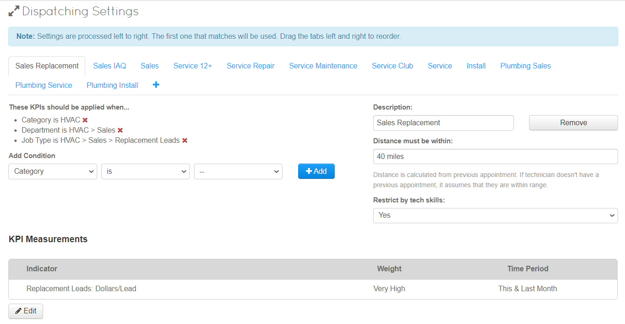
This screen will be displayed and gives you the opportunity to chose When KPI’s will be applied.

Example: 1
Let’s say you want to dispatch:
- Any Plumbing Service Job to anyone
- Call Priority is “Emergency – Pipe Break”
- Distance is within 10 Miles

Add Condition: "Category" - “is” - "Plumbing" Click +Add

Add Condition: "Priority " - “is” - "Emergency – Pipe Break " Click +Add

Change: “Distance Must be within”

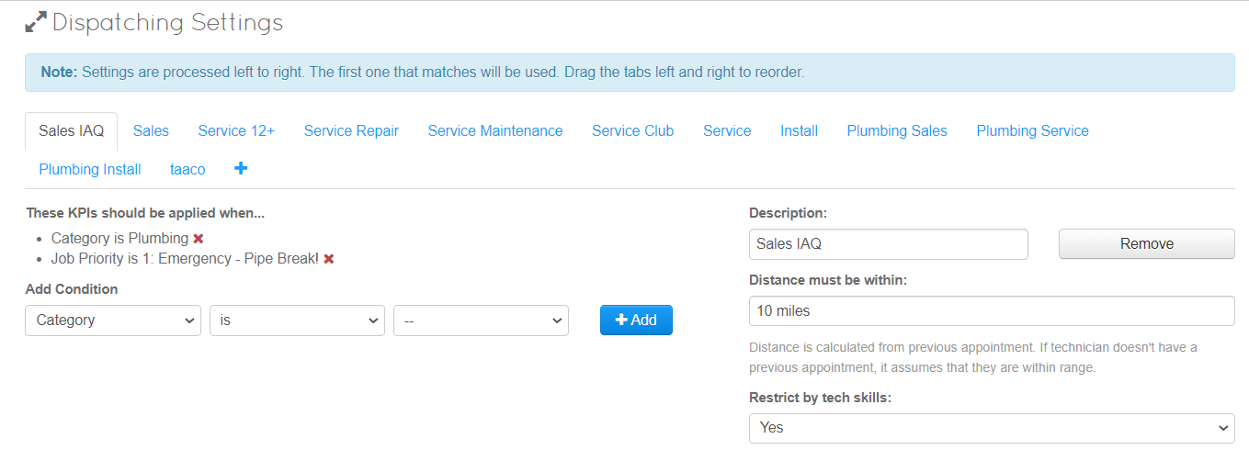
This setting will now only chose someone within 10 Miles if there is a plumbing Job with a Priority of “Emergency – Pipe Break”

Example: 2
Let’s say you want to dispatch:
- A service job for HVAC
- Do not want them to drive over 60 miles
- Want to make sure the tech has the skills
- And will make you the most revenue
- And it is a 12+ opp (old system)
- Description "12+ opp Service"
- Distance "60"
- Restrict Skills "Yes"
- Add Condition: "Category" and "HVAC" Click +Add
- Add Condition: "Department" and "Service" +Add
- Add Condition: "Job Type" and "12+opp Click +Add
- KPI Measurements: Edit -Indicator = "12+ closing rate" Weight = "Very High" (or low if you are lining up other types of jobs more important) Time period: this month or this and last (time period it is pulling numbers for)

