Administration
Inventory
To turn on Inventory management Please Contact a ThermoGRID Support representative and make sure your ENTIRE catalog is Completed. You will be able to still add items later, but the catalog should be refined and used in the field before attempting inventory control.

Manage Locations
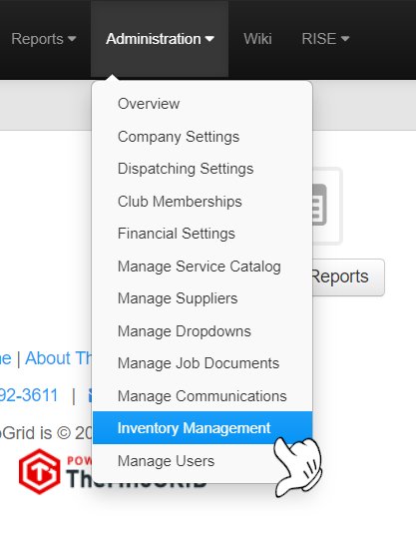
To setup locations (Warehouse, Service truck 1, Truck 2, etc.)
- Click Administration>Inventory Management
- Manage locations

- + Add Location 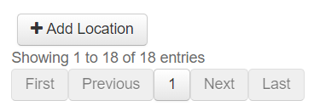

- Select if it is a Warehouse or Truck location.
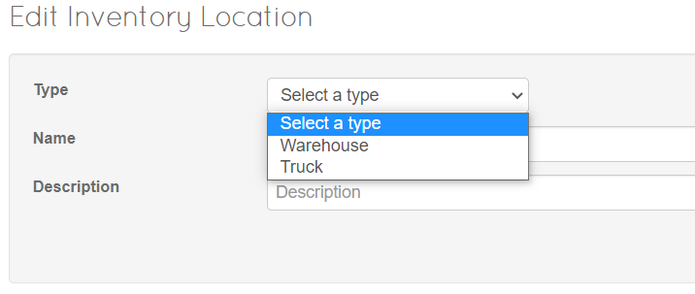
- Type in a Name and Description and Click Save
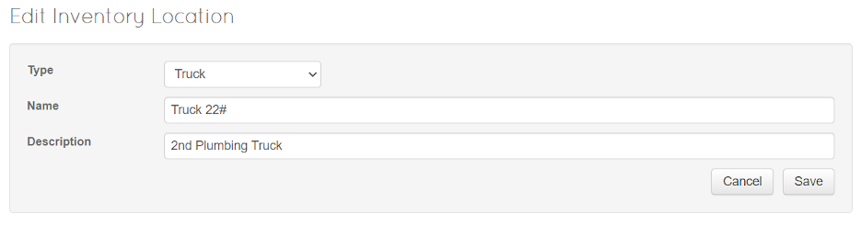

Once this is done you can add items to the location.
Adding items to the location is managed with Stock Levels
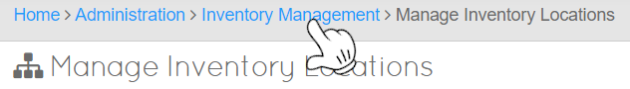

Stock Levels
quantity and type of parts you keep on hand in each location

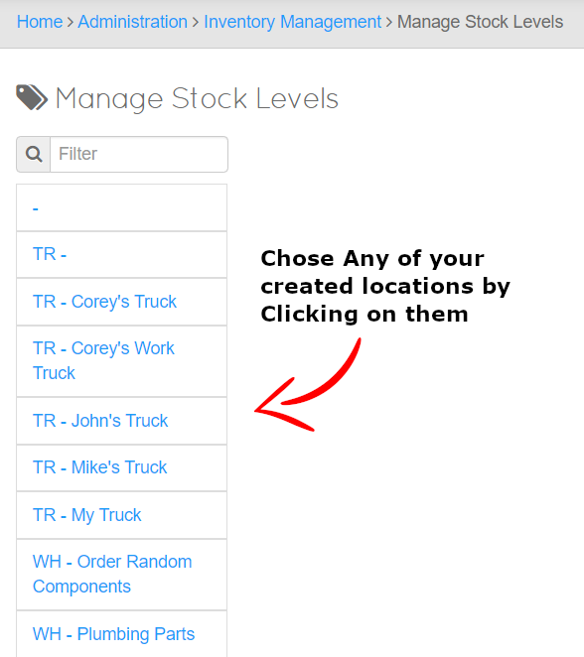

After Selecting which Location you would like to Edit, you will be presented with the screen here
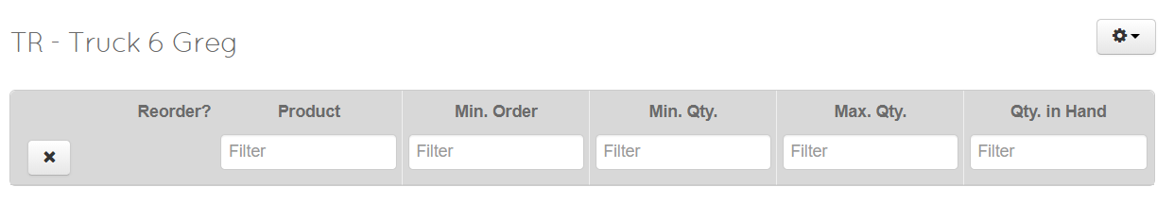

By Clicking on the Cog/Gear/Settings Symbol on the top right we can
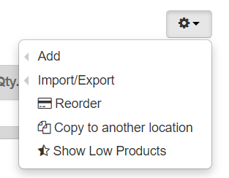
- Add
- Import/Export
- Reorder
- Copy to another location (Truck or warehouse)
- Show Low Products

Add an item to a Location – Option 1

- Hover over Add & Click +Add Stock Item
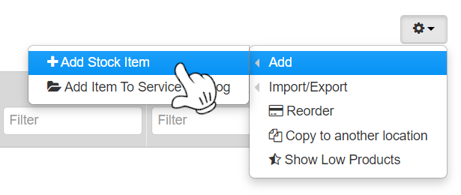

Add Stock Item will allow you to choose from items in your service catalog

- You can search for the name of the item in your catalog you would like to add to the Location.
  - Min. Order = minimum number that will be ordered
  - Min. Qty. = Minimum Quantity that should be on hand
  - Max. Qty. = Maximum Quantity that should be on hand
  - Qty. in Hand = Current Quantity at that Location

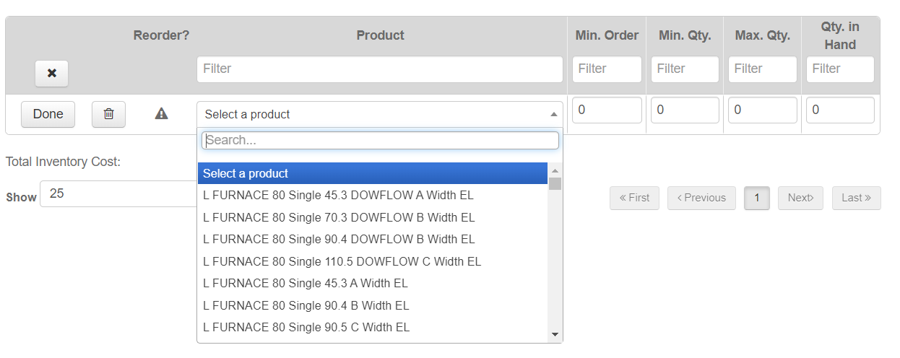
- Click Done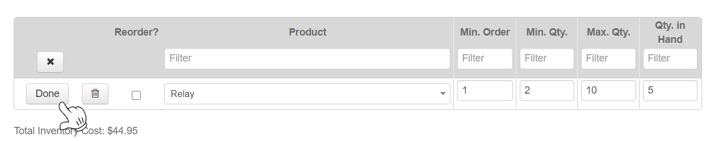

Add an item to a Location – Option 2
(Only use if you are comfortable with Excel)
- Hover over Import/Export & Click Export
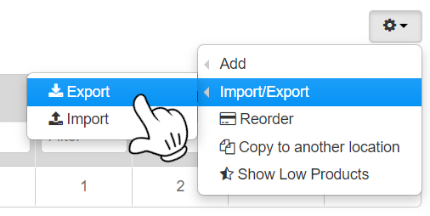
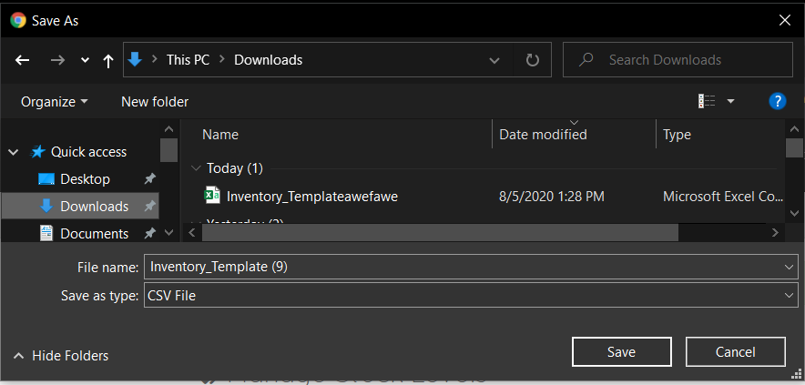

The File will either download directly or a “pop-up” will ask you where you would like to save the File on your computer

- Open the File, you will see something that looks similar to this

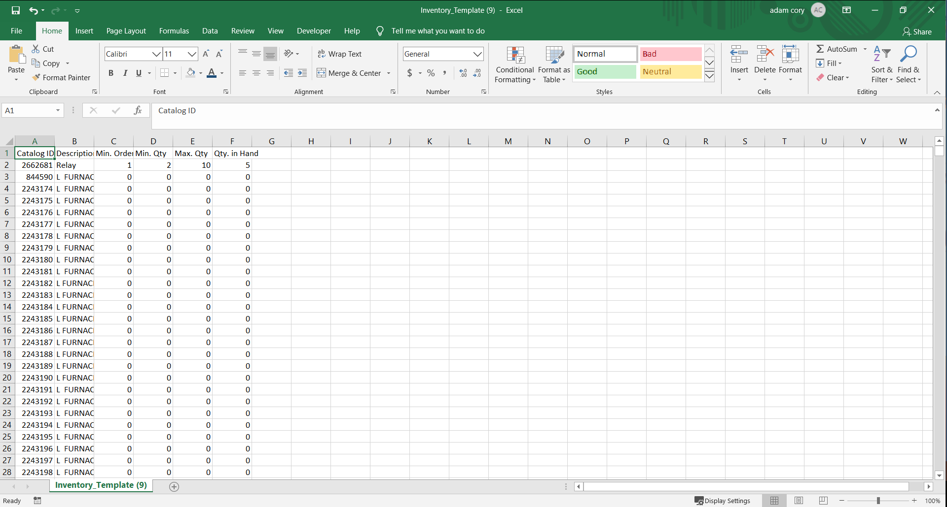

If you fill in any information on any item it will be added to that location

- Fill in any information you would like for this location and save the file.
This is a list of your entire service catalog. Use the Find option to locate items based on description. If it says 0 – 0 – 0 – 0 there will be nothing added to the Location, but if you make a change such as 0 – 0 – 0 – 1, that Item will now be added to the selected Location.

I’ve made edits to mine, let’s see what it looks like when it gets Imported.
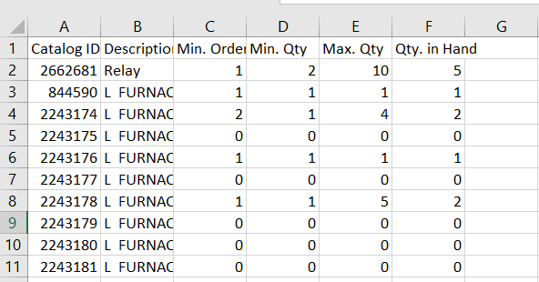
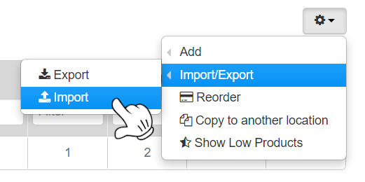

- Hover over Import/Export & Click Import

- Click Choose Files
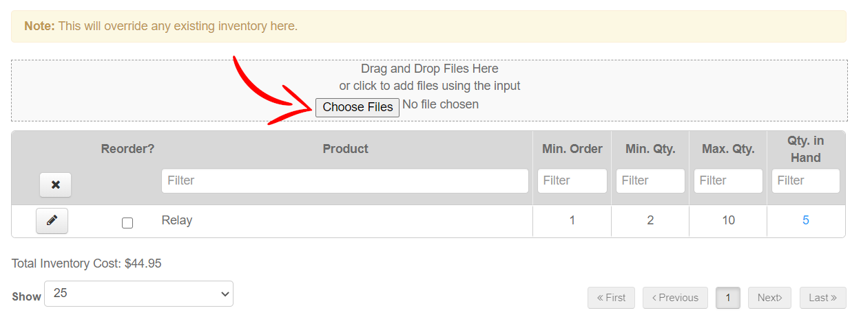

- Find the file again on your computer and open the file
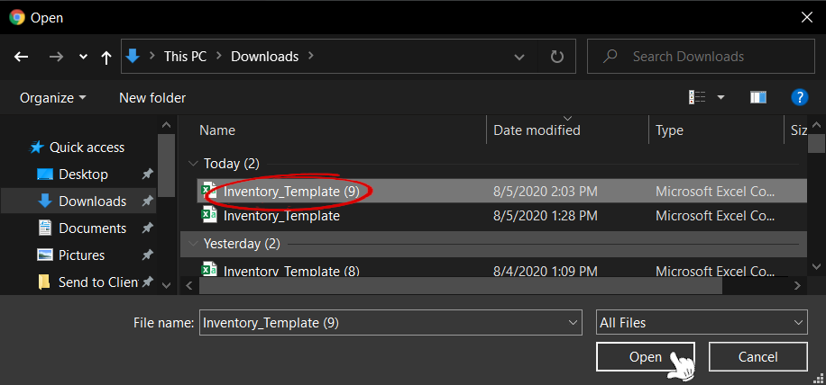

Here is my result
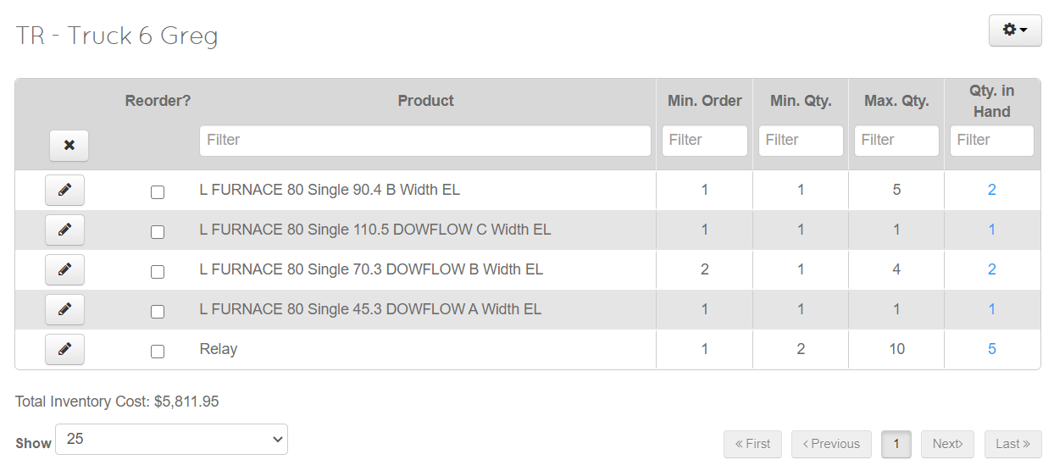
As you can see these are the same changes I made to the Excel/CSV file that we edited outside of ThermoGRID

Inventory Orders
To reorder parts for a Location that is low
ThermoGRID will automatically put a check mark next to all items that need to be reordered. If you do not wish to reorder at this time simply uncheck the item, this can be used to split orders or to just not purchase an item at this time.
If you want to only see items that need to be reordered click Cog wheel in top right corner (Gear symbol) and select Show Low Products.
- Click the Gear/Cog Settings Button and Click Reorder
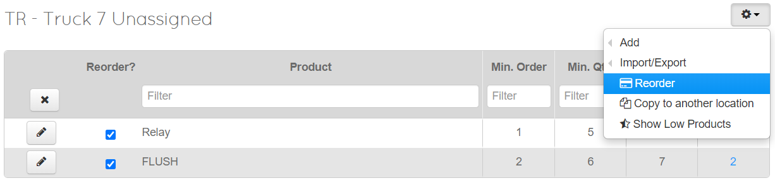
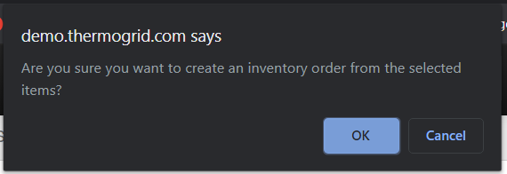
A “Pop-Up Box” will appear with this message, asking if you are sure you would like to create the order for the items

- Click OK to create the order

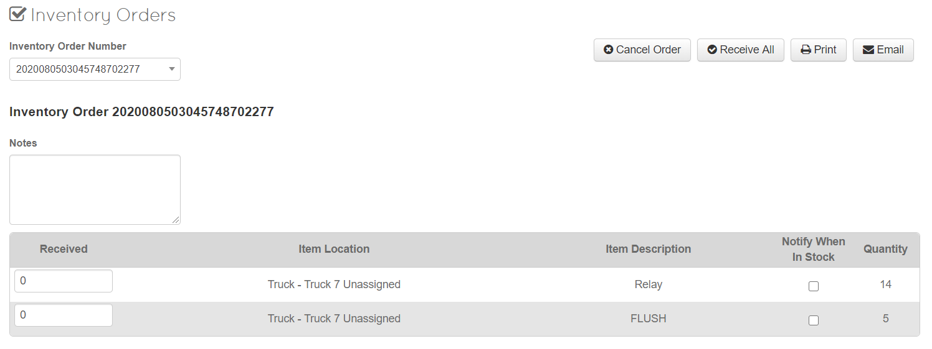
- Add any Notes or Select “Notify When in Stock” if you want notifications sent out when order is received
If an item is being ordered in by the supplier you can check the box Notify When In Stock. Once the item is delivered to you, you can receive the item and a button will appear up at the top called Notify In Stock. This will allow you to notify the tech, the office, and/or client to get the Job scheduled.

You can print or Email the Order to your supplier and when the order is received you can come back to this page. Administration> Inventory Management > Inventory Orders. All orders will be saved here and new orders will be put at the bottom of the list. When you chose “Receive All” for this order it will then add the items to the appropriate Inventory Location.
Possible Challenges

- I cannot create an inventory order.
1) Verify that less than 300 items have been selected.

- I cannot reorder an item
1) This usually means that the item no longer exists in the service catalog. Edit the stock level item and choose a new corresponding service catalog item.

- I cannot receive an inventory order
1) This means that an item on the order references a service catalog item that is no longer in inventory stock levels.
A) Make sure there is a corresponding item in the designated stock level location for this line item.
B) Click the warning icon for the item in question. A popup will appear where you can choose the corresponding item from the stock level location.

- I cannot cancel an inventory order
1) See "I cannot receive an inventory order".

- I cannot receive a particular item on the inventory order.
1) See "I cannot receive an inventory order".

- The total cost of an inventory item is showing as $0.00 on the stock levels page.
1) This usually means that the item no longer exists in the service catalog. Edit the stock level item and choose a new corresponding service catalog item.

If you would like a printable/Editable policy open “Inventory Policy”

