Administration
Account Set-Up 12: Club Memberships
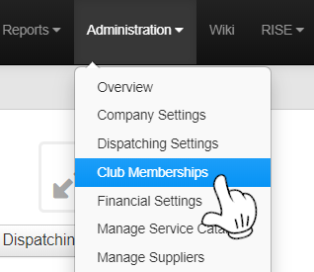
Click Administration> Club Memberships

You will see 3 Pre-built Memberships and you can either update these or create more.
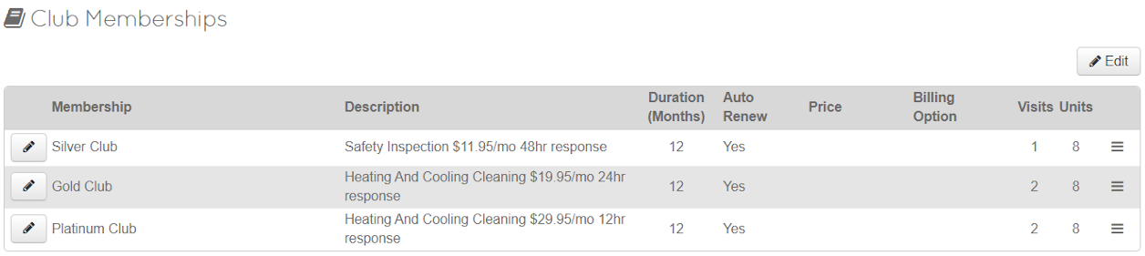

You can Edit the Membership
- Name - of Membership
- Description - What does the membership entail?
- Duration – Length in Months
- Renewal – Will this auto renew?
- Price – Cost of Membership (Determined by month or year in next option)
- Billing Option - Monthly or Annually
- Visits – Included yearly visits (edited after created)
- Units – How many units or what type does this cover (edited after created)
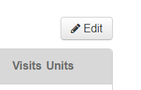
Click Edit on the Top Right

You will now be able to edit Membership Title (Membership display name)
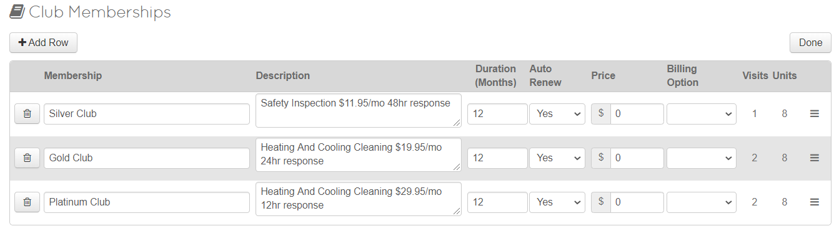
Note: If you want a Yearly and Monthly version of the same Membership, you must make two Memberships, one annual and one monthly.
Once you have Finished Creating your Custom Memberships Click Done

Next we will edit the Memberships visits and Units

Click on the Edit Icon Next to the Membership you would like to edit
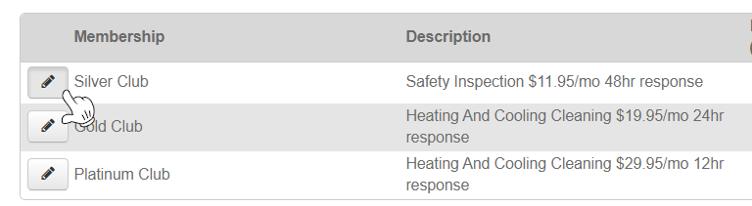

On this Page you are able to edit Visits and Units that can be attached to this membership.
Click + Add Visit or + Add Unit to add any units or visits you would like to this membership
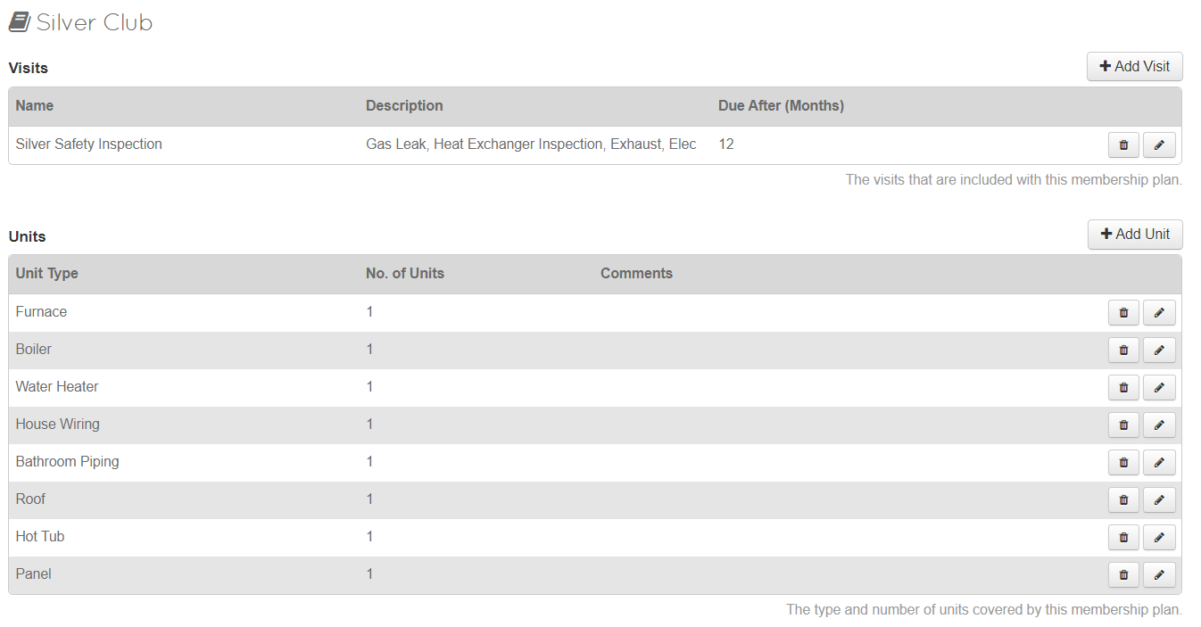
Due After (Months) is the number of months before you owe the Client this Visit
When finished editing this Membership, Click back on Club Memberships, repeat until complete.
Once you’ve completed Editing all of the Memberships, you will need to make sure they are also Line items in your Service catalog, so Techs can sell the membership in the field.

Please refer to Set-Up 9: Manage Service Catalog in ThermoGRID to create the line items

Club Memberships can be built to automatically move your Deferred Revenue to an Income account in QuickBooks Online when membership visits are completed.

This requires Creating separate Line Items to Tag to the Visits when they are completed
The Example Above Displays the Original Membership that was sold and then the Visit Completed under it. This would normally not be done on the same day but this is to show what a sold membership and Visit would look like.
You can see above that the Original Membership had a Cost of 149

When a Membership is sold, it is not actual income and should be put into a Deferred Revenue Account in QuickBooks Online until the Visits are completed. The visits Dollar amount should equal the total of the Membership after all visits are completed.
EX: Membership Cost: $200 Visits: 4 Completed Visits: $50 (200/4=50)

The Gold Club Membership is mapped to Deferred Revenue for $149
The Gold Visit 1 is mapped to Deferred Revenue for -$74.50 (Always Negative)
Completed is Tagged to Gold Visit 1 mapped to Income for $74.50

