Administration
Account Set-Up 6: QuickBooks Settings
Administration>Company Settings

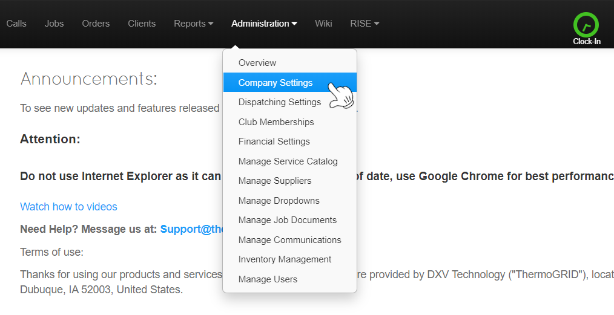
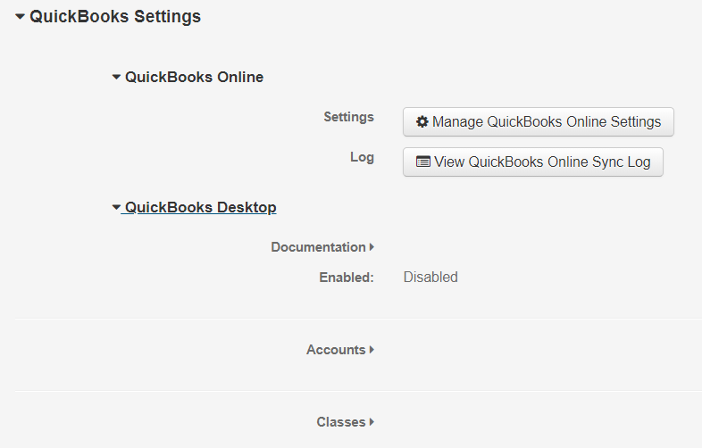

To enable Either, Click on Manage QBO Settings or the EDIT in Top Right corner to Enable

QB Tutorials: https://quickbooks.intuit.com/tutorials/all-quickbooks-tutorials/

***Please Use the appropriate Document for Desktop or Online***

QuickBooks Desktop
QuickBooks Desktop – Getting Started

Supported versions for the Sync from ThermoGRID to QuickBooks Desktop are:
- QuickBooks Enterprise Solutions
- QuickBooks Premier (2002 or later)
- QuickBooks Pro (2002 or later)
- QuickBooks Simple Start (2006 or later)
- QuickBooks Point of Sale (v.4.0 or later)
Any questions regarding this should be sent to support@thermogrid.com.

Web Connector - QBD
Installing the Intuit QuickBooks Desktop Web Connector is the first step

- If you currently have QuickBooks open and/or running, close it now.

- Go to the Intuit site by following this link:
https://developer.intuit.com/docs/0200_quickbooks_desktop/0100_essentials/quickbooks_web_connector

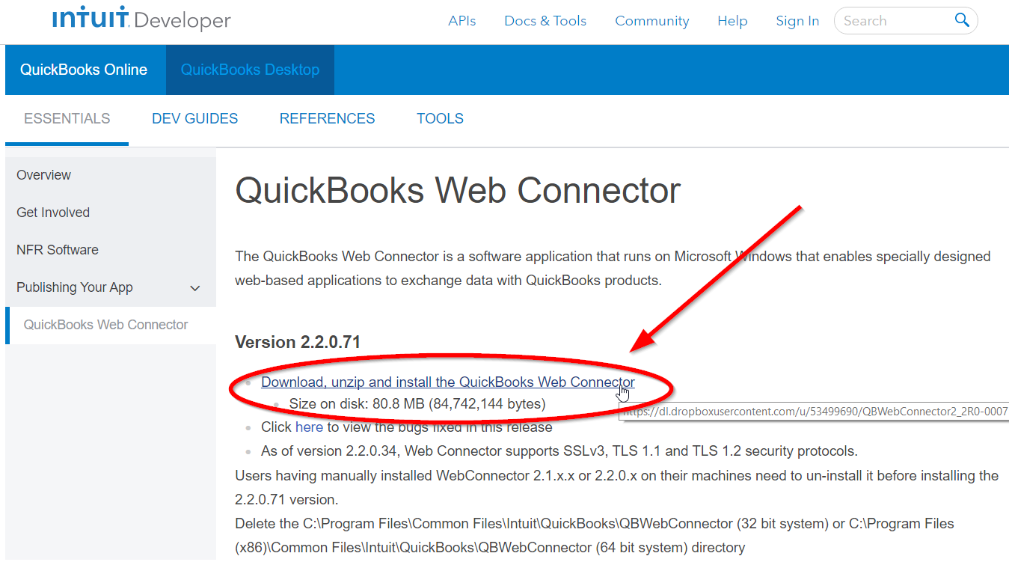
- Click on the “Download, unzip and install the QuickBooks Web Connector” link.
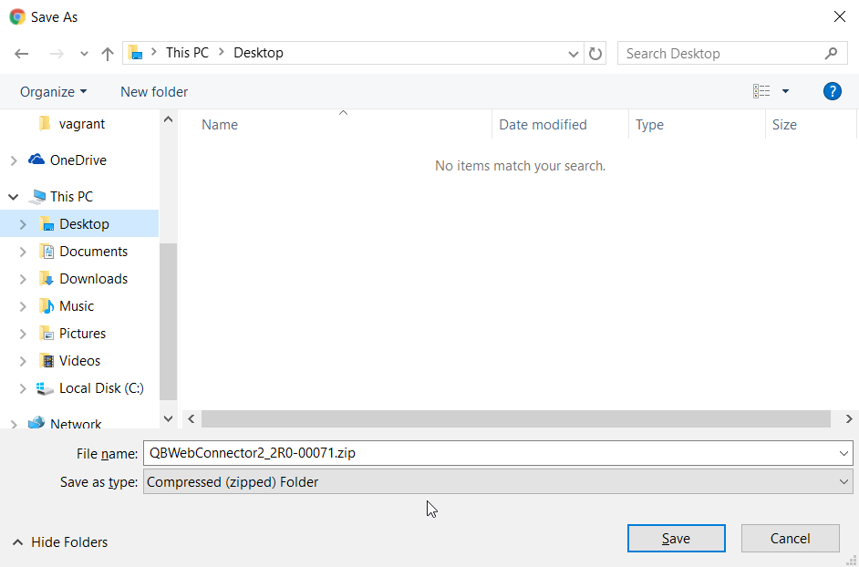
- Download the zip file to an easily accessible location like your desktop.

- Open the zip file and double click on QBWebConnectorInstaller.exe.
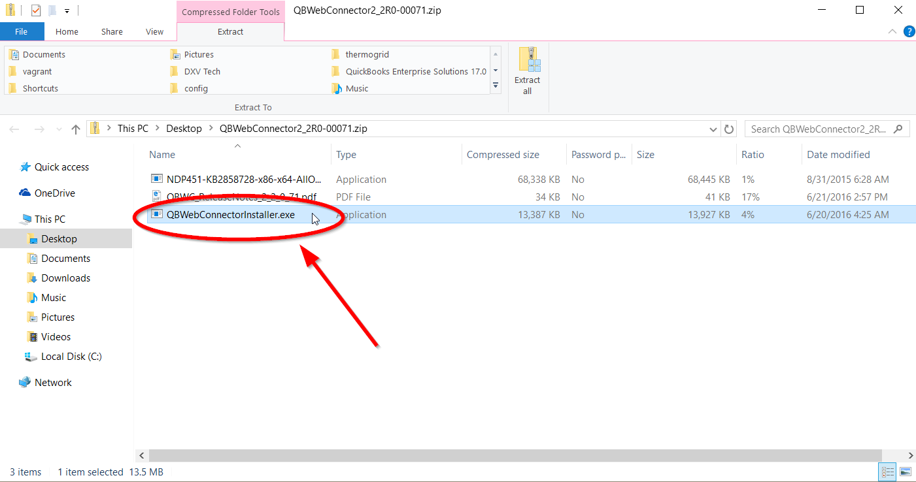

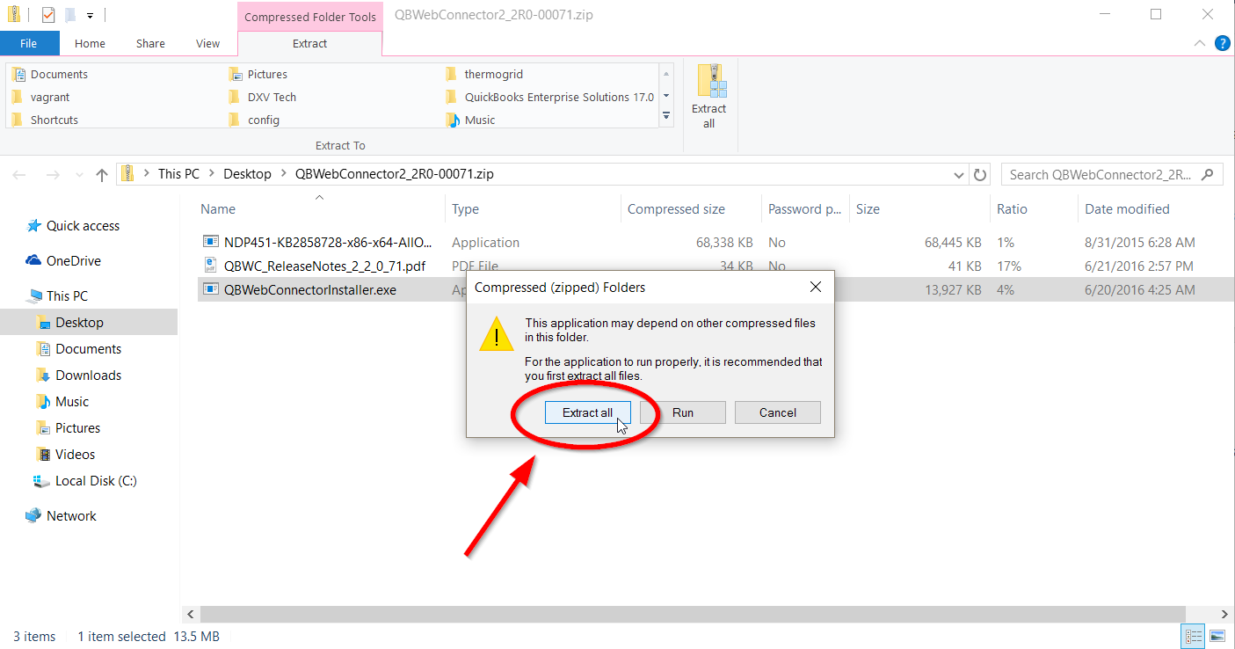
- If you get a pop up asking if you would like to extract files, click the “Extract all” button.

- Extract the files in an easily accessible location, like your desktop.

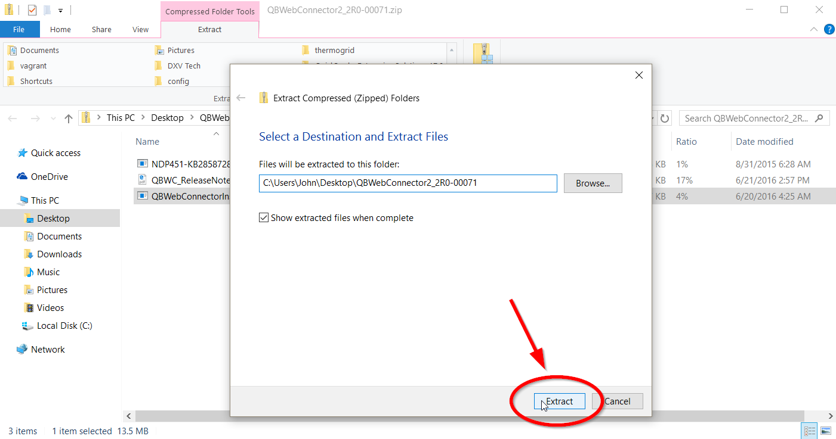

- Open the folder you just extracted. Then right click on the QBWebConnectorInstaller.exe and choose the “Run as administrator” option. If you get a pop up that asks if you want to allow the app to make changes on your computer, click “Yes”.
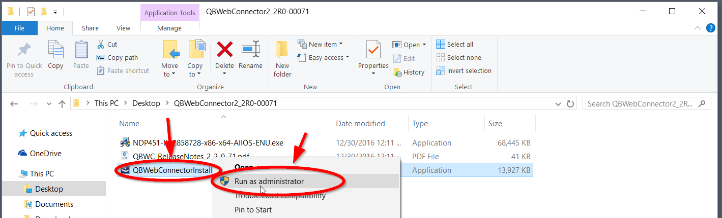

- Click “Next” on the first part of the install wizard.

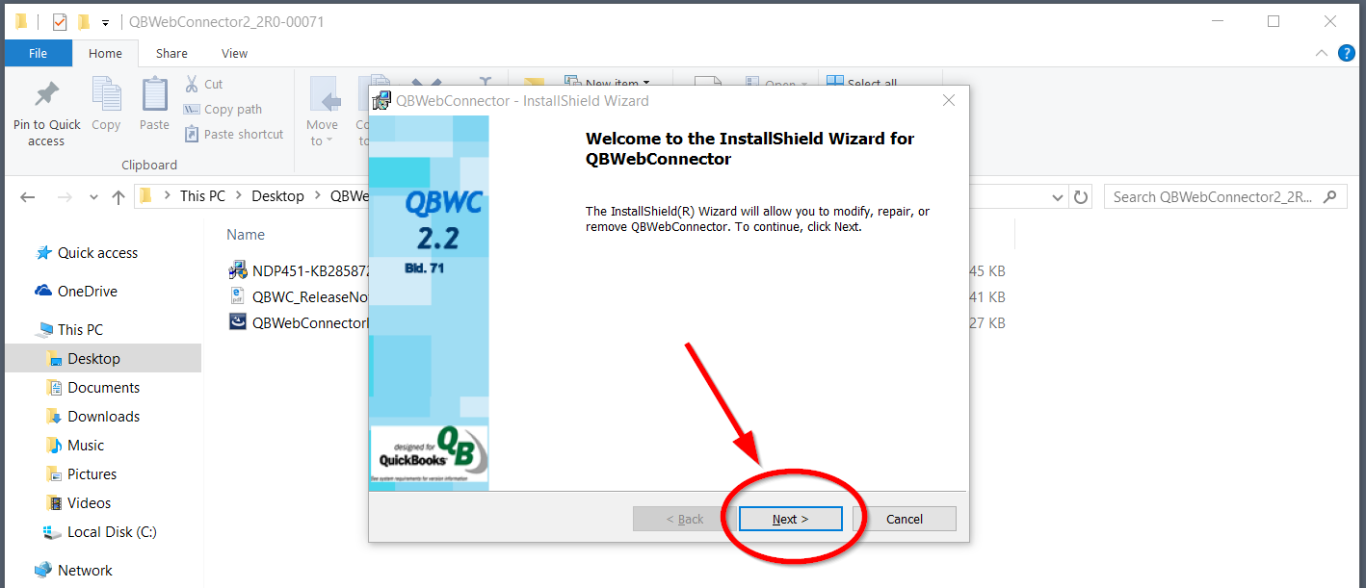
- After Reading, Select “I accept the terms in the license agreement” and click “Next”.
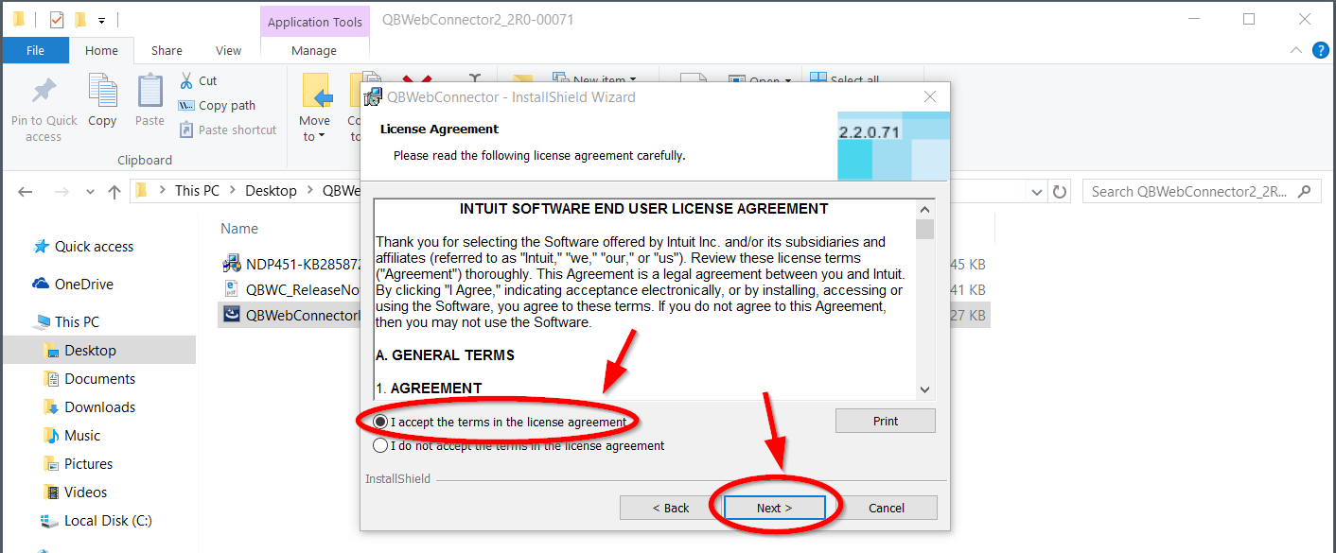

- Click the final “Install” button to begin the installation.

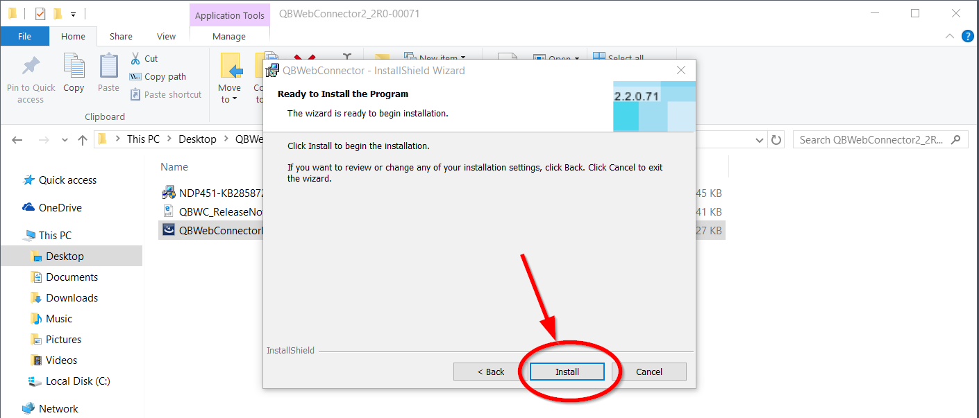
- Wait for the install to complete. You can follow the progress bar to monitor the installation.
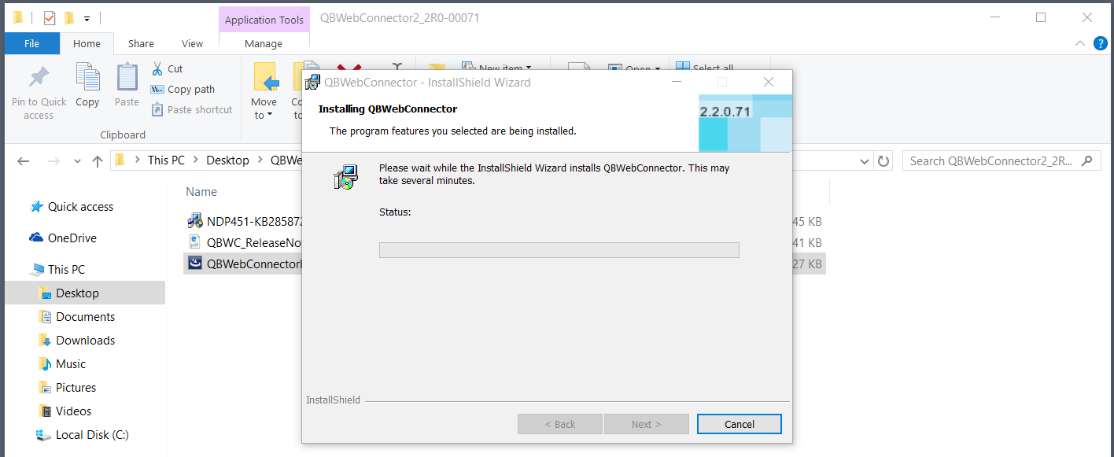
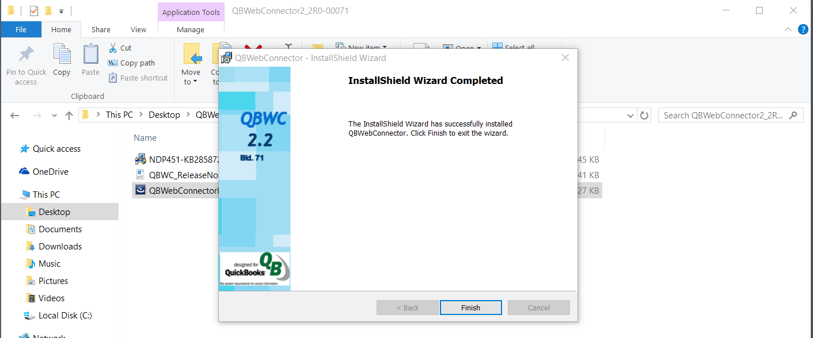
- Click “Finish” to close the installation wizard.

You are now finished with the installation of the Web Connector.

Next will integrate the Web Connecter with ThermoGRID
You will be enabling QBD, saving a sync password, and adding ThermoGRID to your Web Connector using a custom configuration file.

Any questions regarding this process should be sent to support@thermogrid.com.

Steps:

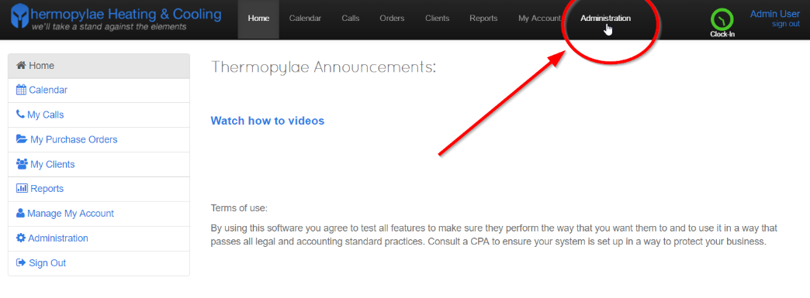
- Click on the Administration tab in ThermoGRID

- Click “Company Settings” in the Dropdown

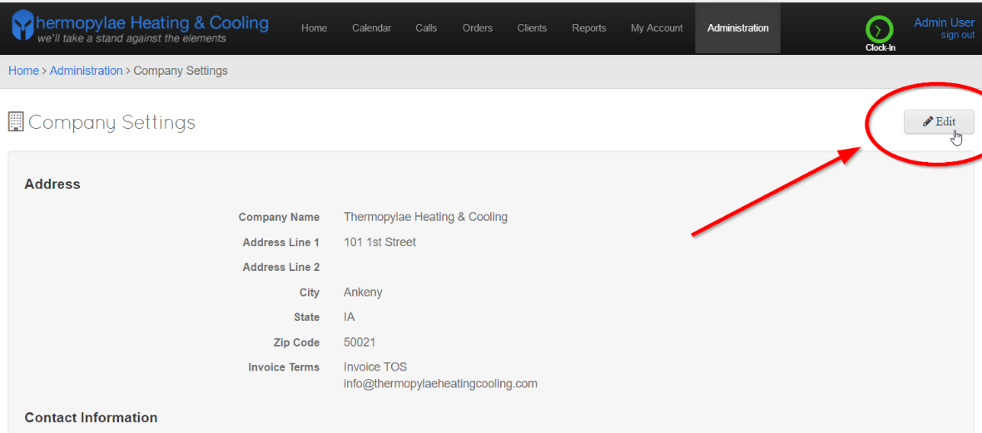
- Click Edit

- Scroll down until you see the “QuickBooks Desktop” section. Then check the “Enabled” checkbox.

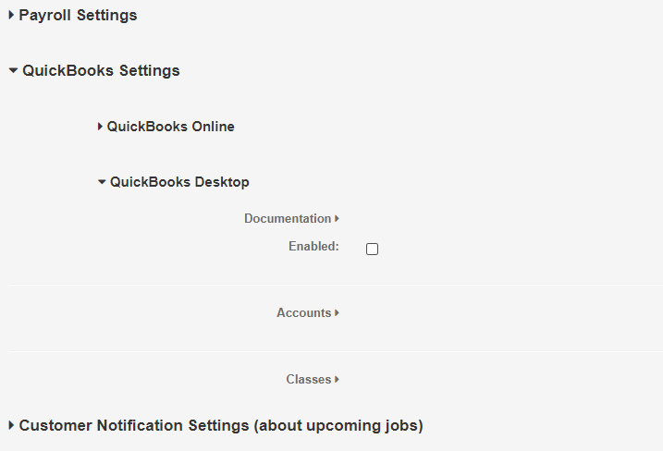

- The system will enable QuickBooks Desktop and provide you with a “Configuration File” link and a “Password”. Take note that the password will only be shown to you once so you’ll need to copy it for later where you will enter it into QuickBooks. The password will get saved so you won’t need it again after that. Highlight the password, right click, then select “Copy”.

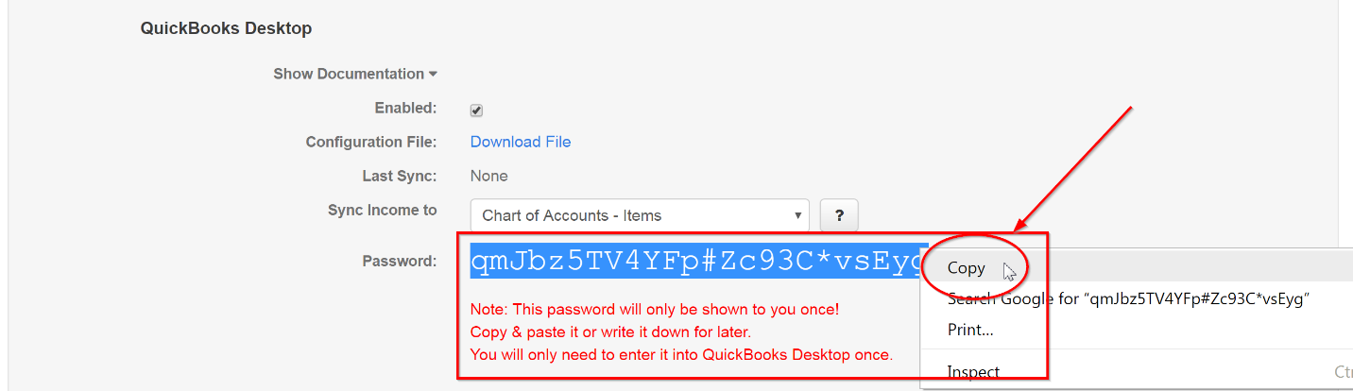

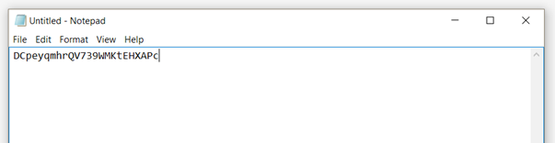
- Paste the Password in Word/Notepad or where ever you can recover it from

- Then click on the “Download File” link to download the customized configuration file.
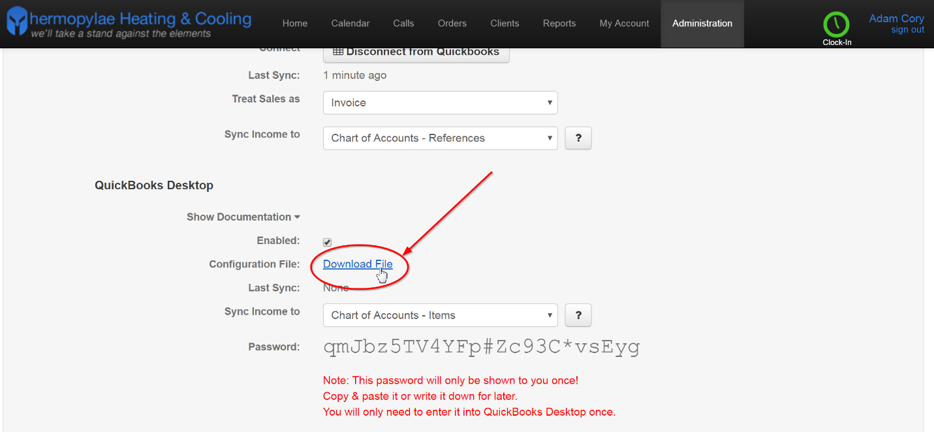
- Download the file in an easily accessible location, like your desktop.
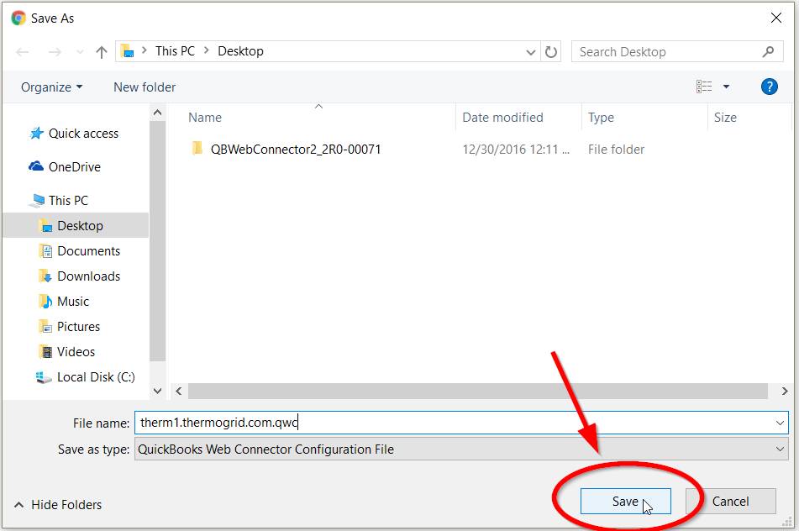

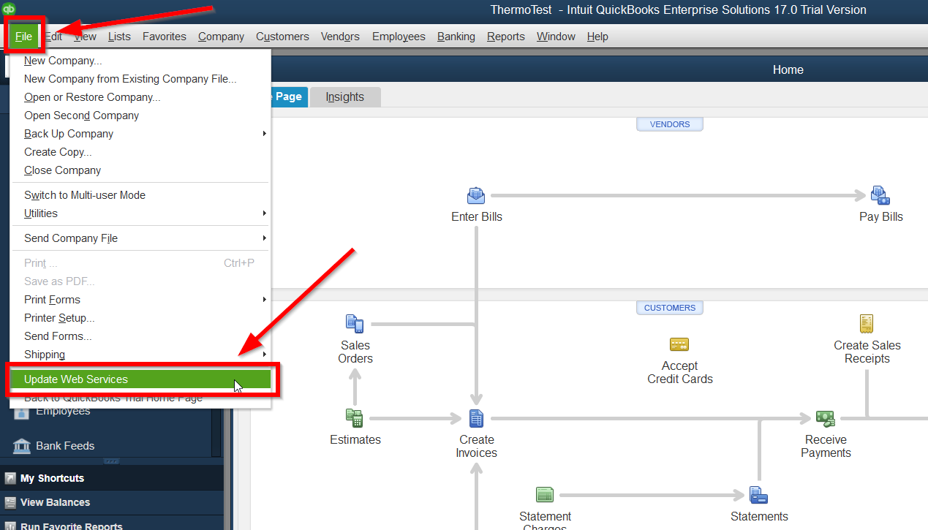
- Open QuickBooks Desktop and click on “File” in the header bar, then choose the “Update Web Services” option. This will open up the QuickBooks Web Connector.

- Click on “File” in the header bar, then choose the “Add an Application” option.

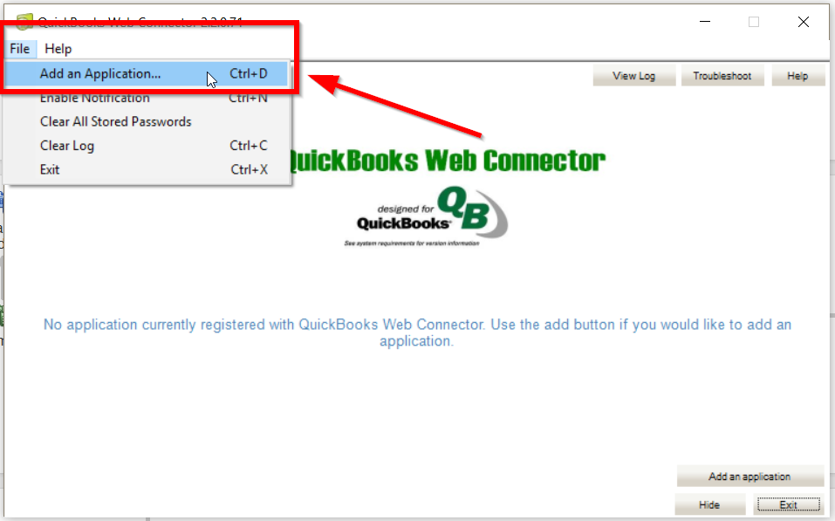

- Select the configuration file you downloaded then click the “Open” button. After this, you will get an Authorize New Web Service pop up window.
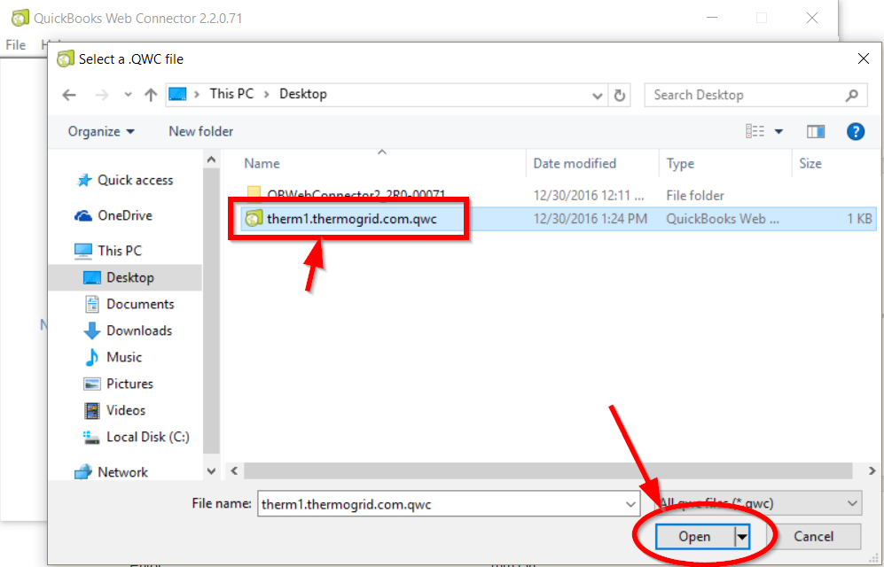
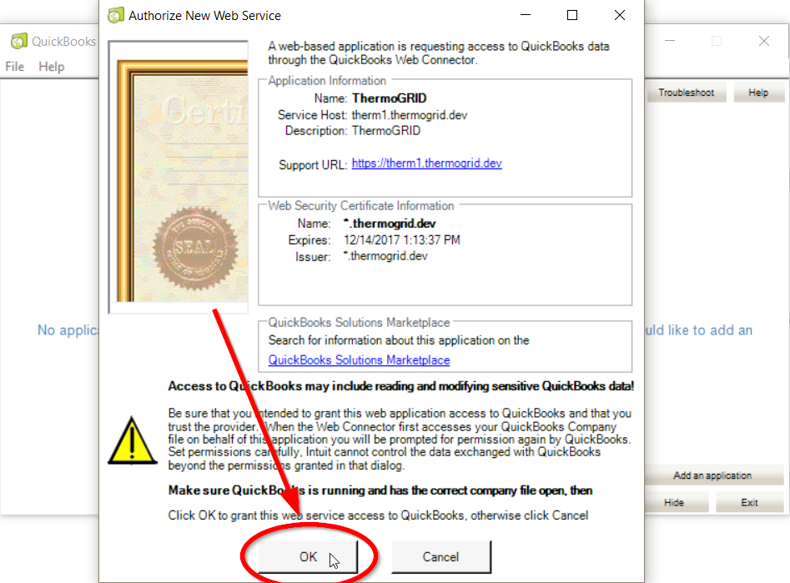
- Click “OK” on the Authorize New Web Service pop up. After this, you will get a Certificate pop up.

- Select the “Yes, whenever this QuickBooks company file is open” option, then click “Continue…”.
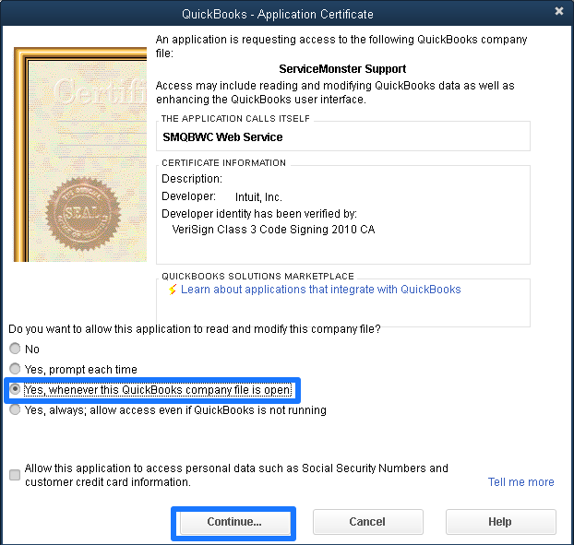

- After you add the ThermoGRID application enter or copy and paste the password you saved earlier (Ref Step 6) in the “Password” field. You should get a pop up asking if you want to save the password, select “Yes”.
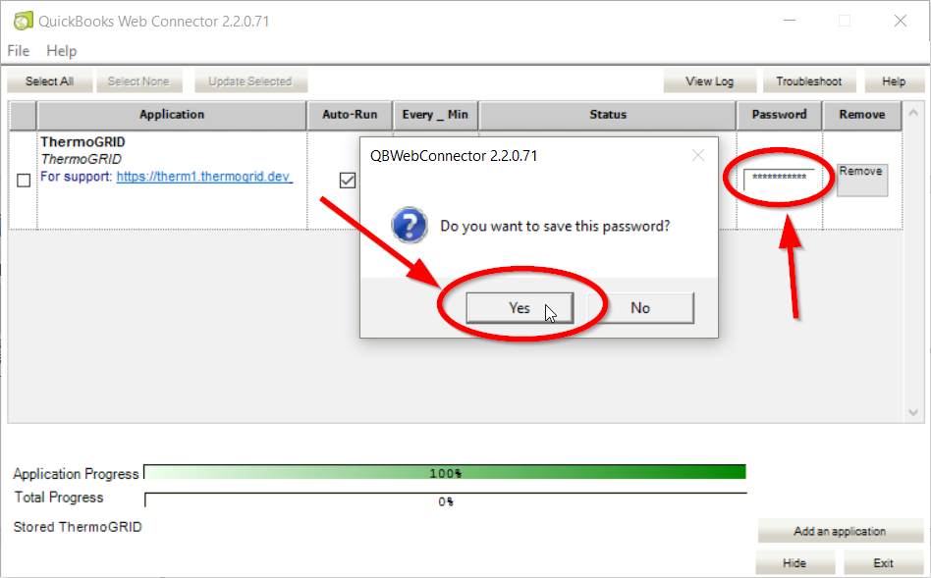
- You are now finished linking ThermoGRID to QuickBooks Desktop.

Syncing Configurations -QBD
We will now chose how data will sync with QuickBooks
From The Dropdowns Provided chose the appropriate syncing options for your company
An accountant may want to be present for this. !!DO NOT SYNC TO BANK!!
- Memberships
  - Don’t Sync Membership payments (This will not sync anything to QuickBooks, meaning you will need to setup a reoccurring invoice in QuickBooks as well as ThermoGRID.)
  - Invoice (This will sync an invoice to QuickBooks so you will need to click receive payment for all agreements invoices.)
  - Sales Receipt (This option is by far the easiest way to manage agreements. When you set up your Service Agreement you have the credit card in for the client and once the credit card payment clears it will transfer to QuickBooks as paid. )
- Invoice Payments
  - Don’t Sync Invoice payments (This means even if there was a down payment on the order estimate page or it was paid in full it will still transfer as an invoice with no payments or not paid so someone will need to receive payment in QuickBooks to clear it from AR. This can provide an extra level of security and checks and balances for larger companies.)

  - Enabled (This means if a client made a down payment of $2,000 on a $10,000 sales the $2000 payment will automatically transfer to QuickBooks. Or if the client paid in full it will transfer through as paid in full.)
- Sync Income to
  - Chart of account – Items
  - Chart of account – References
Chart of Accounts - Items
Orders are synced using Service Catalog Items from ThermoGRID that are added to the Products and Services area in QuickBooks and link to specific Accounts from the Chart of Accounts.
Chart of Accounts - References
Orders are synced using direct references in the Products and Services area in QuickBooks that match specific Accounts/Sub-Accounts from the Chart of Accounts.
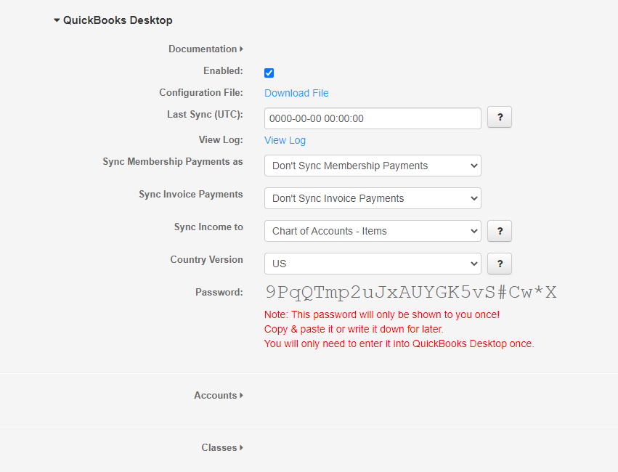
Chose the Accounts you would like Catalog Items to Sync to by typing them in under Accounts.
Match the accounts/Classes with the Same name in QBD
The “Plus/Addition Sign” to add a new Account and the “Trashcan” Will remove it.
These are the Accounts ThermoGRID will Sync with in QBD but Classes DO NOT NEED to be used. (If Classes will be utilized please follow next Section)
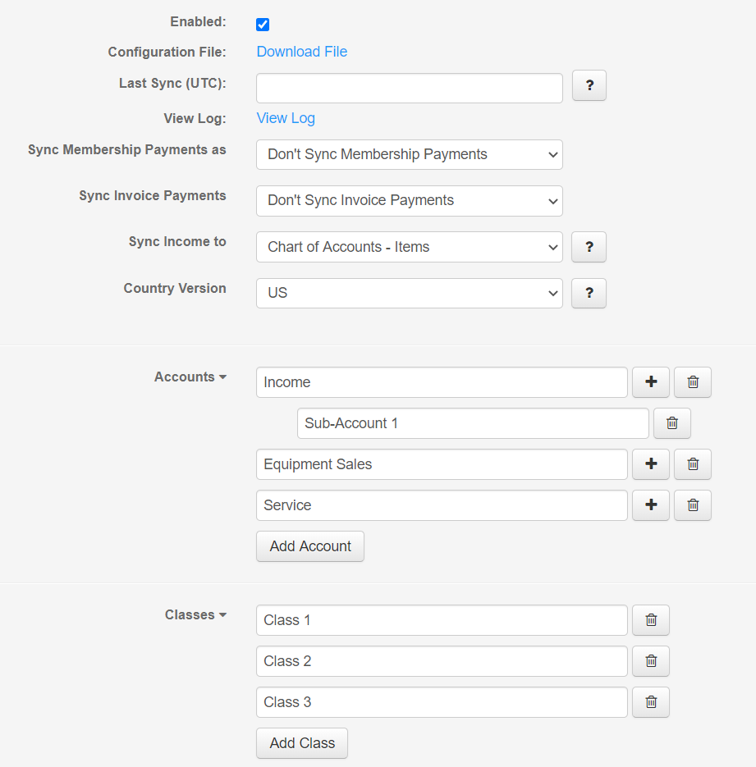

Class Tracking - QBD
This document covers setting up and configuring the Class Tracking feature in QuickBooks Desktop with ThermoGRID. You’ll enable Class Tracking in QBD and add the classes in QBD and ThermoGRID. This document also goes over, how to select classes for order lines items and how to report on them.

Any questions regarding this process should be sent to support@thermogrid.com.

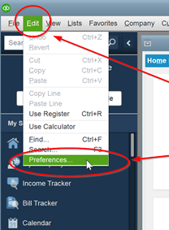
- Open up your QuickBooks Desktop installation and click on “Edit” in the menu bar, then click on the “Preferences” option in the drop down.

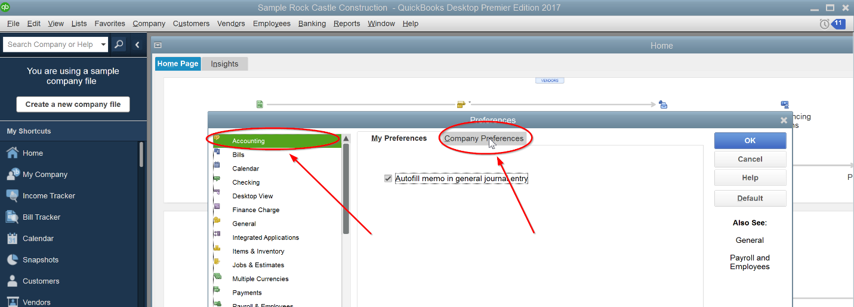
- On the Preferences pop-up, select the “Accounting” option in the list on the left, then click on the “Company Preferences” tab on the right.

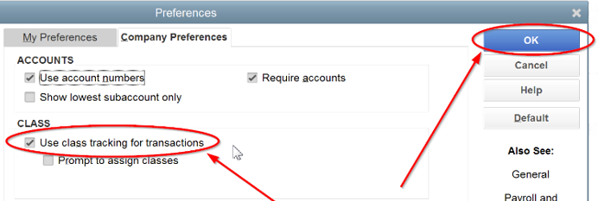
- Make sure that the “Use class tracking for transactions” checkbox is checked, then click OK.

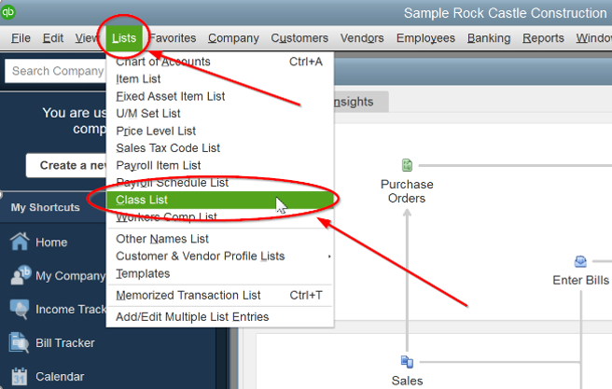
- Click on the “Lists” button in menu bar, then click on the “Class List” option in the drop down.

- On the Class List pop-up, click on the “Class” drop down button, then select the “New” option.
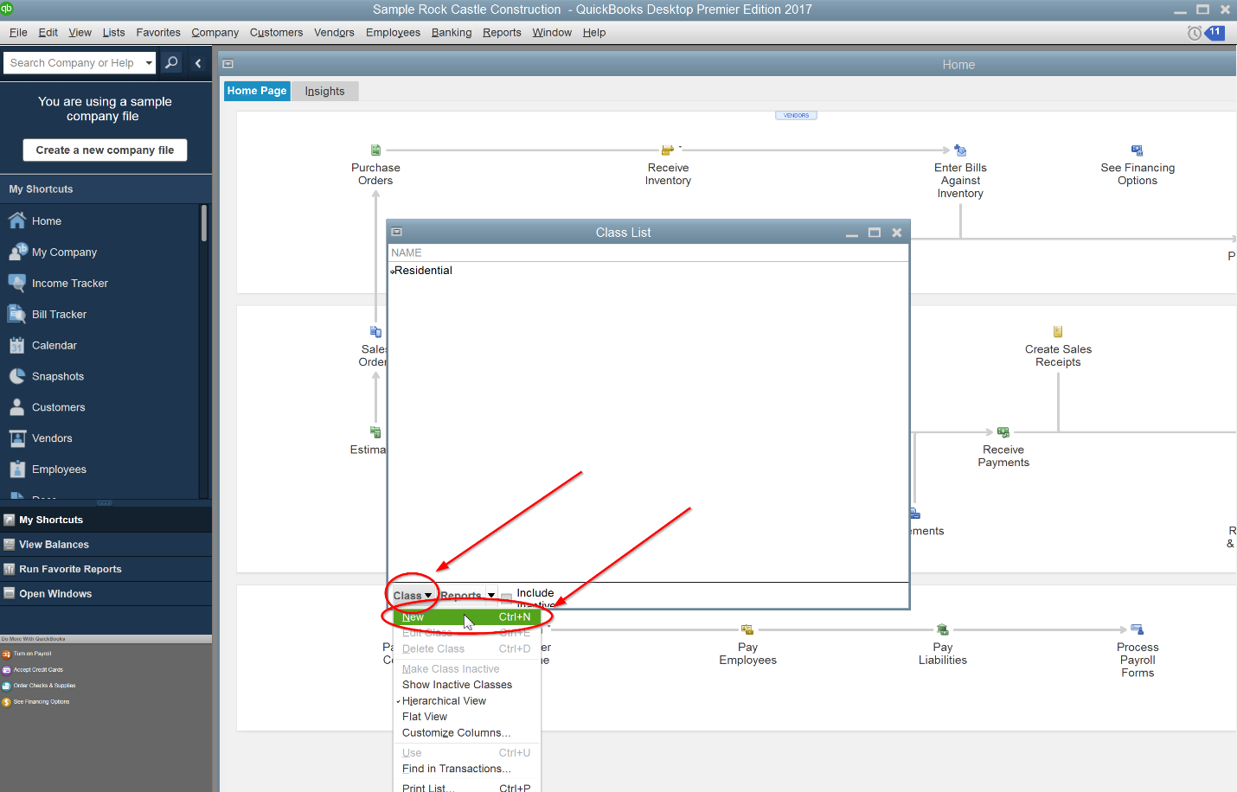

- On the New Class pop-up, enter the name of the Class you need. In this example, we used “Commercial”. Click the OK button when done. Repeat this step for all of the Classes you need.
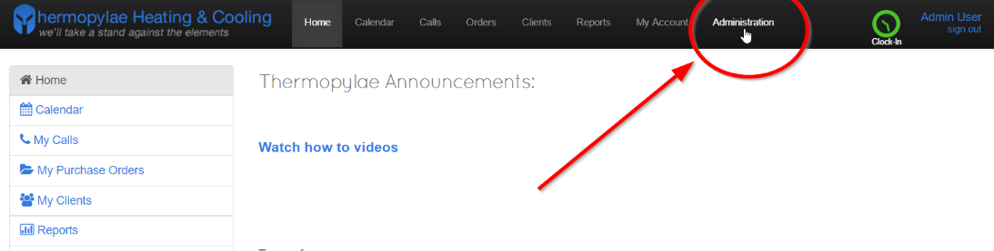
- Sign into ThermoGRID using your administrator account. Then click on the Administration tab.

- Click on the “Company Settings” button
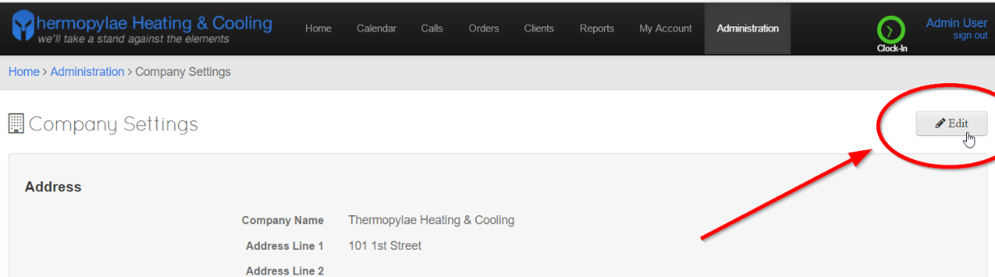
- Click the “Edit” button so you can modify the settings.

- Scroll down until you see the “QuickBooks Classes” settings under “QuickBooks Settings”.
Click on the drop down array to expand the section.
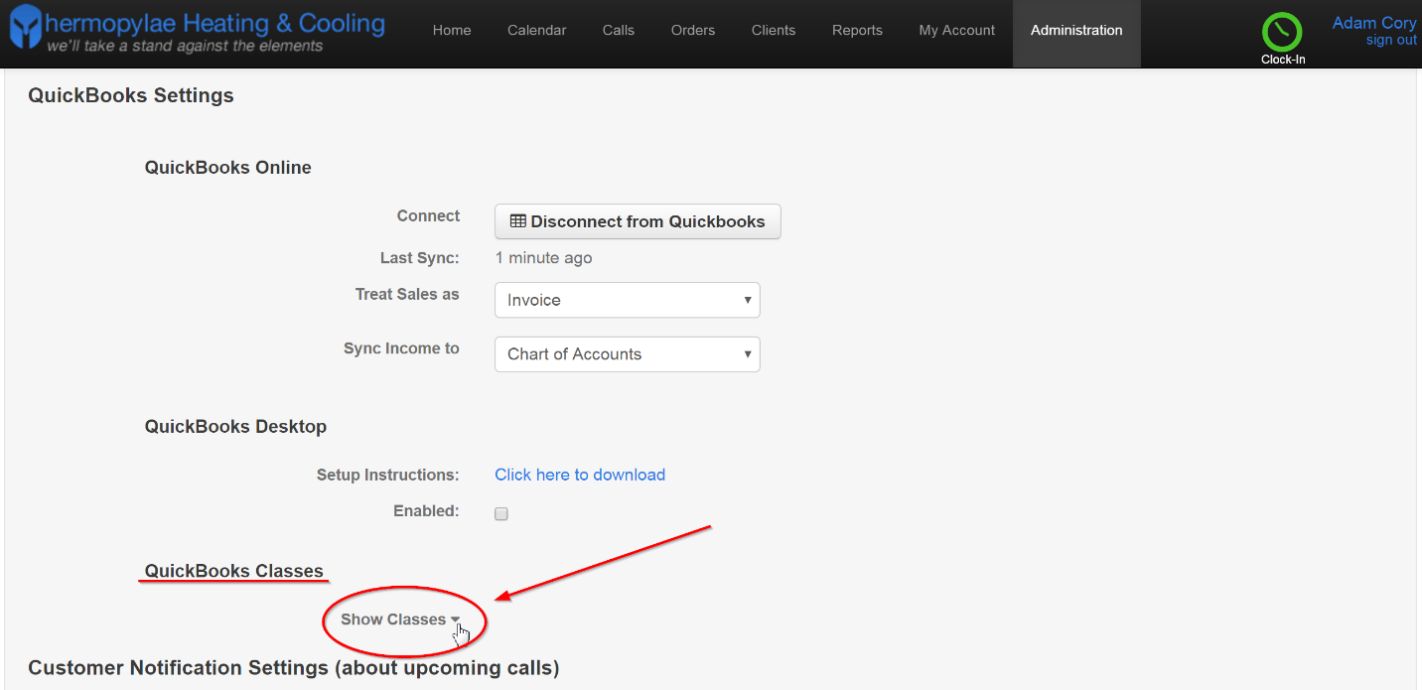
- Click on the “Add Class” button in the “QuickBooks Classes” section.
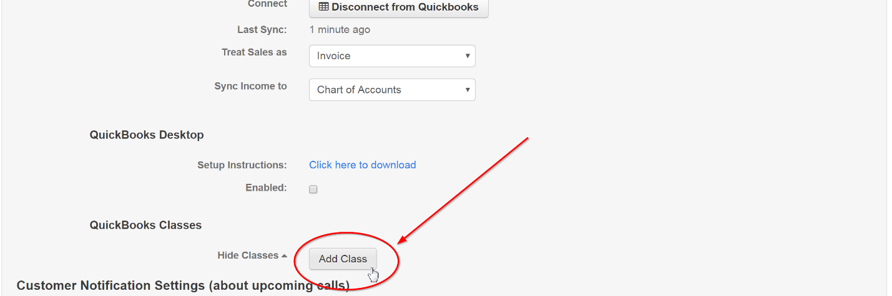
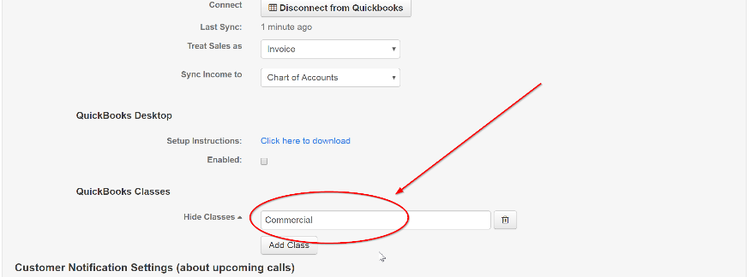
- Type in the name of your classes you want. All classes MUST match QuickBooks Desktop.
Repeat this step for every class you created in QuickBooks Desktop.

- Your QuickBooks Desktop Class Tracking setup is complete. To use the Class Tracking feature, you will need to select a class for each line item on an order when going through the Job Costing.

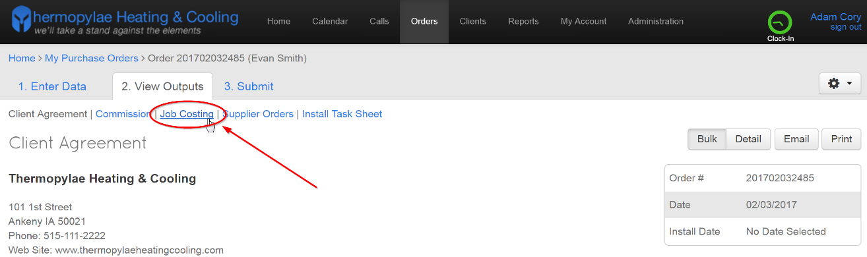
- To select Classes for an order, start by clicking on the “Job Costing” link after an order is submitted.

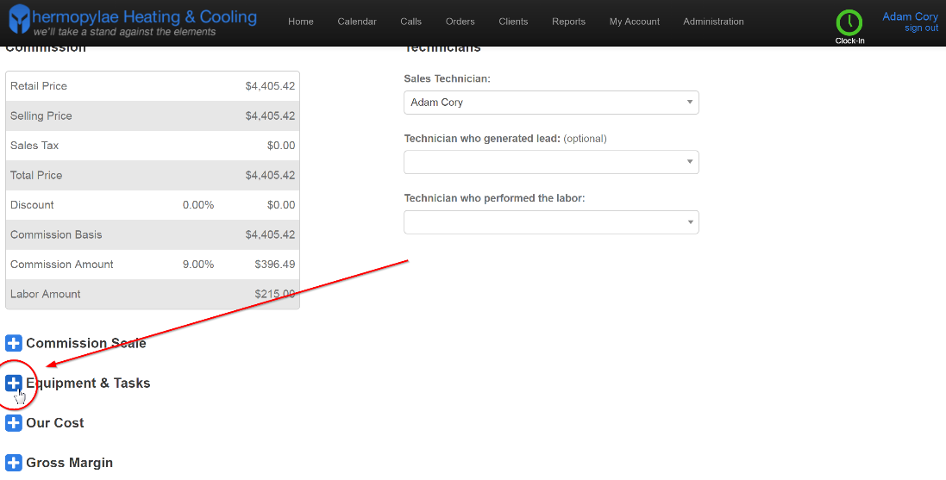
- Click on the Plus sign next to “Equipment & Tasks” to expand the section.
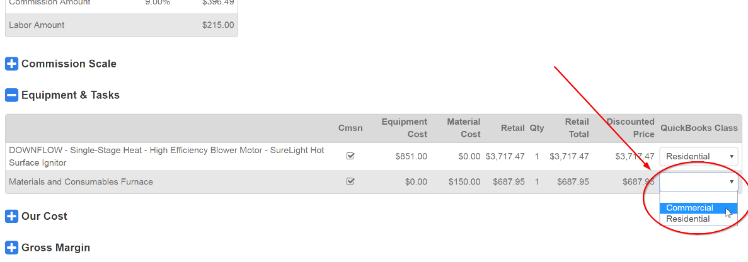
- For each line item on the order, select the Class from the drop down under the column on the right.

- After selecting the classes and job costing, submit the order by clicking the “Mark Complete” button.
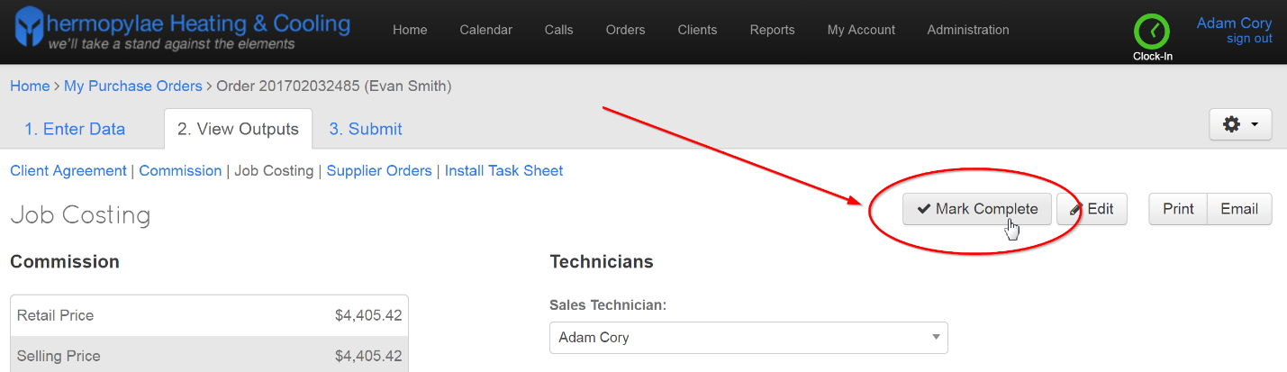
- After selecting the classes for the line items on an order and submitting it, you should be able to run reports in QuickBooks Desktop for those classes.

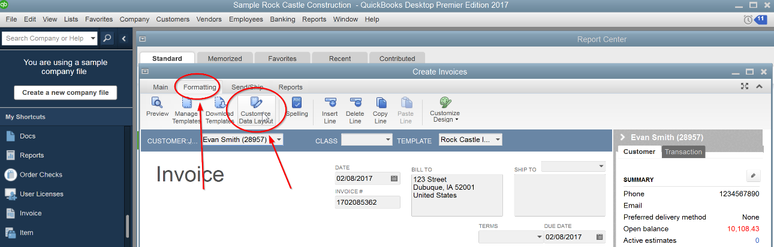
- To view the class on each line item from an invoice, first open up an invoice. Then click on the “Formatting” tab at the top and click on the “Customize Data Layout” button in the toolbar.

- On the Additional Customization pop-up check both “Class” checkboxes and click OK.
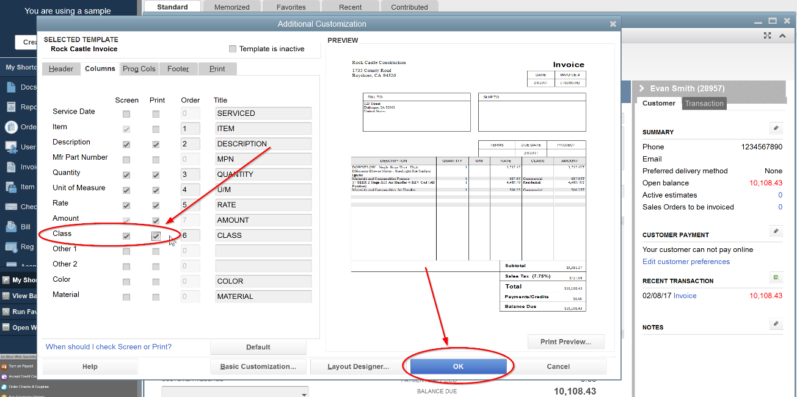

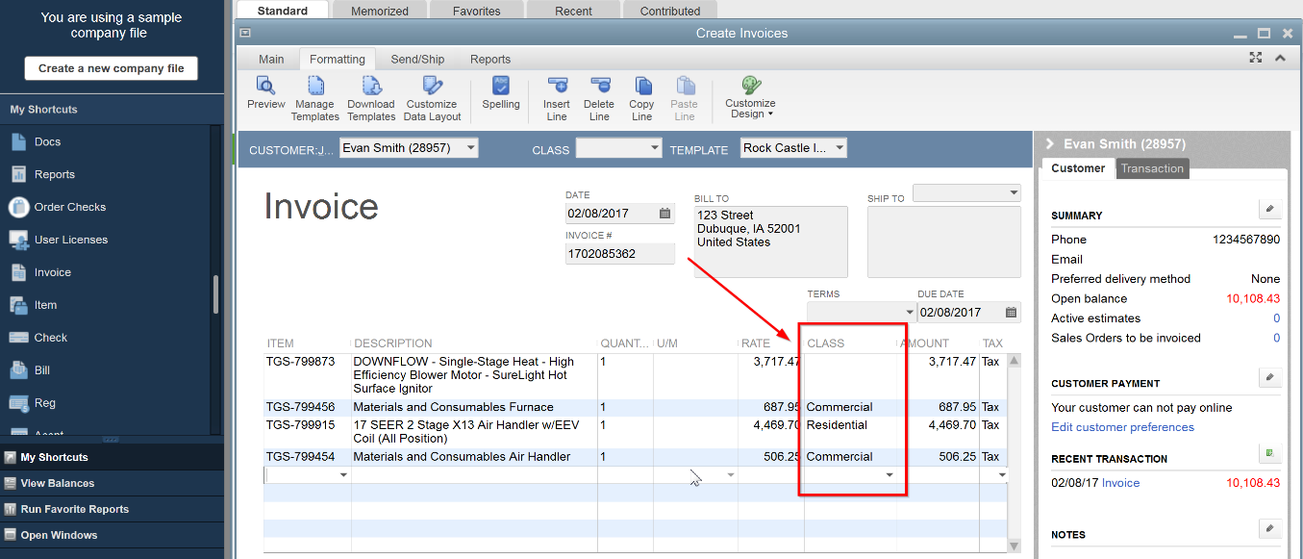
- Now, you’ll notice there is a Class column in the table when viewing an invoice.

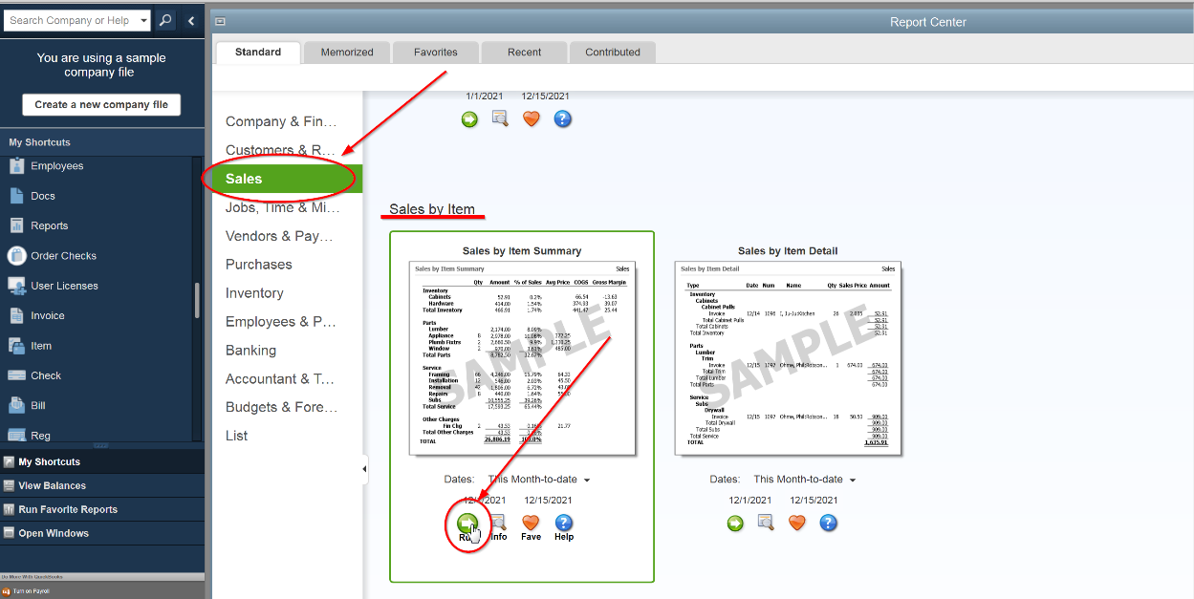
- To get a report on the income of specific Classes, one method is to use the “Sales by Item Summary” report. Open the reports window and click on the Sales Tab on the left. Scroll down until you see the Sales by Item support report, then click on the “Run” button.

- After opening up the report, click on the “Customize Report” button in the window’s toolbar
- On the Modify Report pop-up, open up the “Filters” tab, then select “Class” in the available filters on the left. Next, select which class you would like to report on in the “Class” drop down and click OK.
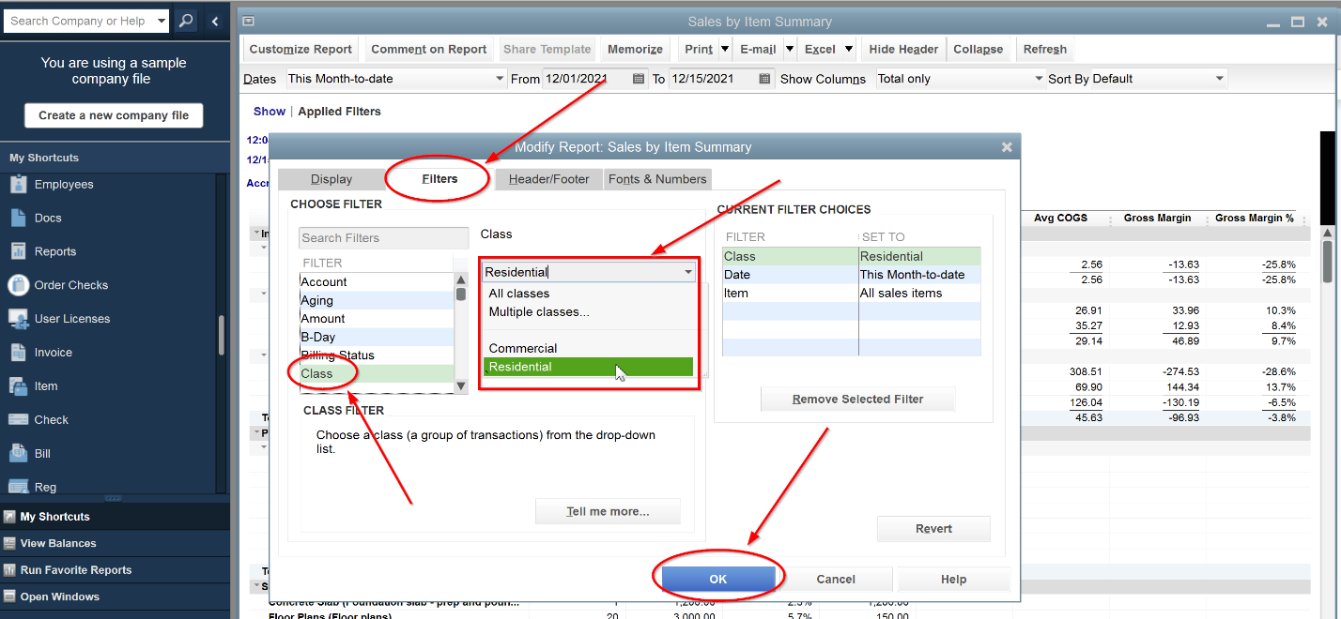
- Now, you’ll notice the report has been filtered. You can also add additional filters if needed.
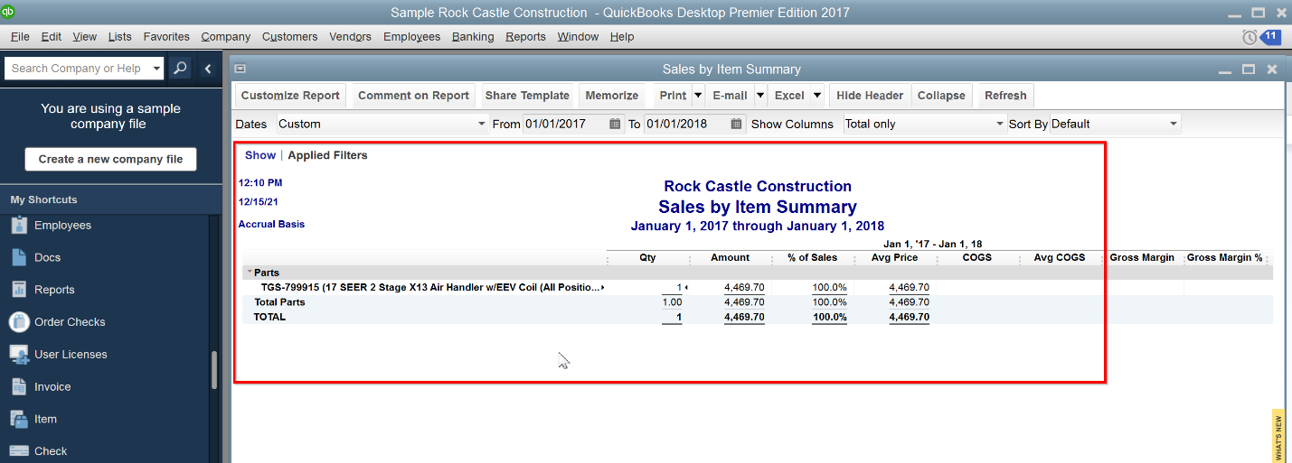

QB Sync Order Paid Status

QBO and QBD Sync Process
- When orders are paid in full in QuickBooks, ThermoGRID will automatically pull in the order status and mark them as paid.
- This can happen after ThermoGRID syncs payments to an order, or after you add payments manually.
- If you were previously doing this manually, you no longer need to do so.
- Orders are considered paid in full when the amount due of an order is 0.
- For QBO, order paid status is updated on a nightly job.
- For QBD, order paid status is updated during every sync.

