- Definitions
- Setup the DMR
  - Categories
  - Departments
  - Types
  - Recommendations for KPI Types
    - Sales
    - Service
    - Installation
    - Call Center
  - Tech Levels
- Reading the DMR Summary
- How the DMR works
- Company Goals & Standards
  - Sales
  - Service
  - Installation
  - Call Center
- FAQ

Definitions 1.

General terms

Job: Jobs are what is dispatched to technicians and sales reps that you see on the calendar.

Order: This is what is created to access the Service Catalog (price book) to create estimates and invoice for your clients.

Working Days: This is the total number of days in a month minus weekends and holidays.

Budget: How much revenue you plan to bring in each month. If you don’t have a budget use $750-$900 per employee per day. Example 20 employees, 21 working days, use $800. $800x21x20=$336,000 budget.

Category: If you have different categories you will have a separate DMR report. They each would have their own summary. (Examples: HVAC, Plumbing, Electrical, Garage Door, Etc.)

Department: These are the sections or departments within a category. (Examples: Sales, Service, Installation, Call Center)

Type: This is the type of KPI you want to track. (Examples: Repair Avg Ticket, Replacement Closing Ratio, PM or Club Conversion, Etc.)

Average ticket: This is the total revenue divided by the number of jobs sold (submitted orders).

Closing Ratio: This is the total number of jobs sold (submitted orders) divided by the total opportunities (Jobs dispatched).

Conversion Ratio: This is similar to a closing ratio. Number sold (submitted orders) divided by number of opportunities (Jobs Dispatched).

Generated: This is a good KPI to track in HVAC, Plumbing, and businesses the track equipment age and replacements. This means out of all the opportunities (example: Jobs dispatched 12+ in age) how many generated a sales lead (Setup a sales appointment for replacement).

Fixed Call Number: this means the goal is a certain number of calls.

Fixed Sales Number: This is a set number of sales.

Percent of calls: This will add a column to show you what percent of all calls this type of goal is.

Total Revenue: This means you can set the revenue as the goal. Example installer $125,000 in revenue.

Dollars/Lead: The total revenue divided by the total number of opportunities (Jobs Dispatched).

Information for setting up a department

Name: Name of the department. It is important to know that TG does a fuzzy search. This means any primary job type name, that has the name of your department in it will auto match them when you create a job. Meaning: department on the DMR “Service” and primary job type on the dispatch board “Service Maintenance” or “Service repair” having the department name in the job type will auto match.

Avg $ per Call: This number will be to be used on the summary page to calculate how many calls you need to hit your budget. Usually this is a worst-case scenario number to ensure you run enough appointments.

User Roles: Any user with a role that matches this role will show up in this department in the DMR.

Track Sales: If you have track sales set to Y, then it adds a column in the summary to show how many are sold (orders submitted). This will also insert a closing ratio.

Opportunity Label: Recommend “Jobs Dispatched” so you see on the DMR this Label and know exactly what is showing up.

Dollars/Lead Label: $/Lead. This means if you sell $40,000 in revenue and you had 10 total leads, you are at $4000/lead. It is a combination of average ticket and closing ratio.

Show Get back on Track: This will take your goal and actual KPI to calc how to get back on track for the next appointment or next 2 appointments, or next 3 appointments.

Include in Sales Conversion Percentage:

Revenue Percentage: This means how much of your total revenue is from this department. Example: Install 80% Service 20%.

Goal $ per Call: This is goal for how much you should bring in for revenue for all appointments ran.

Applies to Budget: This means any revenue from this budget will go towards achieving the total budget. Sales should not, service and install should. If you had sales go towards the budget as well as installation you would be duplicating your revenue. Also, if it sells this month and won’t be installed for a couple months it wouldn’t make sense to take the revenue now as it could cancel.

Track Calls Backs: If you select this, there will be an area you can type in call backs for each person. Call backs could be set up as a type instead of using this field.

Sales Label: This allows you to change the name on the summary of a department. This represents orders submitted or sales.

Sold Label: This allows you to change the name of appointments sold. Recommendation would be Submitted Orders.

Auto Summarize (department): This feature will make the summary where it cannot be edited and will add up all the types below that are not excluded from the summary.

Setting up the DMR (Back to the Top)

The most import part about reporting is understanding “garbage in, garbage out”. This means you need to make this simple for your reps to know what needs to be checked and what doesn’t. The more KPIs you put in the harder it will be for your reps to remember when to select each type. Our system defaults to the recommended setup but it is okay to start even more simplistic.

There are four areas to consider when setting up the DMR.

- Categories (Examples: HVAC, Plumbing, Electrical, Garage Door, Etc.)
- Departments (Examples: Sales, Service, Installation, Call Center, Etc.)
- Types (Examples: Repair Avg Ticket, Replacement Closing Ratio, Etc.)
- Tech Levels (Examples: Senior Tech KPIs, Greenhorn KPIs)

Categories (Back to the Top)
(Examples: HVAC, Plumbing, Electrical, Garage Door, Etc.)
- Add/Edit/Remove
Reports>Daily Management Report>Settings>click on the category

Typically, there are different categories for verticals such as Examples: HVAC, Plumbing, Electrical, Garage Door, Etc. Because there are separate budgets for each department. If you have areas that do not have separate budgets and you want to keep it all together that is fine, you could just differentiate by naming types by categories.

When adding a category simply click Add Category.

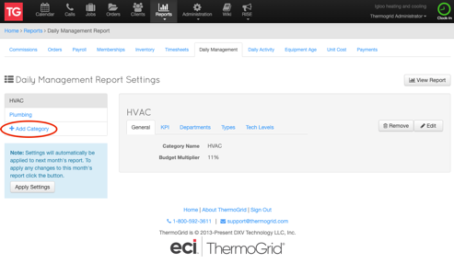
When editing or removing a category simply click edit or remove.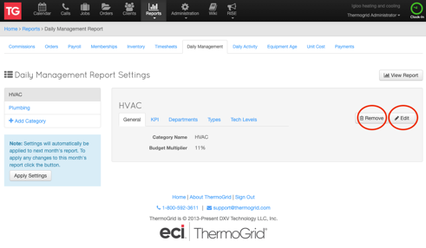

Departments (Back to the Top)
(Examples: Sales, Service, Installation, Call Center, Etc.)
- Add/Edit/Remove
Reports>Daily Management Report>Settings>Click on the Category>Department>Edit

When adding a department click +Add Department in the bottom right. If you do not see this button you need to click edit in the top right first.

Now you can enter the information to the department.

Name: Name of the department. It is important to know that TG does a fuzzy search. This means any primary job type name, that has the name of your department in it will auto match them when you create a job. Meaning: department on the DMR “Service” and primary job type on the dispatch board “Service Maintenance” or “Service repair” having the department name in the job type will auto match.

Avg $ per Call: This number will be to be used on the summary page to calculate how many calls you need to hit your budget. Usually this is a worst-case scenario number to ensure you run enough appointments.

User Roles: Any user with a role that matches this role will show up in this department in the DMR.

Track Sales: If you have track sales set to Y, then it adds a column in the summary to show how many are sold (orders submitted). This will also insert a closing ratio.

Opportunity Label: Recommend “Jobs Dispatched” so you see on the DMR this Label and know exactly what is showing up.

Dollars/Lead Label: $/Lead. This means if you sell $40,000 in revenue and you had 10 total leads, you are at $4000/lead. It is a combination of average ticket and closing ratio.

Show Get back on Track: This will take your goal and actual KPI to calc how to get back on track for the next appointment or next 2 appointments, or next 3 appointments.

Include in Sales Conversion Percentage:

Revenue Percentage: This means how much of your total revenue is from this department. Example: Install 80% Service 20%.

Goal $ per Call: This is goal for how much you should bring in for revenue for all appointments ran.

Applies to Budget: This means any revenue from this budget will go towards achieving the total budget. Sales should not, service and install should. If you had sales go towards the budget as well as installation you would be duplicating your revenue. Also, if it sells this month and won’t be installed for a couple months it wouldn’t make sense to take the revenue now as it could cancel.

Track Calls Backs: If you select this, there will be an area you can type in call backs for each person. Call backs could be set up as a type instead of using this field.

Sales Label: This allows you to change the name on the summary of a department. This represents orders submitted or sales.

Sold Label: This allows you to change the name of appointments sold. Recommendation would be Submitted Orders.

Auto Summarize (department): This feature will make the summary where it cannot be edited and will add up all the types below that are not excluded from the summary.

Types (Back to the Top)

This is used for the type of KPI you wish to track. You are able to add as many KPIs to a department as you wish however, we recommend 4 or less for each department. The default is specifically designed to cause massive success and we can teach you how to understand those KPIs.

Reports>Daily Management Report>Settings>Click on the Category>Types>Edit

+Add Type Goal and choose the department for the goal.

Recommendations for KPIs (Back to the Top)

Sales Department (Back to the Top)
We have a couple variations on what KPIs to track in the sales department.

Option 1 Types:
- Replacement
- IAQ
It is good to know the difference between replacement sales leads and IAQ leads because there is a big difference in the average ticket for each. If your dollars per lead was down overall but individually it was good for replacement, you know it’s a shortage of replacement leads that needs to be resolved.

Option 2 Types:
- Replacement Tech
- Replacement Marketed
- IAQ Tech
- IAQ Marketed
With this option you get to see the difference in Replacement and IAQ again, but you also can see the difference in tech leads vs marketed leads. The benefit in knowing this is because there can be a difference between those two on the closing ratio. National closing ratio for marketed leads is less than 30% and tech leads on average it over 70%. RISE coaching can help bring both of these closing ratios up significantly. Learn More

Service Department (Back to the Top)
We have one recommendation on what KPIs to track in the service department.

Option 1 Types:
- Club Conversion
- 12+ Conversion
- Repair Average Ticket
- Maintenance Average Ticket

Installation Department (Back to the Top)
We have a couple variations on what KPIs to track in the Installation department.

Option 1 Type:
- Install

Option 2 Types:
- Replacement
- IAQ

Call Center Department (Back to the Top)
We have a couple variations on what KPIs to track in the Call Center department.

Option 1 Types:
- Inbound Sales
- Inbound Service
- Club Sales

Option 1 Types: (Here we break our rule for have 4 or less types)
- Inbound Sales
- Inbound Service
- Outbound Sales
- Outbound Service
- Club Sales

Tech Levels (Back to the Top)

This allows each person to have their own goals. The DMR default is for 8 levels, the higher the level is, the higher the expected performance will be.

Each department and type of KPI you created will show up in each level. All you need to do is put in the minimum expectations for each type at each level as well as a goal.

If anyone falls below their minimum for their level the numbers will turn red. If they are higher than their minimum and below their goal, they will have yellow numbers. If the individual achieves higher than their goal for their level, their numbers will turn green.

Each employee should only be in 1 level at a time. Usually when an employee can move up a level after achieving success for 2 months in a row (green). In our RISE program we teach how to use the DMR for pay raises as well as performance reviews. Learn More

Reading the DMR Summary (Back to the Top)

Dashboard

Working Days: Make sure weekends and holidays are not selected.

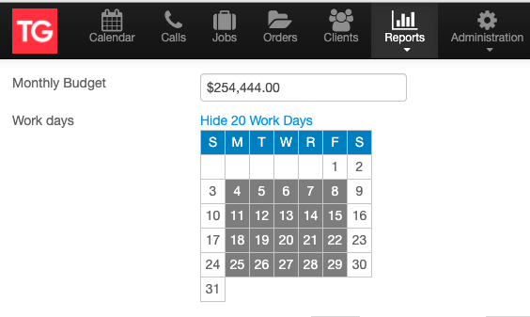

Budget: Revenue column is based on the monthly budget you typed in for this month as well as the percent of totals you put in setting up each department.
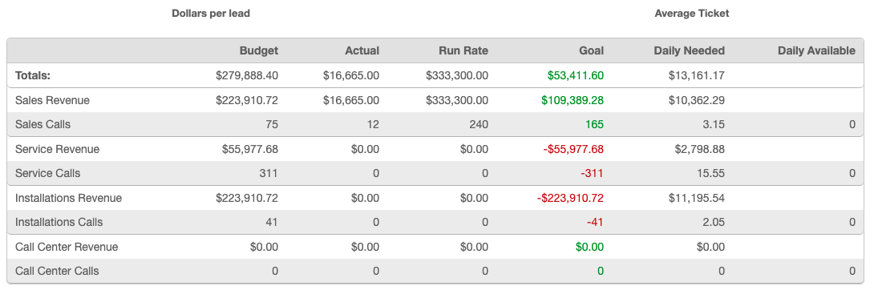

Actual: Column shows the actual revenue being accounted for in each department. The revenue comes from jobs scheduled for this month and orders submitted. See How the DMR works for more info.

If sales revenue is high and install revenue is low, you know you have some installs you may be able to move up to get that revenue in now.

Run Rate: This means based on how many working days that are left and how much revenue came in already what you are project to achieve at the end of the month.

Goal: This shows you much you are projected to be above or below goal. Red is behind goal and green is ahead of goal.

Daily Needed: Tells you how much revenue or appointments you need per day for the rest of the month to achieve your budget.

Indicator: This will tell you if you have a marketing issue or a performance issue. This will multiply out the KPI expectations you setup and show you how much extra revenue you would have if you were achieving them. This will show you how much revenue you are missing, what your actual revenue would be to date, and what your run rate would be.

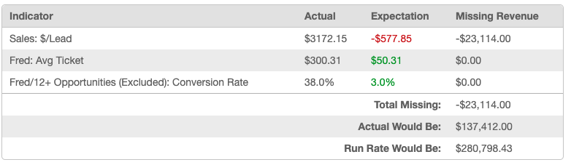

How the DMR works (Back to the Top)
- A technician must be a primary tech to receive credit for the KPIs.

- Job dispatched is an opportunity for the date the job is scheduled for.

- Order submitted is a sale and the revenue will follow the date the job is scheduled for.

- A job can have multiple types that are excluded from the summary. A job can only have one type selected the is NOT excluded from the summary. If you choose multiple types that are not excluded from the summary, you will double your opportunities and possibly revenue.

- Holding for parts – use the additional appointment feature on the dispatch screen if the same tech is going back. This will keep it as one job, so it doesn’t drop their average ticket. If it is a different technician going back to install the part, a new job should be added to the same call for that technician. If you do not want this to count against the second technicians’ average ticket, you need to have a job with a type created that is excluded from the summary.

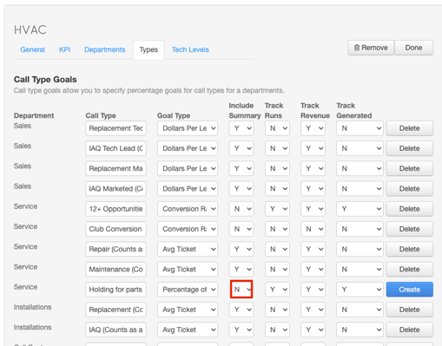

- If a tech is selling IAQ and installing it themselves, they can use the same order for the service work and IAQ, you do not need to select any additional types. If it starts as a repair job that is what gets credit. If the technician needs to go back to install the products use the additional appointment feature on the dispatch screen.

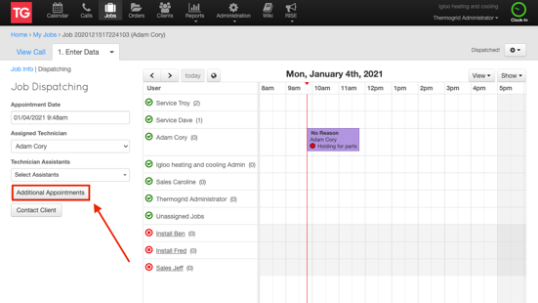

- If the tech is selling IAQ and not installing it – they will have an order for the service job they completed but you will need to add an additional job to the same call that is a sales job. They will create an additional order, but that order will need to tie to the sales job. All the IAQ products they are not installing will go on this order. Then you will create another job for install and assign that to whomever is installing the IAQ. This ensures that the tech gets credit for selling and the installer gets credit for installing it. This will also help prevent double counting revenue.

- As long as you create Call>Sales Job>Sales Order>Install Job you will never need to check the install box on the submit page. The only time you need to check the install box is when you have an install job on a call by itself and you create the order for sales afterwards. This is not the correct way of doing it because you won’t be tracking your sales numbers appropriately, but the option is there for unique situations.

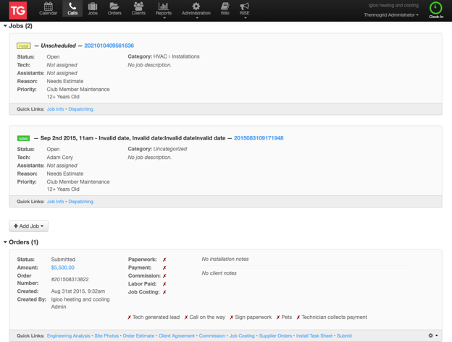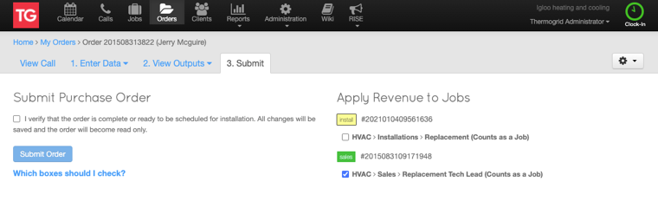

Dispatcher Selects these areas to create opportunities for the techs.

This illustrates how the areas of a job match up to the DMR.

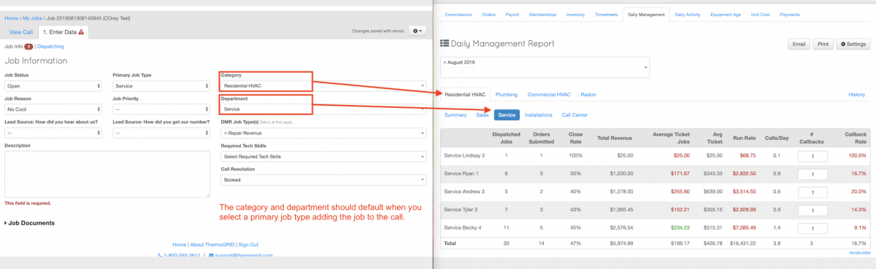

This illustrates how the areas of a job match up to the DMR.

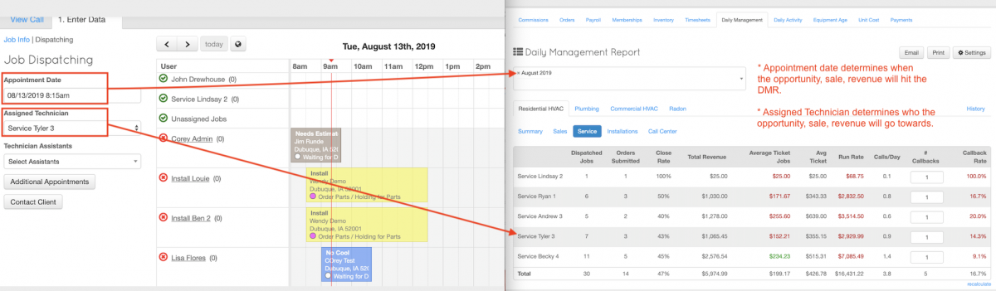

A job can have multiple types that are excluded from the summary. A job can only have one type selected the is NOT excluded from the summary. If you choose multiple types that are not excluded from the summary, you will double your opportunities and possibly revenue.
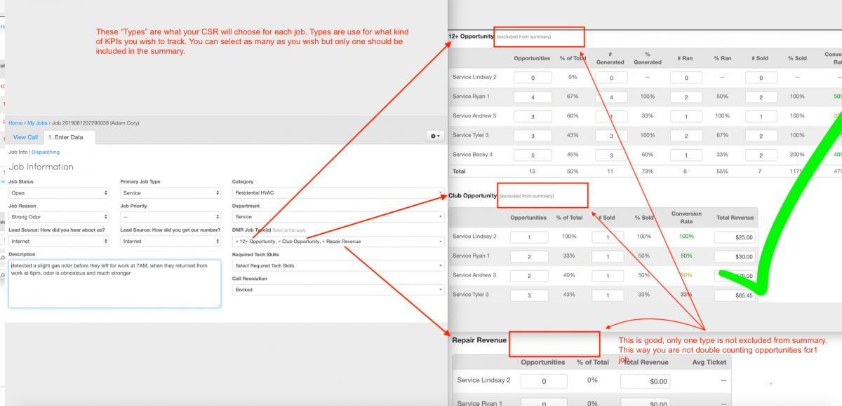

This shows an incorrect way of having too many types on a job as there should only be one that is not excluded from the summary.

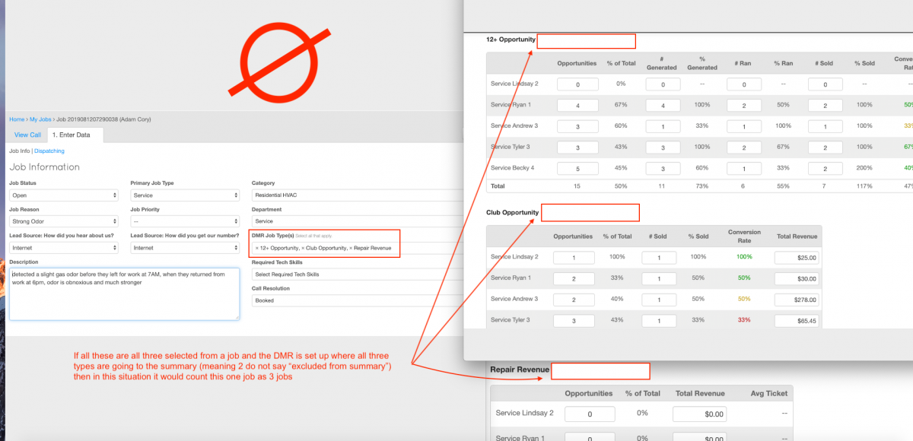

This illustrates how the types the dispatcher selected will allow a tech or sales rep to debrief their appointment before submitting. A debrief selecting how things went on the service job or sales job to track performance.

By default, a tech will check up to 2 boxes.
- The job for a tech should always say either repair or maintenance… not both. On the submit page they will always check whichever one shows up.
- If they sell a club membership, they will select that as well.

That’s it. The tech does not need to select 12+ if they generated a lead. There are two things that will happen to resolve this. When a sales rep creates an order from the call it will ask if it is a tech lead and who generated it. This gives the tech credit for generating the lead.

The sale rep needs to create the order from the call for many reasons.
- So they know if it’s a tech lead or not.
- So they know who generated the lead.
- So they know how much the service ticket was and what’s wrong.
- So the know if any of the repairs and how much is credited back to the homeowner with purchase of a new system.

When the sales rep sells the job there will be a place for them on their order to select 12+ to give credit to the tech on the sale.

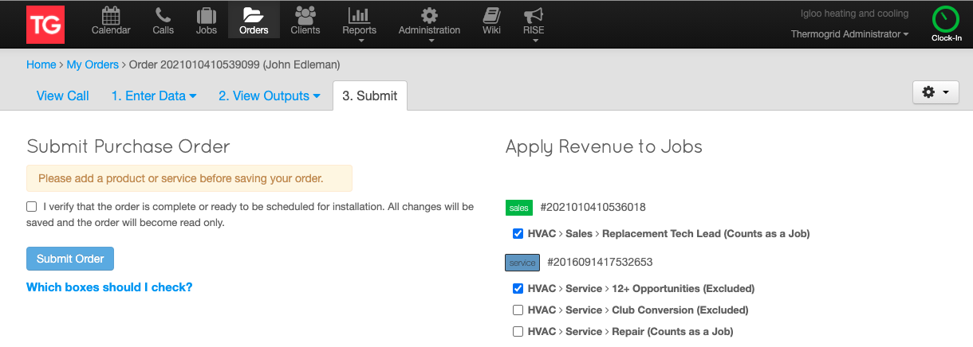

This illustrates how the areas of a job and order match up to the DMR.

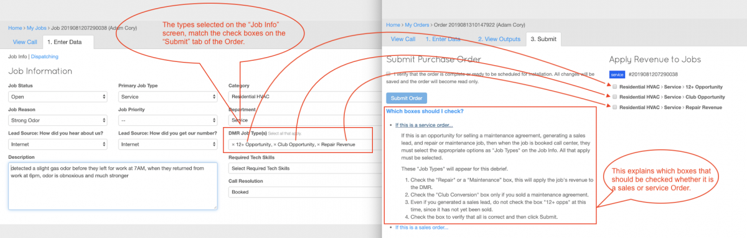
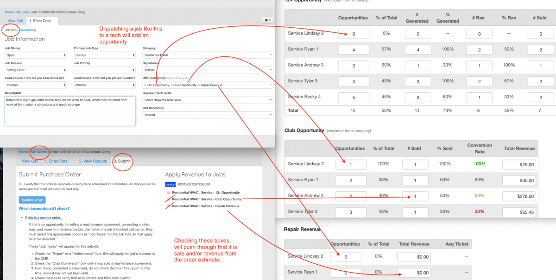

Goals in each area (Back to the Top)

What you will learn in this section is that the numbers are important. It is important to know where you are as well as where you should be. That being said, it is way more important to take action when you know what both of those numbers are.

- * Note: All numbers listed are general and a rule of thumb. If all numbers are followed it will work fine, however if you pick and choose some to follow and others not follow it can cause some major financial issues.
- * For guidance on this please reach out to a RISE Coach and plan out for your company.

Budget: Should be between $750-$900/day/employee as a general rule of thumb if you don’t actually have a planned-out budget already. Replacement revenue should be 80% and service revenue should be at 20%

Sales (Back to the Top)

Average: An okay average ticket is about $6000. When you are better at building systems and offering IAQ as well you can achieve over $8500+.

Closing Ratio: Closing ratio should be over 60% and with a great sales process can be more like 75%+. This is combining marketed leads and tech leads. Typically, 50% of the leads are marketed in a growing company over $3 million in revenue.

$/lead: An average ticket of $6000 and 60% closing ratio equals $3600/Lead. $3600/lead is an okay number but some of the best sales reps maintain over $7500+/lead.

Total Revenue: One sales rep should be able to bring in $1.5 million in revenue per year. $1,500,000/$3600 = 35 leads per month = 1.7 sales leads/day.

Advancing sales appointments mean you have to reschedule for another appointment to qualify it. Qualifying a sales appointment means you get all decision makers there as well as enough time to decide.

20% or less of all appointments can be advanced meaning:
- 35 leads *1.2 = 42 appointments per day /21 days in a month = 2 sales appointments per day on average.

Service (Back to the Top)

12+ Conversion: 12+ means the age of equipment is 12 years old or older. In many parts of the US and Canada this is the average life of a system. So, this will track what percent over this age that buy a new system vs repairing it. In some areas the average life will be less, Florida 10 years and Hawaii 8 years. From here on out 12+ just means whatever your average life is in your area. If you do not know the average life in your area use 12+.

33%+ of all service jobs ran should be 12+ or over the average life.

50%+ of the ones over the average life should be generated into a sales lead.

85%+ of all the leads that are generated should sell.

Here’s how we use the numbers:

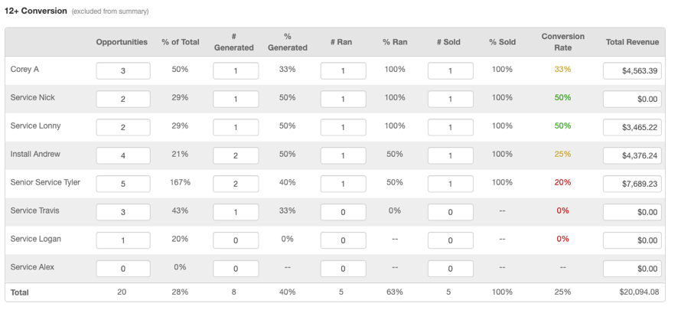

In this image % of Total is only 28% and it should be 33%+. From here I would dig into a couple areas, scheduling and dispatching. I would make sure my dispatchers are leaving room for older systems vs just booking whatever calls in.

I would make sure that if we have to choose between running a 12+ system and a 2-year-old system we are running the older one. If this doesn’t fix it then we would start making outbound calls to clients with 12+ systems from our database to get over the 33%.

In this image we also see % generated is 40% and it should be 50%+. This means I will role-play with the techs to ensure they can comfortably educate a homeowner with the information they need to make a decision to explore replacement. 50%+ of the ones over the average life should be generated into a lead by educating the client on average life, utility overpayment, current and future repairs, how long they plan on living in the home, Etc. We use a graph in RISE Coaching called repair or replace. This graph makes it easy for techs to share with clients and for clients to know what they should do. Learn More

In this image I see only 63% are ran which means we need to figure out why. Do we not have sales reps available, if not need to hire some reps. Are we just not building urgency, if not we need to role-play how to do this? Are they canceling before we get out there? 90%+ of generated leads should be ran and should be ran immediately.

80%+ of all leads ran should be sold. There are many factors that determine the success in closing, like how quickly the lead is ran.

If we can run a lead where the technician is still in the home when the sales rep shows up it will have great odds. This is called a warm hand off and the tech will introduce the sales rep and brief them on the situation in front of the client. This will typically lead to a closing ratio over 90%.

If you are not able to do the warm hand off and the sales rep goes out later that same day closing ratio will be over 80%.

If we are not able to get out to the clients house the same day and we go the following day the closing ratio goes down to 70%. From here risk dropping the closing ratio 5%-10% per day that you wait to run the appointment.

When you achieve these numbers across the board you will be at a conversion ratio of 36%+. Meaning 36% of all of the 12+ service jobs you run buy a new system.

Average Ticket: There are a couple areas within this that we want to measure. The model for great success as a technician is that they can bring in $1000/day. So, if a tech runs 3 jobs/day than the average ticket should be $333.34. If the technician runs 4 jobs/day the average ticket can be $250. You really should not go for and average ticket less than $250 regardless of how many jobs you run.

Club Conversion: This ratio should be 35%+. When you achieve these numbers, it will help you keep your techs busy all year round even while growing and adding more technicians. We use a method called the T-Bar to explain to a client the benefits in a way to hit their hot buttons. Learn More

Call Back %: For the service department the techs should stay below 1% call back ratio. If a tech cannot stay under this percentage, it will make it really tough to hit the revenue per day goals. Most call backs are caused by silly careless mistakes. One of the best ways to help eliminate call backs is to track what causes them and have a job checklist they fill out on every job. Some items on the checklist may be “re-light the water heater” or “system ran a full cycle”.

In many cases call backs are simple issues that can be resolved be a checklist reminder to do something.

Installation (Back to the Top)

Within the installation department it is really important to keep call backs down so the install crew can keep putting revenue in.

Total revenue: One installation crew should be able to install 1.5 million per year. $1,500,000/12 = $125,000/month = $5952.38/day which is just shy of the sales average ticket of $6000.

Call backs: Should be less than 5% for the installation department.

Call Center (Back to the Top)

Call Conversion: Most companies think they need more marketing but when they start tracking this number, they realize they don’t. Most companies that do not track this number very well book less than 55% of the calls coming in. This is very tough for most to believe but it is the hard truth.

For inbound service calls you should book 92% of them in average and slow seasons. In the busy season you should be able to stay above 85% conversion ratio.

The sales conversion ratio must be at 98%+ year-round. These leads are the most expensive to generate and they must be booked.

Club Sales: A beginner CSR should be able to sell 5 club memberships per month on average. An advanced CSR can sell 25+ club memberships per month.

FAQ (Back to the Top)

Employee is not showing up on the DMR
- Make sure they are added to a tech level. You can do this by going to their profile under manage users or by going to the settings of your DMR. Reports>Daily Management Report>Choose Category>Tech Levels>Edit
- Make sure you clicked Apply Settings as well.

Don’t see opportunity
- Is the Job info filled out correctly (Category, Department, and Type)?
- Is the job assigned to the persons you are looking at?
- Is that person a primary tech?
- Is the job schedule in the month of the DMR month you are looking at?

Revenue or sale not showing up
- Is the Job info filled out correctly (Category, Department, and Type)?
- Is the job assigned to the persons you are looking at?
- Is that person a primary tech?
- Is the job schedule in the month of the DMR month you are looking at?
- Did the person create their own order?
- Is the order submitted with the proper checks on the submit page?

